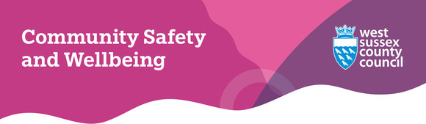
Welcome to our December 2025 eNewsletter
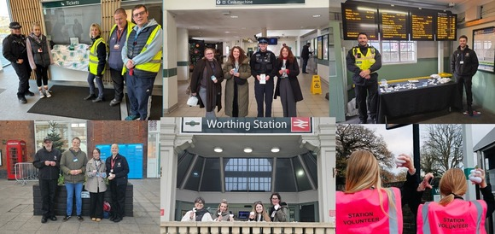
Thank you from the bottom of our knitted hearts
Last month, to mark White Ribbon Day, the Southeast Communities Rail Partnership and Safer West Sussex Partnership came together to hand out over 6,000 handmade knitted and crocheted white hearts to passengers and staff at stations across West Sussex.
These hearts were not just designed to raise awareness about the importance of ending violence against women and girls, they were also created to spread kindness to everyone in the community.
The day was a great success, and we just wanted to say a HUGE thank you to everyone who helped make kindness travel further – from the knitters, crocheters and crafters to the volunteers from 28 partner organisations who came out on the day to share the message 'Your Community Cares' - none of this would have been possible without you.
Any left-over hearts have now been added to community Christmas trees in stations across the county for passengers to take home, so if you want to carry a bit of kindness with you, make sure you pick one up at your local station.
Community Rail Partnership | Your Community Cares

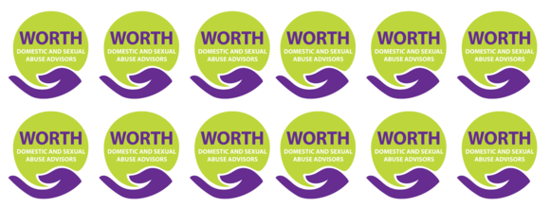
#YouAreNotAlone this Christmas
Domestic abuse can happen at any time of year, but there is always an increase in reporting over the festive season. This can be due to a combination of more alcohol, money being tighter and families spending more time together at home.
If you, or someone you know, is a victim of domestic abuse and you want help, our WORTH Domestic and Sexual Violence and Abuse service can be contacted over the holidays. Their opening hours are:
- Monday 22 December and Tuesday 23 December: 9am-5pm
- Wednesday 24 December: 9am-3pm
- Thursday 25 December and Friday 26 December: CLOSED
- Monday 29 December - Wednesday 31 December: 9am-5pm
- Thursday 1 January 2026: CLOSED
- Friday 2 January: 9am-5pm
You can get in contact by phone on 0330 222 8181 or email DomesticAbuseServicesCentral@westsussex.gov.uk.
If WORTH is closed, you can contact the freephone 24hr National Helpline provided by Refuge on 0808 2000 247. If you are in need of urgent help, call 999 immediately.
WORTH services | Access help online

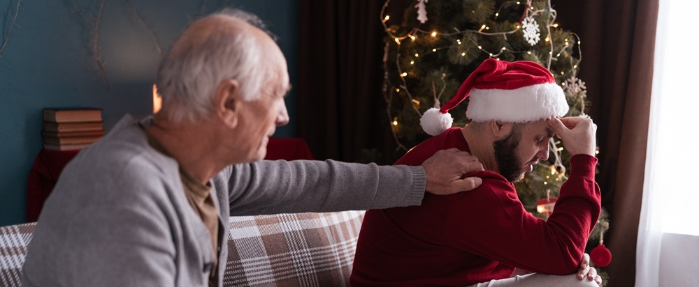
Lysenko Andrii/Shutterstock.com
Mental health support still available over the festive period
Although Christmas is traditionally seen as a time of celebration, it can be hard for people who struggle with their mental health.
That's why there is lots of support available if you need to reach out for help at any point over the holidays.
- Call NHS 111 and select the mental health option (available 24/7).
- Call the Samaritans on 116 123 (available 24/7).
- Visit a Staying Well service in Brighton, Crawley, Eastbourne, Hastings or Worthing (out-of-hours mental health crisis support service for people aged 18+).​​​​​​
- Text the word SUSSEX to 85258 (24/7 mental health text-messaging support service).
- Download the Stay Alive app - a suicide prevention resource full of useful information and tools to help you stay safe in crisis.
For further details, just visit the Sussex Partnership NHS Foundation Trust website.
Sussex Partnership NHS Foundation Trust | Mental health support


Share your memories of West Sussex Libraries
This year marks the 100th anniversary of West Sussex Library Service, a milestone that has been celebrated with a packed programme of events and activities, including residents sharing their own treasured library experiences.
From spaces to learn and grow, to rediscovering a love of reading, libraries have clearly always held a special place in the hearts of our communities.
With just two weeks left of this centenary year, there is still time to share your own cherished memories of West Sussex libraries — big or small — on the Your Voice website.
If you don’t have a memory to share, you can still take part by exploring the wonderful stories others have contributed.
Your Voice | Centenary celebrations


Want to learn how to stay safe online?
Our Digital Safety & Fraud Prevention team have the following online safety and fraud awareness sessions coming up over the next few months which are free to attend:
- A brief introduction into Artificial Intelligence (AI) - A 45-minute online course which is a clear introduction to what AI is, how it works and how it's used.
- Are you scam savvy? - A one and a half hour in person session at Crawley Library on Wednesday 18 February at 1.30pm looking at the rise in scams, including telephone, courier and romance fraud and what you can do to stop yourself becoming a victim.
- Online safety for parents - A one-hour online course providing you with the essential knowledge and tools to help keep your children safe online.
To find out more and book your place, visit their Eventbrite page.
Eventbrite | Digital Safety & Fraud Prevention

Supporting self-esteem in children and young people
West Sussex Mind Parenting Service is running a free Experts by Experience session called 'Supporting self-esteem in children and young people' on Wednesday 21 January 2026.
This online session is aimed at parents and carers and runs between 7.30pm and 9.30pm. Book your free ticket on the link below.
Eventbrite | West Sussex Mind


Throughout December and January, we’ll be supporting Sussex Police and partner organisations in the national Safer Streets Winter of Action initiative.
The campaign will target town centre criminality, including shop theft, street crime, and anti-social behaviour. It will also focus on the night-time economy, tackling violence against women, alcohol-related disorder, and spiking.
In West Sussex, the initiative is running in Bognor Regis, Chichester, Crawley, Horsham, and Worthing, with coordinated efforts to make town centres safer and more welcoming for all.
Sussex Police | Winter of Action

With Christmas shopping, festive markets, pantomimes and concerts filling the winter calendar, Counter Terrorism Policing is reminding everyone to stay alert when they are out and about.
By trusting your instincts and reporting anything that doesn’t feel right, you can play a vital role in protecting your community.
Together, we can ensure the festive season remains safe and enjoyable for all.
Counter Terrorism Policing | ACT



