

Christmas & New Year
Opening Hours

Dear customer,

As we fast approach the end of 2025, we would like to take this opportunity to thank all our customers for their valued custom and advise everyone of our opening hours over the festive period.

Our Traffic Office and Call Centre at our Head Office in Fareham and our Portsmouth and Southampton Recycling Facilities will be open as follows:

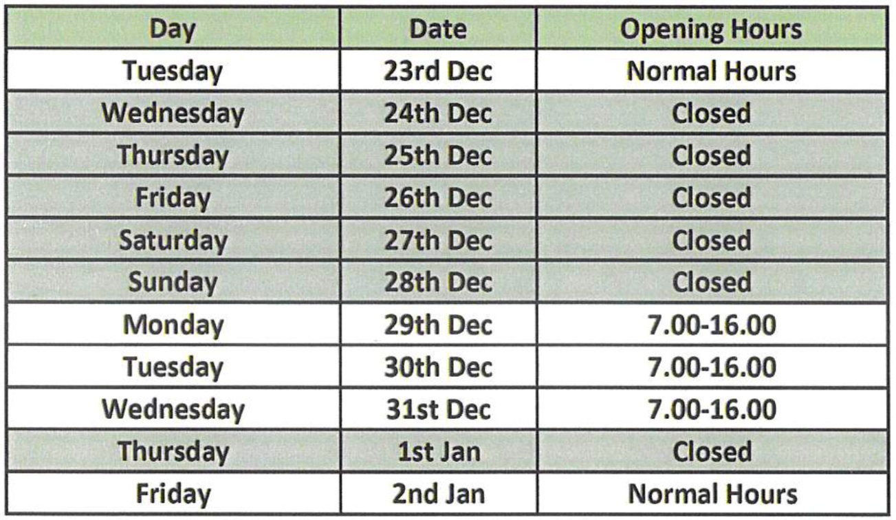

Our Pegham Recycling Centre and Railhead Aggregate Site will close from Wednesday 24 December 2025 and will re-open on Friday 2 January 2026.
ENQUIRIES



