
Welcome to our special Christmas and New Year Residents’ eNewsletter.
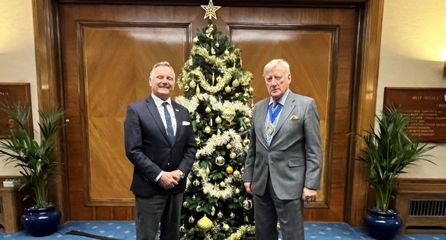
A message from our Chairman and Leader
We would like to take this opportunity to wish you all a very Merry Christmas.
However you plan to spend the festive season, we hope you find time to enjoy the celebrations, meet with family, friends and loved ones or perhaps take a moment to reflect on the past year.
As always, our county council staff are here should you need us right through the festive season, providing services such as highways, the Fire and Rescue Service, and adults and children’s social care.
If you have time over the festive period we would urge you to complete the Government’s consultation on Local Government Reorganisation which you can find here. The consultation is open until 11 January 2026.
We also want to wish you a Happy New Year and good wishes for 2026.
Cllr Paul Marshall (Leader) and Cllr Pieter Montyn (Chairman)
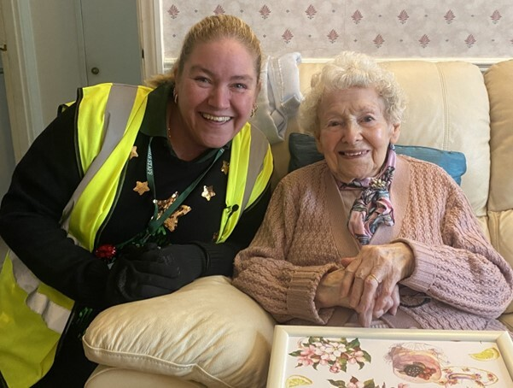
Bringing festive cheer this Christmas
The festive season can feel especially lonely for older or vulnerable people living alone.
A visit from Health & Independent Living Support (HILS) not only provides a hot, nourishing meal but also a friendly face and a wellbeing check.
HILS delivers meals to homes across West Sussex every day of the year in partnership with the county council.
With no contracts you can just order as often as you need them.
In addition, over Christmas you may notice your loved ones could use extra help and support with meals.
If you’re concerned about a loved one losing weight, there is also free Nutrition and Wellbeing telephone support for clients.
Find out more


Local holiday fun for all!
Looking for ways to keep the whole family entertained this Christmas and New Year? Experience Sussex is full of family-friendly ideas to enjoy during the holidays.
Why not get your skates on at a festive pop-up ice rink? Or treat yourself to an experience at one of the stunning light trails around West Sussex.
For Boxing Day walks, check out our guide to winter walks along the South Downs or the coast, then warm up with a hot chocolate by searching a local café or pub.
As the New Year approaches, plan a day exploring the countryside or local nature trails. It’s the ideal way to start 2026 with fresh air and family time.
Discover local festive fun!

And as you take in the festive lights and sights across the county, why not make the journey part of the joy?
With improved bus stops, upgraded shelters, and new bus lanes, we’ve made changes to help make your journeys smoother and more enjoyable.
Let the bus be your sleigh as you enjoy the magic of the holidays!
Bus it!

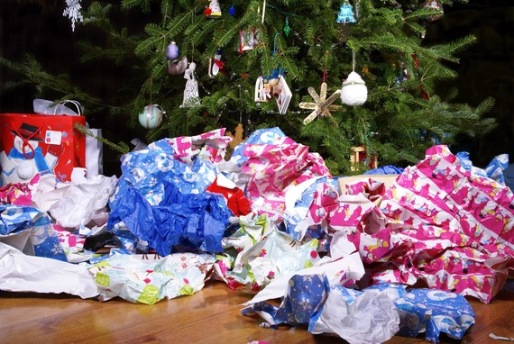
Get ready to reduce waste this Christmas
Here’s some top tips from our West Sussex Recycles team to help you reduce your waste this festive season:
- Recyclable wrapping paper – buy wrapping paper that can be recycled at home. Look for rolls that aren't wrapped in plastic and don’t have too much glitter. That way you can reduce your plastic waste and make sure it passes the 'scrunch test'. Scrunchable paper means your friends and family can recycle the paper once they have unwrapped their gift!
- Think about the gifts you give – give experiences, shop second hand or make your own gift.
- Recycle everything you can - recyclable items include Christmas cards, wrapping paper (that passes the scrunch test), paper bags, glass bottles and jars, plastic bottles (with lids on), plastic pots, tubs (including sweet/chocolate tubs), trays (including black plastic), tins, cans, foil, and crisp tubes (eg Pringles). Just make sure your recycling is clean, dry and loose. For more information, check out our A-Z here.
More tips for reducing Christmas waste

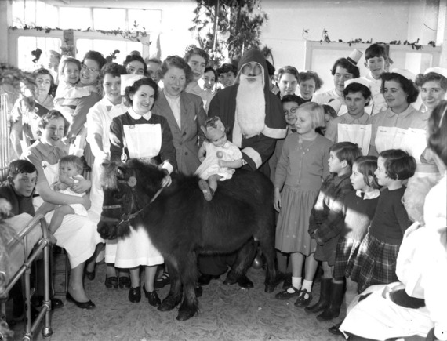
Horse play in hospital!
You’re unlikely to see a pony in a hospital ward these days!
But this vintage photo, which is in our Record Office archives, shows a Christmas Day party at St Richard’s Hospital, Chichester, in 1955.
If you’re looking for a last-minute, quirky, local gift, then visit the Sussex Pictures website on the link below to choose unique images for a range of products, including framed and canvas prints, mouse mats, jigsaw puzzles, coasters and cushions, that all feature local people and places from times past.
The images, which include Byworth in the snow, a shepherd and his dog at Goodwood, and Boxgrove Tipteers Christmas Mummers Play, are from the historic collections held at our West Sussex Record Office.
Take a trip down memory lane


 |  | Our fantastic eLibrary is available 24/7 over Christmas and New Year, and is free to use with your library card.  There are thousands of eBooks, eAudioBooks, eMagazines and eNewspapers to read or listen to – something for everyone, including the latest bestsellers, award winners and more!

Did you receive this eNewsletter from a friend? Sign up here.

