NEWS RELEASE | 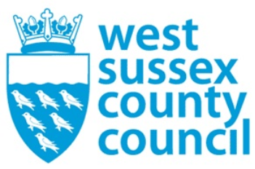

08 December 2025

Statement regarding shipping containers coming ashore in West Sussex
Statement provided by Arun District Council, Chichester District Council and West Sussex County Council
Several agencies are working together to resolve the issue of shipping containers that have come ashore between Selsey and Bognor Regis in West Sussex.
Late on Saturday evening (6 December) it was reported that 16 shipping containers had gone overboard from a cargo ship in the Solent. Tidal indications showed that the containers were likely to come ashore along the West Sussex Coast.
To date, eleven of the 16 containers lost from cargo ship BALTIC KLIPPER have been washed ashore in areas of West Sussex. Seven containers have so far been located in Selsey, two at Pagham Harbour and two at Bognor.
As part of the operational response, HM Coastguard helicopter and fixed wing aircraft have been undertaking offshore searches in an attempt to locate the outstanding containers. All wreck material should be reported to the Receiver of Wreck, however this does not include perishable goods like foodstuffs.
Any additional sightings of containers should be reported to the coastguard on 0344 382 0560.
The remaining containers, some of which have opened and spilled their contents of fruit, mainly bananas, are now subject to a clean-up operation lead by West Sussex County Council, Arun District Council and Chichester District Council.
A waste management company, Ambi Par, has been appointed to lead on the clean-up and is placing skips in the areas where the containers are, (Bognor Regis, Pagham and Selsey).
There is also an email address (marine.response@ambipar.com) and telephone number (01202653558) for anyone who wishes to report where they have seen waste from the containers to Ambi Par.
The three local authorities are grateful to those members of the public who have aided so far in helping to clear the fruit that has come ashore but would continue to urge people to avoid the area while the clear-up takes place, as there may be fragments of metal from the damaged containers along the shoreline.
There is also a strong warning to everyone that the fruit that has come ashore may be unfit for consumption. Anyone who has taken fruit home is advised to discard it immediately.
The clean-up operation is ongoing and, as yet, there is no confirmed deadline as to when the operation will be complete. However, all agencies involved are meeting regularly to ensure the operation is brought to a close as soon as is possible.
Once again, all partners involved want to thank those who have helped so far with cleaning up and for their continued support.
Further updates will be made when available.
For further information please contact the news desk on 0330 222 8090 or email pressoffice@westsussex.gov.uk.
For urgent out-of-hours enquiries please call 07767 098415.
 

Click to Unsubscribe

