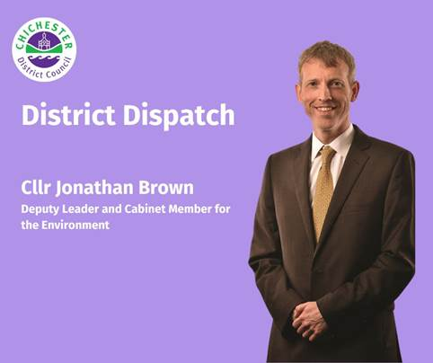
District Dispatch
As you may have noticed, the weather is becoming increasingly unsettled throughout the year. Winters are bringing heavier rainfall, sudden cold spells, and more extreme conditions — all of which can increase the risk of flooding and disruption. That’s why it’s more important than ever to be prepared. There are several practical steps we can all take to ensure our homes, gardens, and businesses are ready for whatever the weather may bring.

If you experience a power cut during severe weather, you should call 105 to be connected to your local electricity distribution operator. It’s also a good idea to check the flood risk for your postcode area by visiting www.gov.uk/check-long-term-flood-risk. In many areas, you can sign up for flood warnings at www.gov.uk/sign-up-for-flood-warnings. These alerts cover flooding from rivers, the sea, and groundwater, and can be sent by phone, email, or text. Please note that not all areas are covered by this service.

In case of flooding, it’s essential to know where your mains water, gas, and electricity shut-off points are. These vary between properties, but gas shut-off valves are usually located beside the meter, and the mains electricity cut-off is typically a large red switch on your fuse box. If you’re unsure where your water stopcock is, ask someone with practical experience or a plumber to help you locate it.

If you're a vulnerable resident, you may be eligible to join the Priority Services Register with your utility provider. This gives you access to additional help if your electricity, gas or water supply is disrupted during an emergency. You can find out more about this at: www.thepsr.co.uk.

While preparation can go a long way, sometimes extreme weather can still cause damage. That’s why it’s important to make sure your insurance policy is up-to-date and provides the cover you need. Insurance offers peace of mind, knowing that your home and property are protected. It’s worth checking that your policy is up-to-date and covers what you need. If you’re finding it difficult to get flood insurance, the National Flood Forum may be able to help: www.nationalfloodforum.org.uk

It's also worth packing a bag of essential items to take with you if you need to leave your home and keeping this in a safe place. This could include spare medication, glasses, clothing, important documents, and contact details — such as your insurance company’s number.

When high winds are forecast, everyday items like garden furniture can become dangerous objects. Make sure these are secured or stored away before a storm hits. It’s also wise to inspect your roof for loose tiles, slates, or flashing, and remove any dead branches from trees. During winter, leaves can build up in your gutters and drainpipes, preventing water from draining properly and potentially causing leaks into your roof and walls. Consider having your gutters cleared to avoid this.

Cold weather can also pose a risk to your water system. Make sure your pipes and water tanks are covered with good quality-insulation to prevent freezing and help reduce energy costs. For the latest weather warnings, you can subscribe to Met Office alerts at www.metoffice.gov.uk/about-us/news-and-media/media-centre/subscribe-to-email-alerts. We also share their updates and advice on our social media channels.

If you have a mobile phone, we recommend downloading the Chichester District Council app from the Apple App Store or Google Play. The app allows you to view your waste and recycling collection dates, sign up for reminders, and, if you switch your notifications on, you will also receive live updates if there are any changes due to severe weather or other unforeseen issues. You can find out more at: www.chichester.gov.uk/chichesterdcapp.

By taking these steps now, you can help protect your property and stay safe during the months ahead. Please also consider sharing these tips with family members and neighbours who might find them useful.

Best wishes
Cllr Jonathan Brown
Deputy Leader and Cabinet Member for Environmental Strategy at Chichester District Council

 | Terri Foster  Senior Communications Officer  Communications  Chichester District Council

Ext: 21226 | Tel: 01243521226 | tfoster@chichester.gov.uk | https://www.chichester.gov.uk
East Pallant House opening hours: 9am-4pm Monday to Friday

