
Countdown to Christmas

Did you know Christmas is the most wasteful holiday of the year? In the UK, we create an extra 3 million tonnes of waste and recycling during the festive season, from wrapping paper and cards to food and packaging. But with a few simple steps, we can all make a big difference in reducing waste.
Over on our socials, we are sharing a new festive tip every day to help residents reduce their waste! Here are our favourites:
- Prepare for your Christmas shopping – write a list of meaningful gifts before you go! That way you avoid panic buying or purchasing something the recipient may not need, just for the sake of giving a gift! Don't forget to take your reusable bags and coffee cup too!
- Recyclable wrapping paper – buy wrapping paper that can be recycled at home. Look for the rolls that aren't wrapped in plastic and don’t have too much glitter. That way you can reduce your plastic waste and make sure it passes the scrunch test. Scrunchable paper means your friends and family can recycle the paper once they have unwrapped their gift!
- Think about the gifts you give – give experiences, shop second hand or opt for secret Santa and make the most out of the gifts you give. Instead of giving away meaningless presents that won’t last long, invest time and effort into a meaningful gift or experience that will last a lifetime.
- Recycle everything you can at home - We understand that not all waste can be avoided, so remember to recycle as much as possible. Recyclable items include Christmas cards, wrapping paper (that passes the scrunch test), paper bags, glass bottles and jars, plastic bottles (with lids on), plastic pots, tubs (including sweet/chocolate tubs), trays (including black plastic), toothpaste tubes, tins, cans, foil, and even Pringles tubes. Just make sure your recycling is:
  - Clean– Free from food and drink leftovers.
  - Dry– Keep your recycling bin lid shut.
  - Loose– Not in plastic bags.
- Know what to do with extra recycling - if you have more recycling than will comfortably fit in your recycling bin, check with your local district or borough council to see if they can take extra recycling after Christmas. You can also recycle more, including electricals, at your local Recycling Centre. For more information, including opening hours and to book an appointment, visit our Recycling Centre webpage.
For more information on what can be recycled in West Sussex, check out our A-Z here.
Countdown to Christmas with us on X, Instagram, or Facebook using @WSRecycles.
Fight Against Food Waste this Christmas
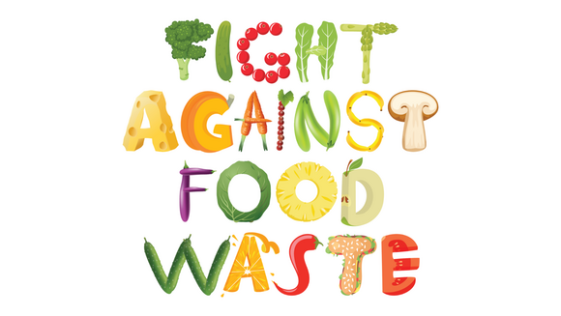
Food waste increases significantly over the festive period. The most wasted Christmas foods in the UK are potatoes (710,000 tonnes), poultry (100,000 tonnes), carrots (96,000 tonnes), and enough gravy to accompany Christmas dinner for the whole country! When food is wasted, all the resources (water, energy, etc.) used to produce it are wasted too. Give our top tips a go and reduce your waste this Christmas, protecting the planet and saving some money too:
- Buy loose fruit and veg - Research shows that if all apples, bananas and potatoes were sold loose, 8.2 million shopping baskets' worth of food waste could be prevented every year. That’s simply because when fruit and vegetables are sold loose, people can buy only what they need and will use.
- Love your leftovers – planning ahead for how you'll use up leftover veg, and turkey can help reduce food waste and save money. Will it be turkey sandwiches on Boxing Day or a turkey curry next week? It’s worth thinking about now so you can pick up any extra ingredients you’ll need to make those meals happen.
- Freeze with ease –Don’t forget, you can freeze leftover veggies and meat to use later. Freezing keeps food fresher for longer and helps reduce waste.
Visit our Fight Against Food Waste page for more top tips, or check out our video, produced in collaboration with UKHarvest.


Bin collections and Recycling Centre opening hours
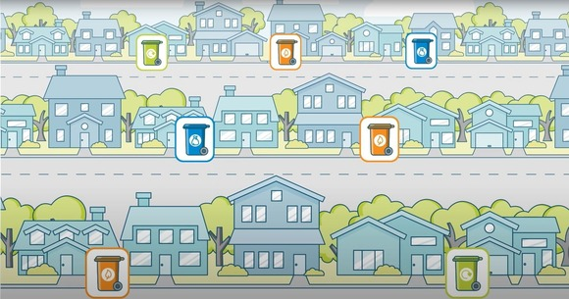
Due to the bank holidays, some collection days may change over the Christmas period. It is important to check with your local district or borough council for more information on how you may be affected:
- Adur & Worthing Councils
- Arun District Council
- Chichester District Council
- Crawley Borough Council
- Horsham District Council
- Mid Sussex District Council
If you live in Adur & Worthing, Arun, Chichester or Horsham districts why not download their apps and stay up to date on any changes with your bin collections?
Alongside collection changes, all the Recycling Centres will be closed on the 25 and 26 December. They will also be closed on 1 January 2026. For more information on Recycling Centre opening hours, please visit our website.
Upcoming waste prevention events

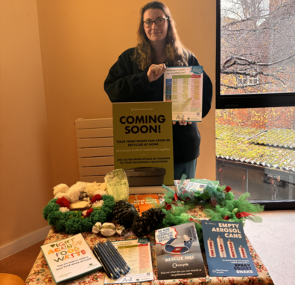
Throughout West Sussex, we are proud to work alongside a team of passionate waste prevention and recycling volunteers. They attend public and private events to promote waste prevention, reuse, and recycling, and are eager to answer questions about the county's recycling services and waste reduction initiatives.
In addition to the public events listed below, we are participating in numerous privately hosted talks and events for local community groups, schools, and other organisations. If you would like our team to give a talk, visit your school, attend an event, or if you would like more information, please contact us at: waste.prevention@westsussex.gov.uk.
We also support our partners at the district and borough councils with community outreach in selected areas, engaging residents on both recycling and waste prevention topics.
December/ January events
- Friday 5 December (5:30pm–9pm) – Waste Prevention Information Stand at Cuckfield Christmas Street Festival, Cuckfield Main High Street
- Saturday 6 December (9am–2pm) – Waste Prevention Information Stand at Midhurst Market, Midhurst High Street
- Saturday 6 December (10am–1pm) – Waste Prevention Information Stand at Lindfield Repair Café, United Reform Church, High Street, Lindfield, RH16 2HL
- Saturday 6 December (10am–2pm) – Waste Prevention Information Stand at Craft Fair, Hurstpierpoint Village Centre, Trinity Road, Hurstpierpoint, BN6 9UY
- Wednesday 10 December (10:30am-2:30pm) – Waste Prevention Information Stand at Crawley Wellbeing – K2 Crawley, Pease Pottage Hill, Crawley RH11 9BQ
- Friday 12 December (12pm–7:30pm) – Waste Prevention Information Stand at Light Up Shoreham, Marlipins Museum, 36 High St, Shoreham-by-Sea, BN43 5DA
- Saturday 13 December (10:30am–4:30pm) – Waste Prevention Information Stand at Amberley Museum Christmas Craft Market, Amberley Museum, New Barn Road, Amberley, BN18 9LT
- Wednesday 17 December (4pm-7pm) – Waste Prevention Information Stand at Bohunt School Christmas Fair - Bohunt School Bailey Rd, Horsham RH12 6AP
- Saturday 20 December (9am-1pm) – Waste Prevention Information Stand at Arundel Farmers Market – Arundel Green Living, Arundel
- Monday 22 December (10am-6pm) - Waste Prevention Information Stand at Tilgate Magical Christmas, The Walled Garden, Tilgate Park, Tilgate, Crawley RH10 5PQ
- Tuesday 23 December (10am–6pm) – Waste Prevention Information Stand at Tilgate Magical Christmas, The Walled Garden, Tilgate Park, Tilgate, Crawley, RH10 5PQ
- Saturday 24 January (1pm-3pm) - Waste Prevention Information Stand at The Community People's Community & Volunteer Fairs, Haywards Heath College, Harlands Rd, Haywards Heath RH16 1LT
- Saturday 31 January (10am-12pm) - Waste Prevention Information Stand at The Community People's Community & Volunteer Fairs, East Court, College Lane, East Grinstead RH19 3LT
See a full list of events, over on our website.

Sign up for our newsletter
Finally, we know that if you receive this email, you are passionate about waste prevention and recycling.
If you find these emails helpful, why not share it with a friend and get them to subscribe to the West Sussex Recycles newsletter as well.
To hear more about how we are tackling climate change and helping protect the environment in West Sussex, why not sign-up to receive our regular Environment and Climate Change eNewsletter too! View the November edition here.
Help us spread the message and get more people on board to make West Sussex a strong, safe, and sustainable place to live.




