Could You Help Your Community in a Time of Disruption?
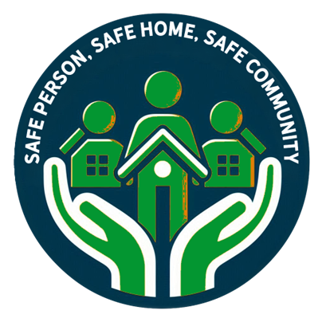
When things don’t go to plan — such as during severe weather, power cuts, blocked roads, or supply disruptions — communities are strongest when people support one another.
That’s why we’re building a team of local volunteers to support our Community Emergency Hub.
The hub is a place where people can come during a disruption to:
- Get reliable local information
- Stay warm, safe, and connected
- Receive practical help and reassurance
- Support one another until normal services resume

Who Can Volunteer?
We’re looking for people with everyday skills and local knowledge, such as:
- Being a friendly face who can listen and reassure
- Helping organise people or resources
- First aid, care, or welfare experience
- Knowledge of the local area and its residents
- Practical skills, admin, or communications
- Helping make refreshments or welcome visitors

What Volunteering Involves
Volunteers may help with:
- Setting up and running the hub
- Sharing information clearly and calmly
- Supporting vulnerable or isolated residents
- Working alongside other local volunteers
Interested in volunteering?
Please get in touch to find out more about supporting your local Community Emergency Hub.
Contact: Alison Colban parishclerk@sidleshamparishcouncil.gov.uk /07386731159

