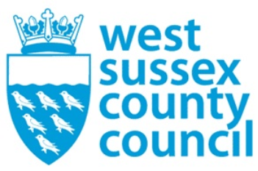

news release
01 October 2025

A loan that could save your life! 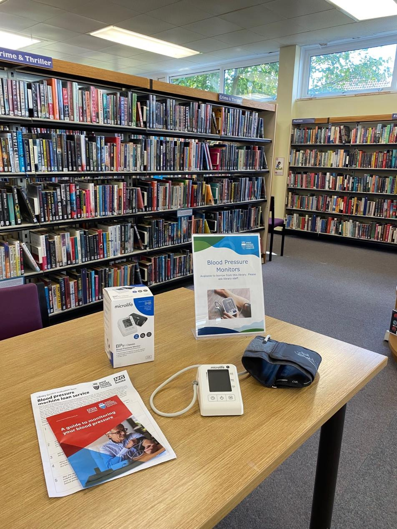
You can now borrow potentially life-saving blood pressure monitors free of charge from all 36 libraries in West Sussex.
High blood pressure (or hypertension) is a leading cause of heart attacks, strokes and other diseases, but it is a treatable condition and early detection is key.
The easy-to-use blood pressure monitoring kits can be borrowed for up to three weeks by local library members and used at home to check blood pressure daily.
The kits come with a guide on how to measure blood pressure, interpret the results, and a diary to log them. For low and high blood pressure readings, people are encouraged to contact their GP for further advice and treatment. Further information to support being healthy is also provided in the kit.
The initiative is a partnership between West Sussex County Council’s public health and library services and NHS Sussex, with the aim of increasing the detection of undiagnosed hypertension.
Often called ‘the silent killer’ as it usually has no symptoms, high blood pressure can only be detected via a blood pressure check, which is quick and painless.
For many people, there may not be a single cause, but reducing your risk through being a healthy weight, minimising your salt intake, being physically active, drinking within recommended guidelines and stopping smoking can all help reduce your blood pressure. Being aware of your blood pressure and checking it regularly is an important way that you can take charge of your own health and wellbeing.
The West Sussex Wellbeing Programme can support West Sussex people to makes these changes. Delivered by partnership working between district and borough councils and the county council this supports people to maintain and improve their health through practical advice and support that addresses inequalities and supports people to be healthy and well. This programme supports a key priority in Our Council Plan to help people and communities fulfil their potential.
Councillor Bob Lanzer, Cabinet Member for Public Health and Wellbeing, said: “The county council is passionate about improving the health and wellbeing of our residents so we are delighted to join with our NHS colleagues to roll out this vital initiative which will allow people to measure their blood pressure at home, and if there is a potential problem seek help from their GP.”
Councillor Duncan Crow, Cabinet Member for Community Support, Fire and Rescue, said: “This is another superb example of how our libraries support health and wellbeing in our communities and I’m delighted they are able to offer this valuable service which I’m sure will benefit many people.”
Dr Suneeta Kochhar, Clinical Lead for Cardiovascular Disease Prevention at NHS Sussex, said: “Having raised blood pressure is associated with an increased risk of heart disease, strokes and chronic kidney disease. Up to a third of people in the UK may be unaware that they have raised blood pressure, this is because most people do not have any symptoms. This means that the only way to detect this is by having a blood pressure check. A blood pressure check can be done at your GP surgery, local community pharmacy or through initiatives like the library blood pressure monitor loans in West Sussex.”
From East Grinstead to East Preston and Southwater to Southwick, find your nearest library.
Not a library member yet? It’s free and easy to join if you live, work or study in the county.
For support with health and wellbeing for adults who live or work in West Sussex, please contact an advisor at your local wellbeing hub or find out more at West Sussex Wellbeing www.westsussexwellbeing.org.uk
​
For further information please contact the news desk on 0330 222 8090 or email pressoffice@westsussex.gov.uk.
For urgent out-of-hours enquiries please call 07767 098415.
 

