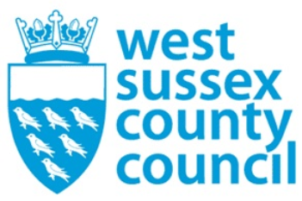

news release
09 October 2025

Apply for your child's place to start school in 2026

Applications are now open for children who are due to start in reception at primary and infant schools across West Sussex in September 2026. The quickest and easiest way to apply is online via School places - West Sussex County Council and the deadline for applications is 15 January 2026. Children born between 1 September 2021 and 31 August 2022 are eligible to start school next September.
Children who are currently in Year 2 at an infant school will also need to apply for a place to start a junior school in September next year.
We strongly advise that parents and carers apply on time, before 15 January 2026, which will give them the best chance of being offered one of their three preferences. Those who apply late are far less likely to get a place at one of their three preferred schools and will still need to apply, as they will not automatically be given a place.
Councillor Jacquie Russell, Cabinet Member for Children, Young People and Learning, said: "Supporting individuals and communities to thrive remains a central focus of Our Council Plan, and schools are vital in helping us achieve that goal
"As families consider their school preferences, I strongly encourage them to explore all available information, visit school websites, reach out directly with any questions, and take advantage of open days."
All of the information about applying can be found on the county council website here: School places - West Sussex County Council.
Free use of computers with internet access is available in all West Sussex libraries, where there is no need to book. Those unable to apply online can request a form is e-mailed or sent in the post by calling 033 301 42903.
Parents/carers are advised:
· To include three preference schools on your application, listing them in order of preference.
· Parents/carers who want their child to go to their catchment school (where applicable) will need to include that school as a preference for it to be considered.
· If you apply after the closing date you are far less likely to get a place at one of your preferred schools.
West Sussex County Council admissions staff can offer support to anyone who needs help with their application. Contact the admissions team by phoning 033 301 42903 or email the Admissions Team North: admissions.north@westsussex.gov.uk or the Admissions Team South: admissions.south@westsussex.gov.uk.
Secondary school applications are currently open for pupils due to start in September 2026. The application window closes on Thursday 31 October 2025 and the application form is available via: Secondary school places - West Sussex County Council.
​
For further information please contact the news desk on 0330 222 8090 or email pressoffice@westsussex.gov.uk.
For urgent out-of-hours enquiries please call 07767 098415.
 

