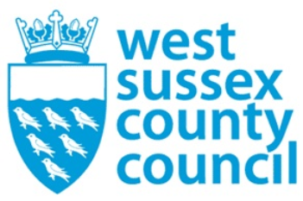

news release
13 October 2025

Settle down with some spine-tingling tales from West Sussex!

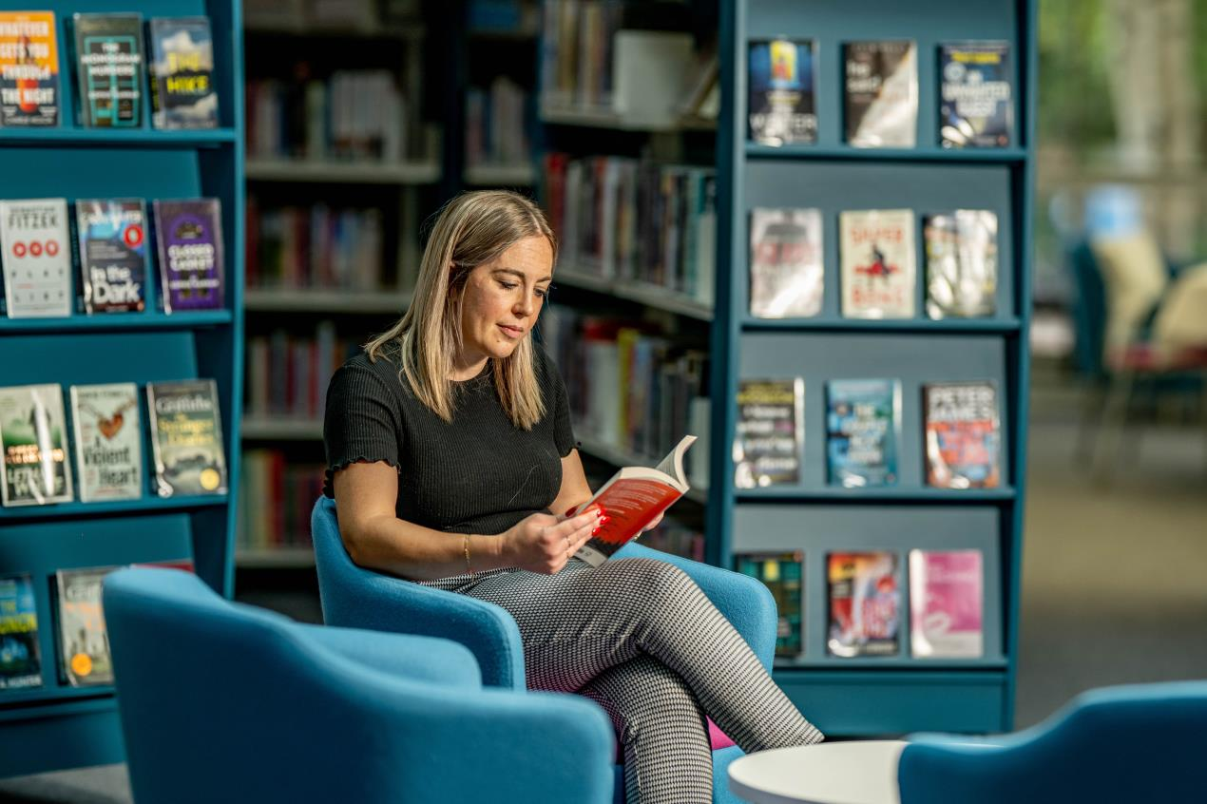

Do you like reading about ghastly ghosts or supernatural spectres?
With Halloween at the end of the month it’s the perfect time to set your spine tingling with spooky tales that you can borrow free of charge from your local library!
For instance, have you heard about the ghostly Roman soldier who reputedly patrols the ancient city walls in Chichester, or the witch from Goring who changed into a big black dog?
These are just two spooky legends that you can read about in the tens of thousands of books available at our 36 libraries and eLibrary.
And two of our libraries even have ghosts to call their own!
At Arundel Library, the ghost has been named Betty for as long as anyone can remember. It’s thought she was either a teacher or headmistress of the school which used to be in the building.
There are stories of seeing her standing in the middle of the room, dressed in Victorian or Edwardian dress.
Over the years she has apparently had the habit of moving things around the building, and some say they have heard footsteps on the staircase or even received a ‘shush!’ in the ear!
In Worthing Library there is allegedly a ‘ghostly guardian’ who purportedly haunts the basement. Local author Wendy Hughes in her book Haunted Worthing writes about the ghost. Staff say some parts of the Worthing basement do feel a bit creepy!
You can read more tales of local hauntings in books such as British Witch Legends of Sussex and Haunted Places of Sussex, available along with many others in our libraries. Search the catalogue here.
And if you’ve watched a spooky TV series or seen a horror film and want to continue learning about the characters, then head to your local library or browse the e-library where you can often find books with a TV series or film tie-in, such as The Long Walk by Stephen King, 28 Years Later by Alex Garland or Frankenstein by Mary Shelley.
You can also explore our list of horror and gothic titles available to borrow free in eBook and eAudio via the Libby app to get inspiration for some haunting reads. Libby - Horror & Gothic Reads.
Councillor Duncan Crow, Cabinet Member for Community Support, Fire and Rescue said: “Our libraries are keen to encourage more people to enjoy reading, and as the nights draw in, it’s a perfect time to settle down with a good book. We have thousands of fiction and non-fiction titles to choose from, so if spooky is not your thing, then there will certainly be something to interest you on the shelves or in the eLibrary!”
Our library service is celebrating 100 years of being at the heart of our communities this year. One of the council’s key priorities is to help people and communities to fulfil their potential, and our libraries fulfil that aim every single day.
From Selsey to Shoreham, Lancing to Littlehampton, find your nearest library.
Not a library member yet? It’s free and easy to join if you live, work or study in the county.
​

For further information please contact the news desk on 0330 222 8090 or email pressoffice@westsussex.gov.uk.
For urgent out-of-hours enquiries please call 07767 098415.
 

Click to Unsubscribe

