NEWS RELEASE | 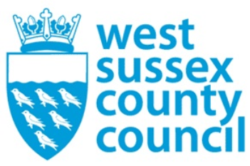

23 September 2025

Lights, camera, action! Road safety shows to return to Sussex schools
The importance of road safety will be brought to life by Theatre-in-Education (TiE) shows in secondary schools across Sussex this autumn.
Theatre-in Education is an entertaining as well as informative experience that combines drama, humour and audience participation to reinforce student learning about road traffic dangers.
Year 7 students (age 11-12) will have the opportunity to see a show titled ‘Look Up’, with a focus on helping them learn about their responsibilities as pedestrians. Year 11 students’ (age 15-16) show ‘Take a Second,’ will help students think about the consequences and effects of choices they make as both passengers and drivers.
Cllr Joy Dennis, West Sussex County Council Cabinet Member for Highways and Transport, said: “I am proud that together with our partners we can bring road safety to children in an engaging way that will help them to see the importance of these messages.
“Many year 7 students will be walking to school for the first time without their parents and it is important that we help them learn how to manage this responsibility safely. Year 11 students also face new responsibilities as they enter their final year of secondary school and helping them to consider road safety in their day-to-day lives is an important lesson.”
The programme is sponsored by West Sussex County Council, in partnership with East Sussex County Council and Brighton & Hove City Council as part of their vital, ongoing commitment to road safety through education. Sussex Councillors are all invited to visit participating schools to see the impact the shows have.
Theatre-in-Education will tour schools across Sussex throughout the Autumn Term, performing between 23 September to 25 October and 4 November to 22 November.
NOTES TO EDITOR
Local media are invited to attend a performance or arrange interviews with cast members, teachers, or students. For more information, to request a media pass, or to schedule an interview, please contact: Gabi Bloor, Project Director, The Rapport Group, gabib@rapportgroup.com,
The shows are produced by specialists in theatre-in-Education, The Rapport Group Ltd.
For further information please contact the news desk on 0330 222 8090 or email pressoffice@westsussex.gov.uk.
For urgent out-of-hours enquiries please call 07767 098415.
 

