Flood Action Week 2025 Assets
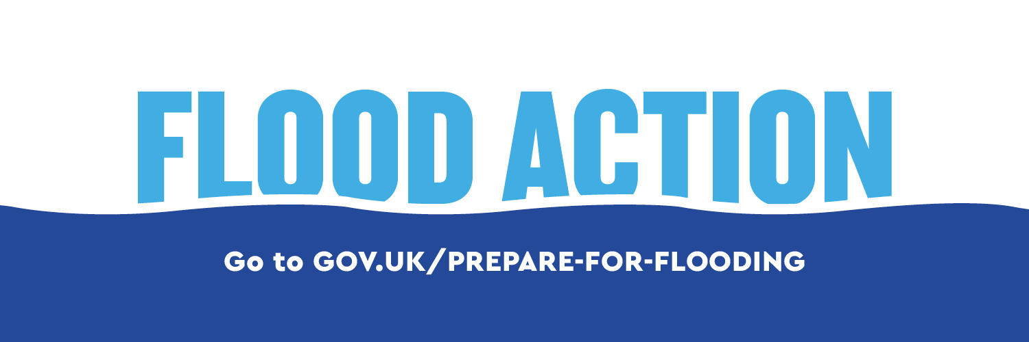

Contents
- Flood Action Week 2025
- How you can help
- Social media content
- Social media copy
- Other content

Flood Action Week 2025 (13-19 October)
The UK is experiencing more frequent and intense extreme weather due to climate change, and this year, the Met Office has warned of a wetter than average autumn. Communities are warned not to be complacent about the risk of flooding following this summer’s dry weather.
Rainfall was up to a third higher than usual in 2024 and, last winter, the Environment Agency issued more than 3,000 flood alerts, 1,600 flood warnings, and three severe flood warnings to people at risk.

In England around 6.3 million homes and businesses are in areas at risk of flooding, but many people are unaware and unprepared. The cost of flooding to a home can be tens of thousands of pounds. Devastatingly, flooding also brings a significant risk to life, damage to homes, businesses and communities, and can impact people’s mental health.
Preparing before a flood, and knowing what to do when it happens, can reduce these significant impacts.
Flood Action Week takes place from 13-19 October. It encourages the public to check their flood risk, sign-up to flood warnings and understand the immediate actions they can take to keep themselves and their loved ones safe and reduce the devastating impacts flooding can cause to homes, families and livelihoods. It also invites them to consider more planned actions, like installing property flood resilience measures that can make homes and businesses more flood resilient in the longer term.

Please note:
- If you’ve downloaded Flood Action Week assets in the past or shared our messages, please download the latest versions and make sure you’re using the most up-to-date links to our main web page.
- Only use the digital assets as they are provided and please note that you cannot edit, move or delete individual elements of the assets (videos and graphics).
- This content is for England only.

How you can help…

- Posting content
  - You can use our social media videos, images and graphics below for posts on your own channels.
  - Please always link to the Environment Agency’s ‘Prepare for Flooding’ page in your content: https://www.gov.uk/prepare-for-flooding?utm_campaign=faw25&utm_medium=partner&utm_source=link&utm_content=toolkit
  - Please use our hashtag #FloodActionWeek
  - Update your social media channel headers during Flood Action Week using our flood specific headers below

- Amplifying our activity
  - Follow our social accounts and like/share our Flood Action Week content throughout the week. You can find our accounts here:
    - Facebook
    - X
    - Instagram
    - LinkedIn
  - Follow your local Environment Agency regional account, which will be posting local messages:
    - EA Anglia
    - EA Yorkshire and North East
    - EA North West
    - EA Midlands
    - EA South West
    - EA South East

- Publishing information and assets on your website, newsletters and other communications channels
  - We have a number of assets you can download including social media headers, email signature banner, posters and a template article. You can find this in the ‘Other Content’ section below.

If you have any questions about the campaign or how to use any of these materials, please contact Flood and Coastal Erosion Risk Management Communications Team: FCERMCommunications@environment-agency.gov.uk
Social media content
Statics
Download statics here
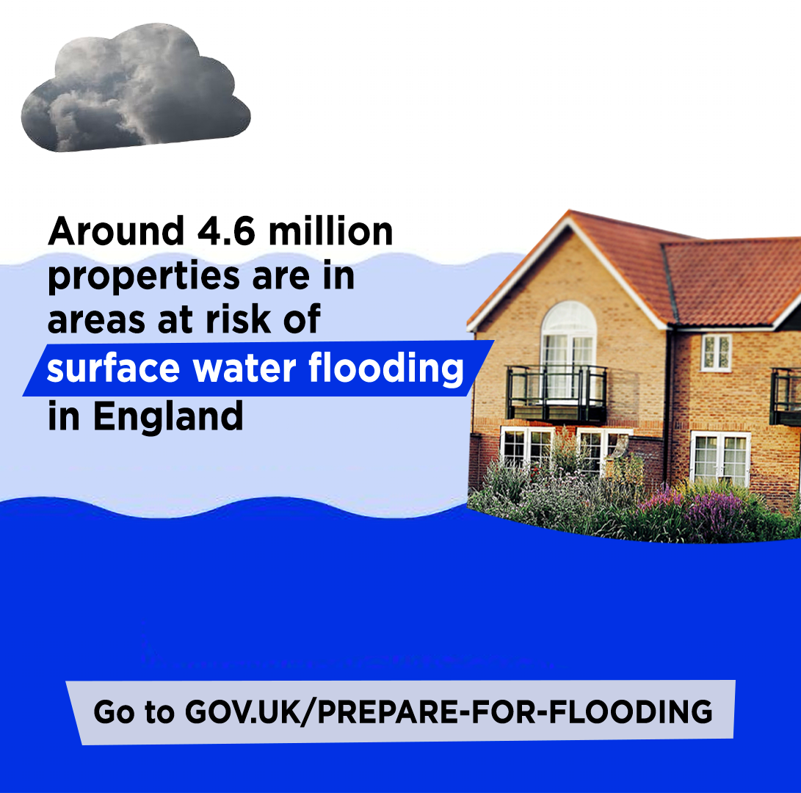4.6 million homes at risk of surface water flooding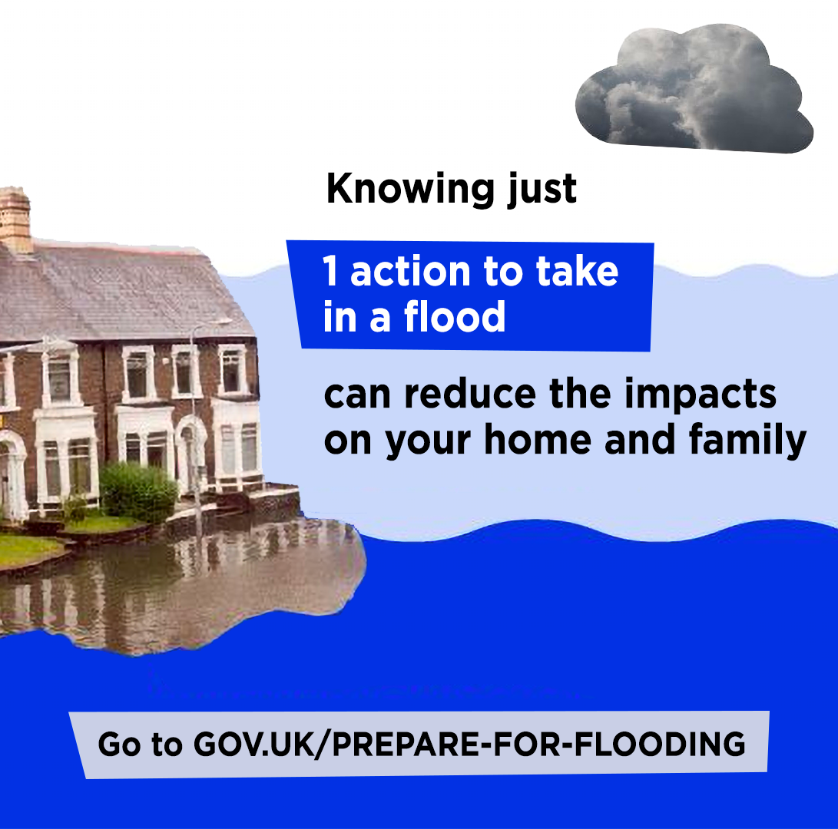Knowing 1 action to take
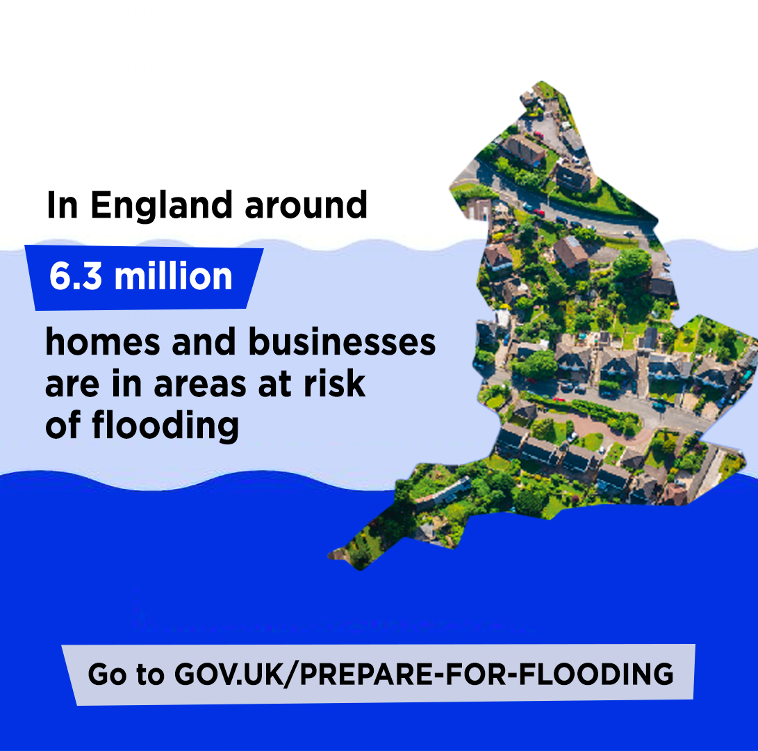6.3 million homes in areas at risk of flooding
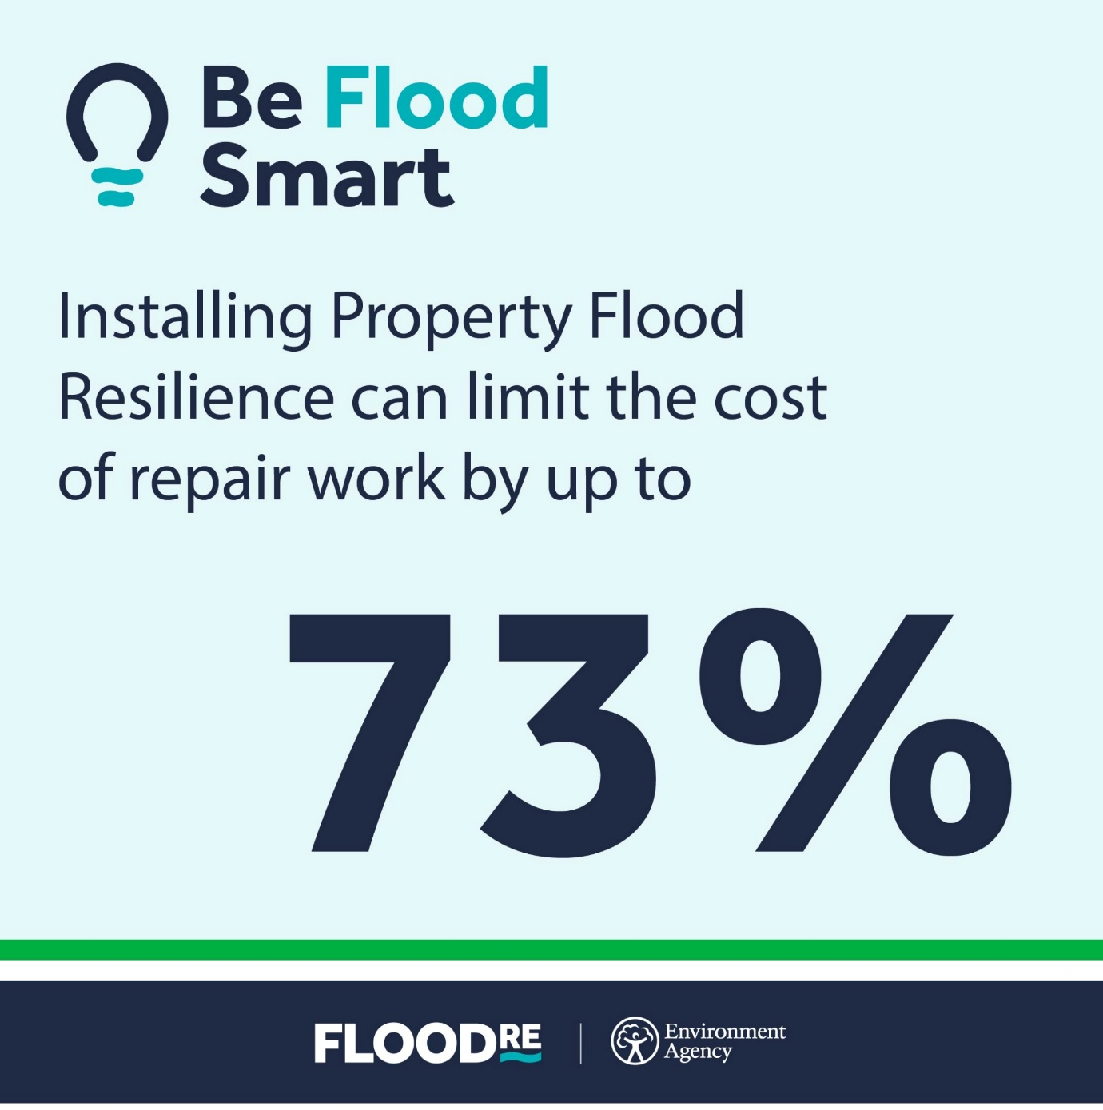Installing PFR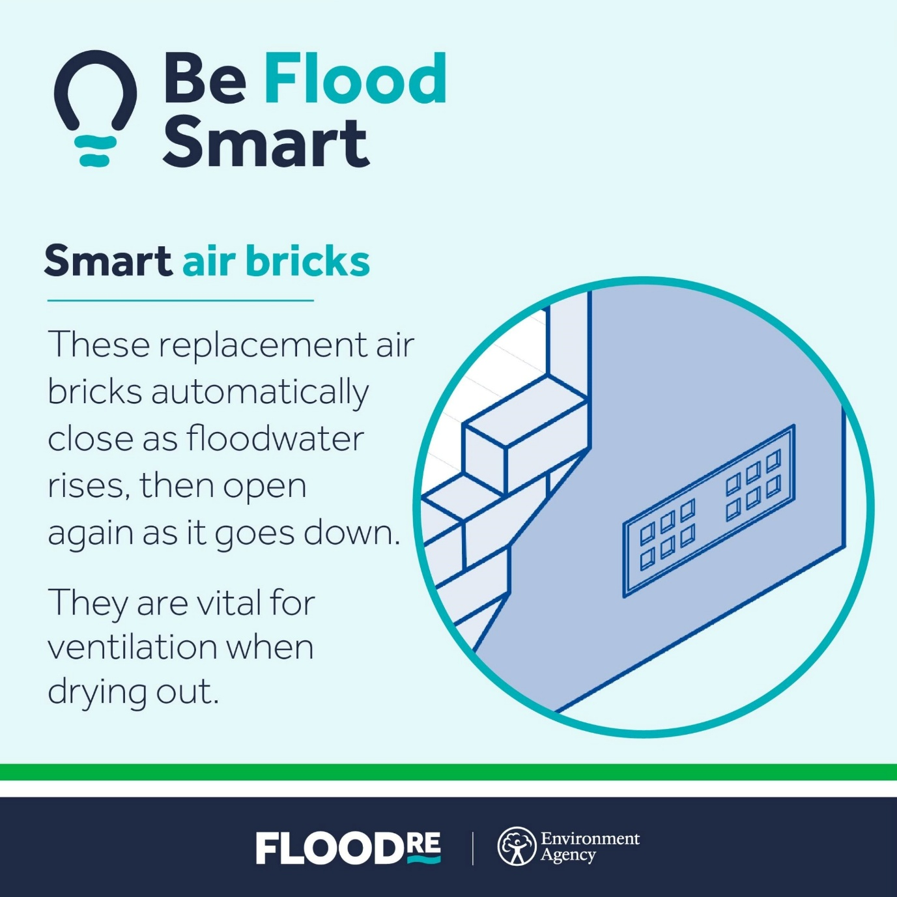Smart air bricks

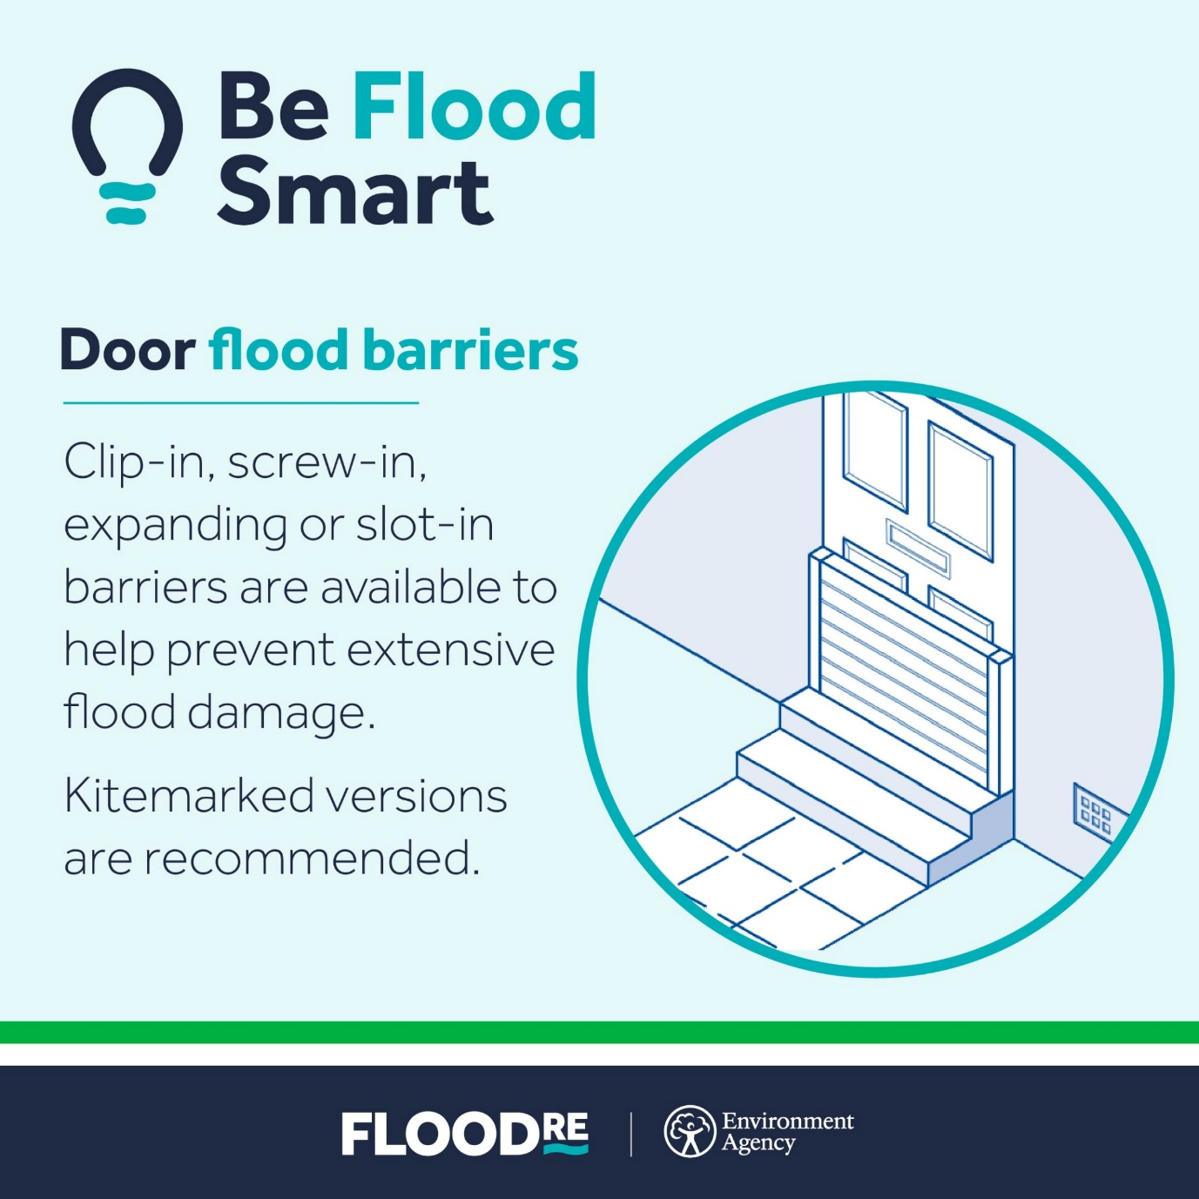Door flood barriers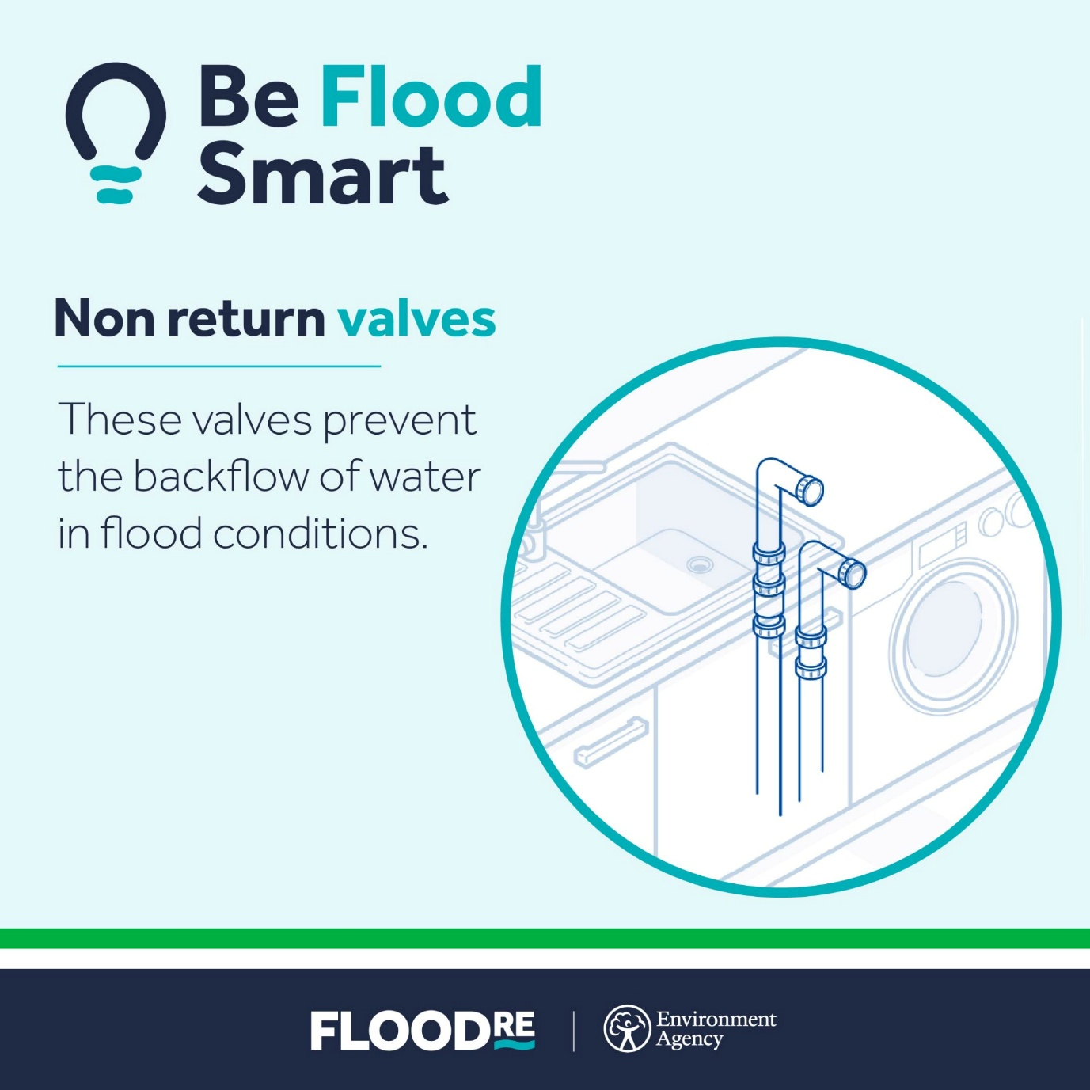Non return valves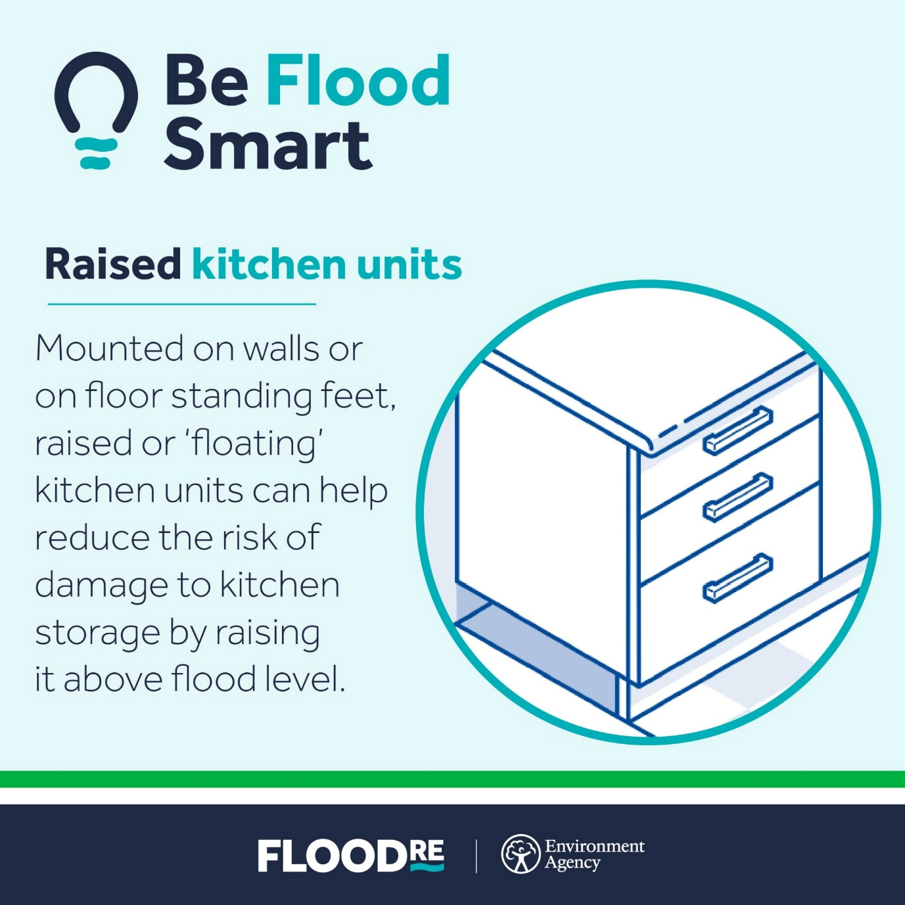Raised kitchen units

Videos
Download videos here
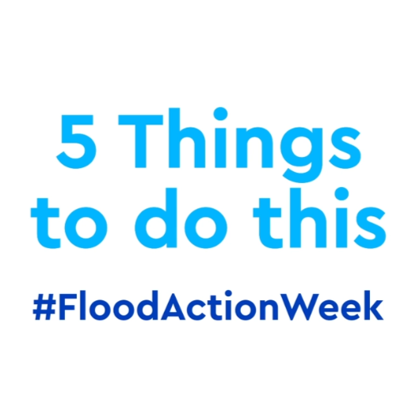5 things to do in Flood Action Week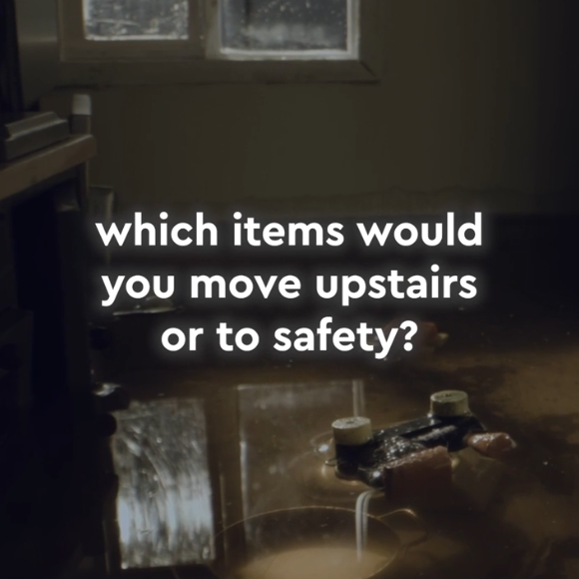Moving items to safety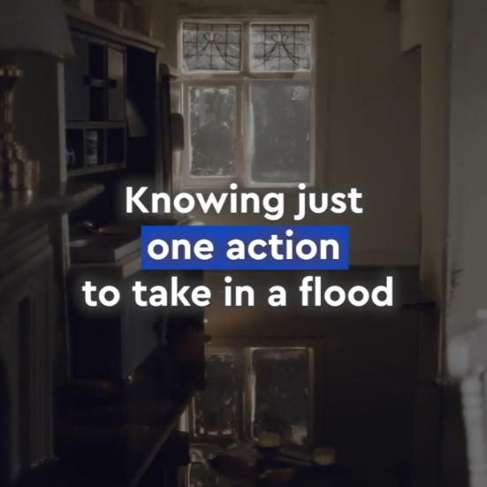Knowing one action
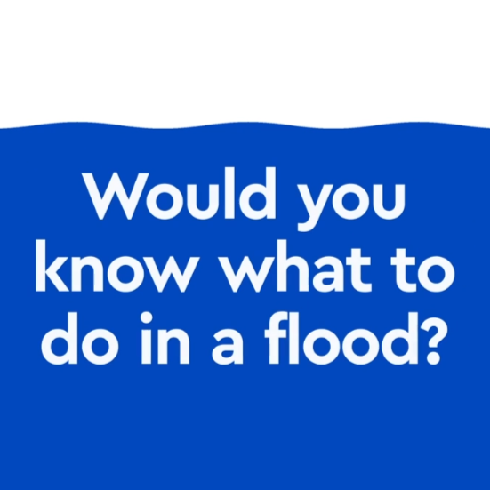Would you know what to do?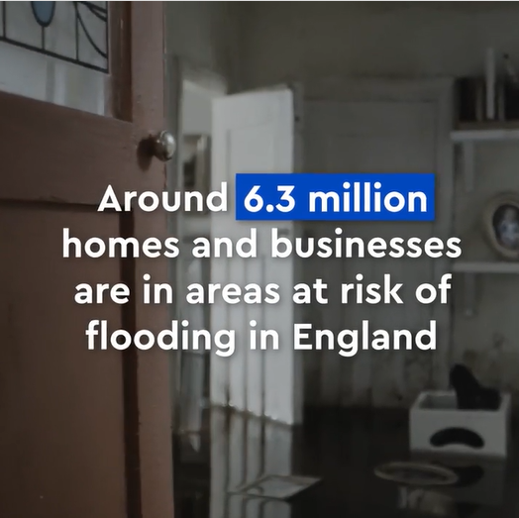Homes at risk
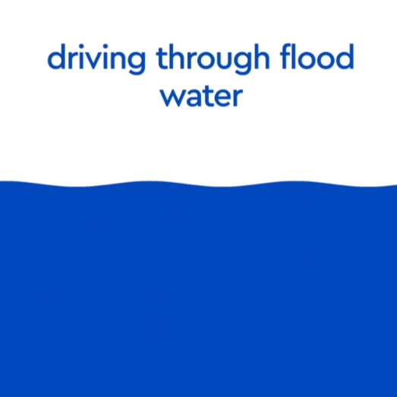Road safety: Number 1 cause of death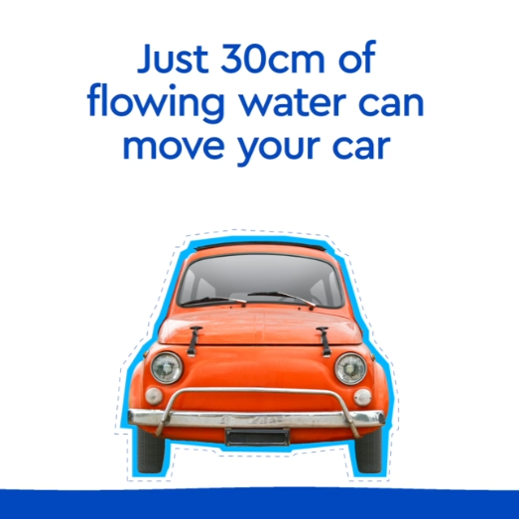Road safety: Just 30cm of water can move your car

Instagram Carousel
Download carousel assets here

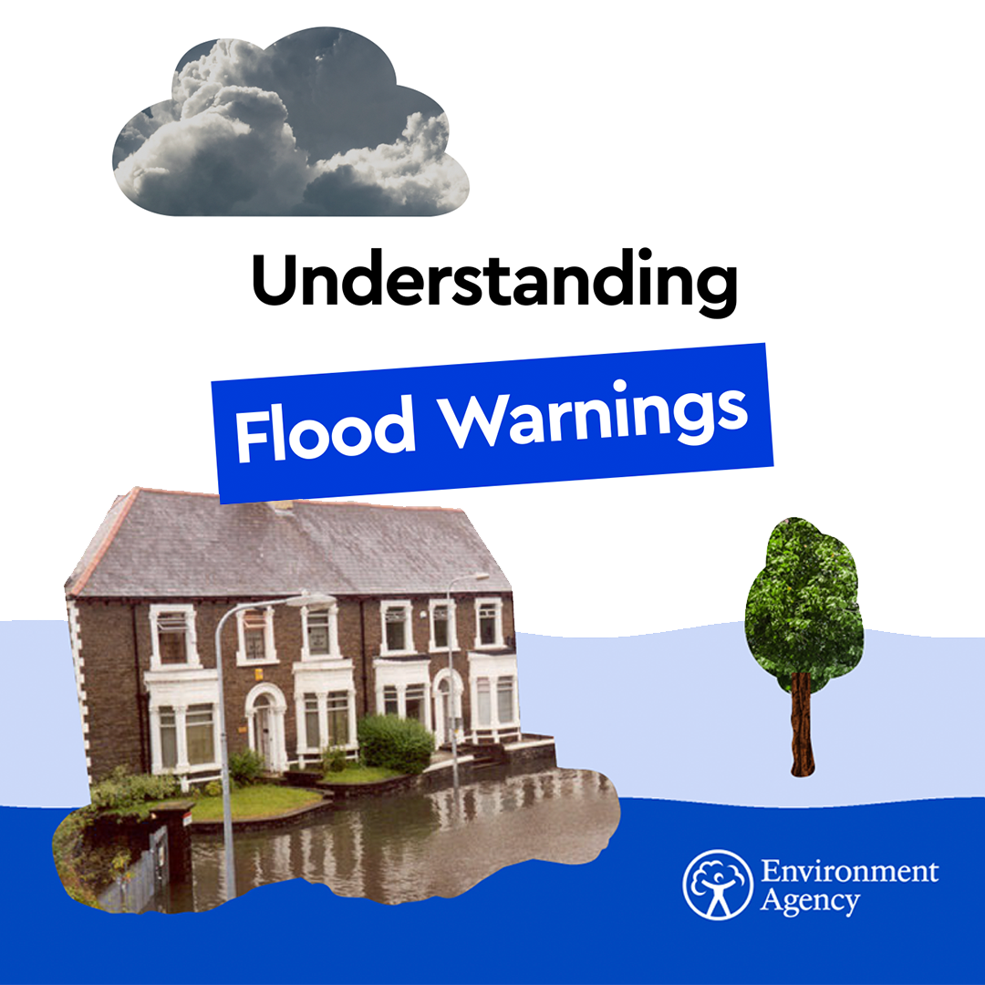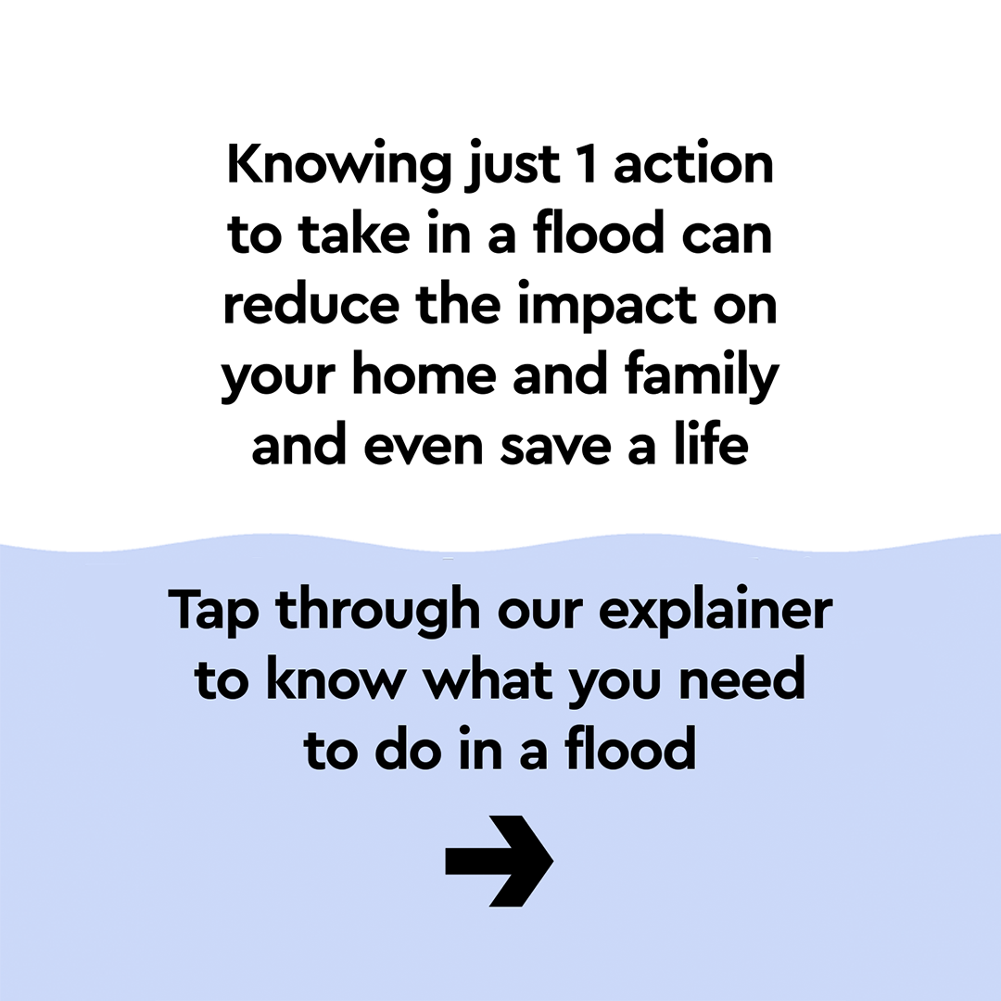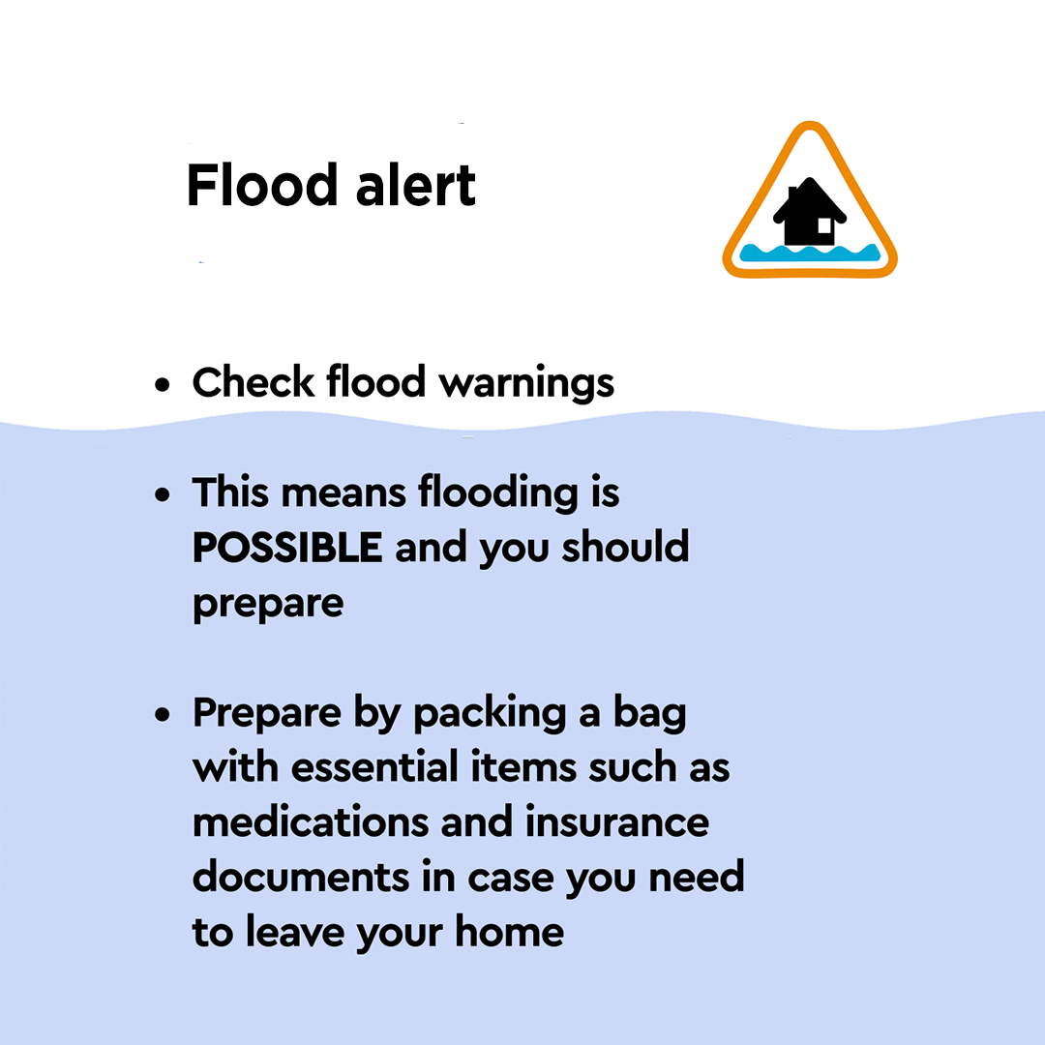
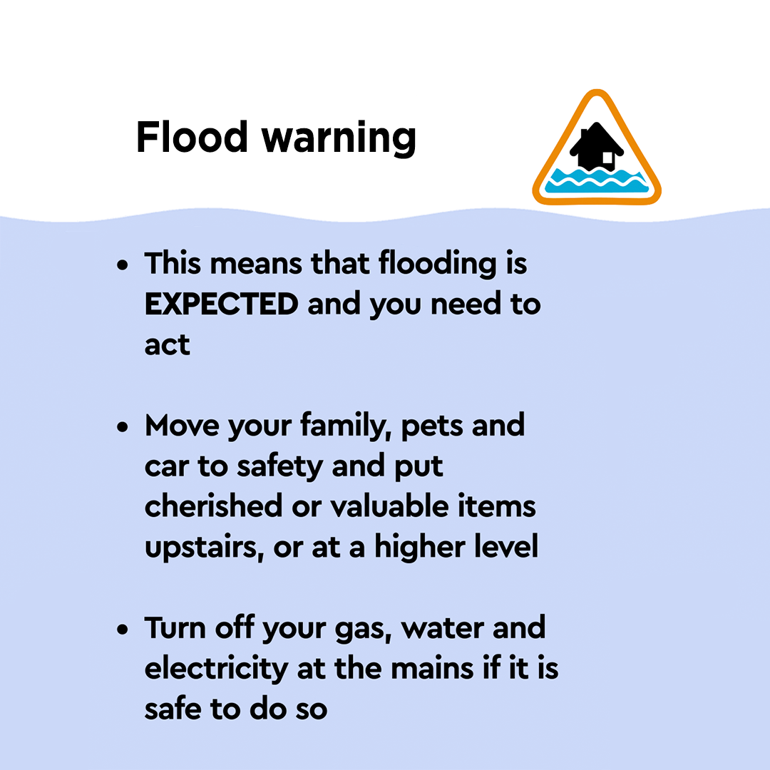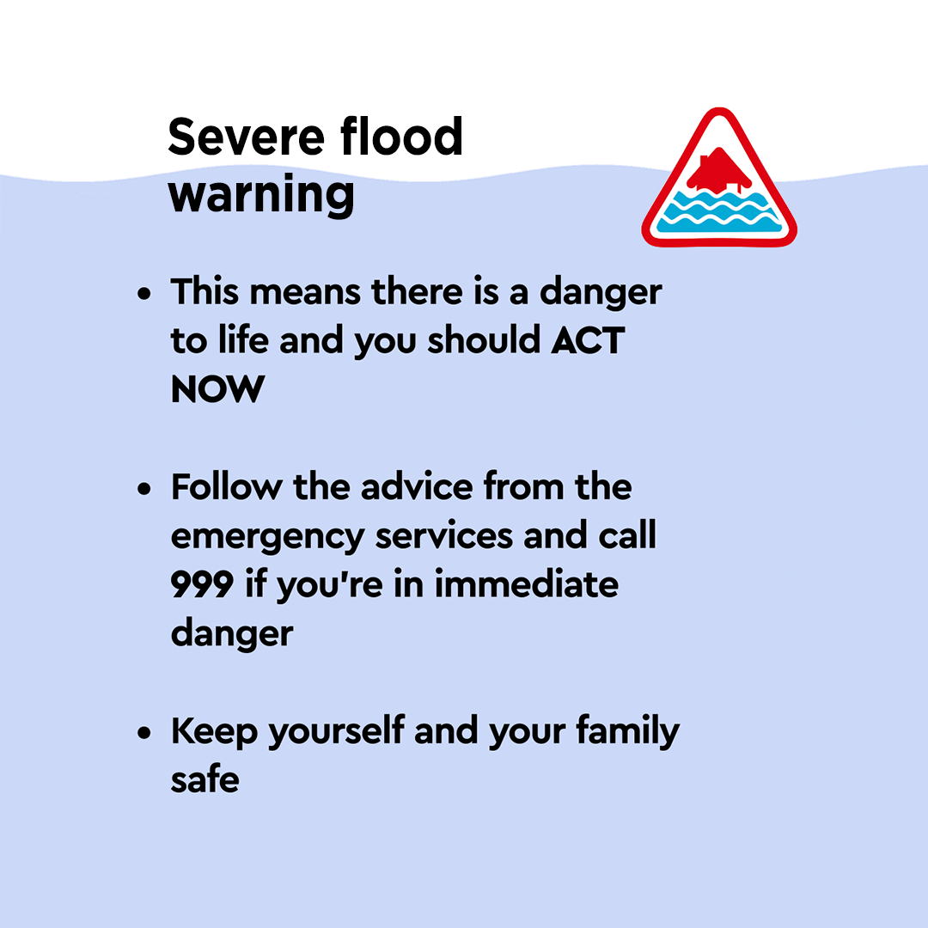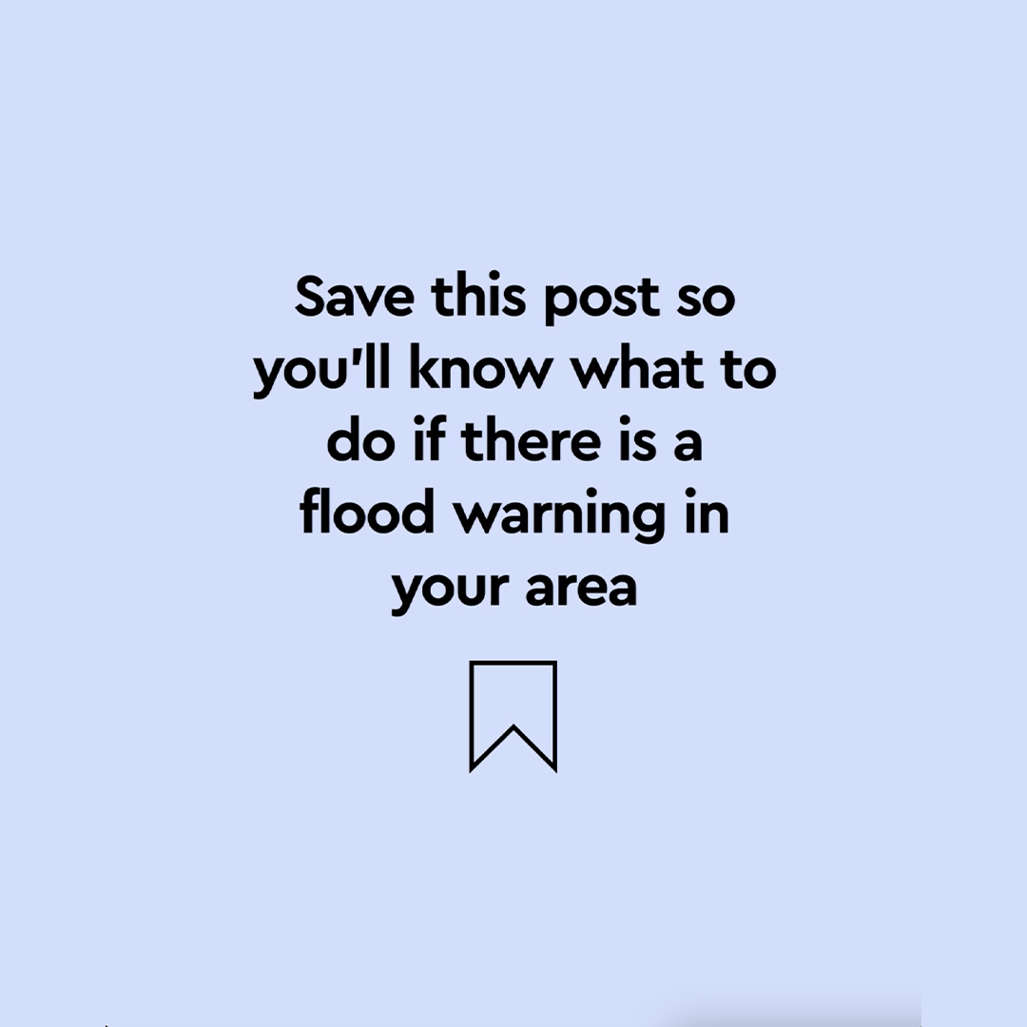

Social media copy

5 things to do during Flood Action Week

Check out the 5 things you can do this #FloodActionWeek to be better prepared for a flood.

Take action to protect yourself, your family and your home now 

https://www.gov.uk/prepare-for-flooding?utm_campaign=faw25&utm_medium=partner&utm_source=link&utm_content=toolkit

It’s Flood Action Week

It's #FloodActionWeek!

Around 6.3 million homes and businesses are in areas at risk of flooding. Don't assume it won't happen to you.

Learn what to do in a flood: https://www.gov.uk/prepare-for-flooding?utm_campaign=faw25&utm_medium=partner&utm_source=link&utm_content=toolkit

Knowing just one action (Instagram)
Knowing just one action to take during a flood can reduce the effects on your home and family, and even save a life.

This week, make it your aim to know what to do in a flood.

Move items upstairs or to safety.
Turn off electricity, gas, and water.
Follow advice from the emergency services.

For more info, head to @envagency page

#FloodActionWeek

Around 6.3 million homes and businesses
Would you know what to do in a flood?

Around 6.3 million homes and businesses in England are in areas at risk of flooding. Don't assume it won't happen to you.

Check your flood risk and prepare for flooding https://www.gov.uk/prepare-for-flooding?utm_campaign=faw25&utm_medium=partner&utm_source=link&utm_content=toolkit

#FloodActionWeek

Surface water flooding risk
Around 4.6 million properties in England are in areas at risk of flash flooding, which happens when the amount and intensity of rainfall overwhelms local drainage.

It can happen very quickly.

Be prepared, check your flood risk: https://www.gov.uk/prepare-for-flooding?utm_campaign=faw25&utm_medium=partner&utm_source=link&utm_content=toolkit

#FloodActionWeek

Flooding can ruin lives
Flooding can destroy homes and ruin lives.

Take action in advance and you can minimise damage to your property and possessions.

https://www.gov.uk/prepare-for-flooding?utm_campaign=faw25&utm_medium=partner&utm_source=link&utm_content=toolkit

#FloodActionWeek

Preparing for a flood
Taking action before a flood could save your most valued possessions and even your life.

Find out the steps to take to minimise damage to your home: https://www.gov.uk/prepare-for-flooding?utm_campaign=faw25&utm_medium=partner&utm_source=link&utm_content=toolkit

#FloodActionWeek

Moving items to safety
Do you know which items to move to safety in a flood?

You won't have much time to prepare if it happens.

Learn the simple steps you can take to ensure you keep the things you love safe
https://www.gov.uk/prepare-for-flooding?utm_campaign=faw25&utm_medium=partner&utm_source=link&utm_content=toolkit

#FloodActionWeek

Road safety - 30cm of flowing water
Did you know that just 30cm of flowing water is enough to move your car?

You should never drive through floodwater.

This #FloodActionWeek find out the actions you can take to stay safe.

https://www.gov.uk/prepare-for-flooding?utm_campaign=faw25&utm_medium=partner&utm_source=link&utm_content=toolkit

Road safety - Number 1 cause of death
Driving through flood water is the number one cause of death during flooding.

It is never worth the risk.

This #FloodActionWeek, find out other actions you can take to stay safe.

Property Flood Resilience
#BeFloodSmart and find out about property flood resilience measures.

They can reduce the detrimental effects of flooding such as damage to your home and loss of precious belongings.

Find out more https://www.floodre.co.uk/be-flood-smart/

#FloodActionWeek

Property Flood Resilience maintenance
Do you know how to maintain your Property Flood Resilience?

#BeFloodSmart and keep your home protected.

Learn how to prepare your property this #FloodActionWeek https://thefloodhub.co.uk

