
Welcome to the October 2025 edition of our Residents’ eNewsletter, featuring the latest news and updates from your county council.

Tackling flood risk at the source
Flooding is often blamed on heavy rain, but the cause could start many miles away due to an overgrown ditch, blocked brook, or water running off a development.
On their own they seem small and unconnected but can add up to create a flood risk.
Our new Local Flood Risk Management Strategy uses a catchment-based approach to understand how water moves through an area to find the source of the problem.
Then we can plan how to remove or minimise the flood risk before heavy rain comes, to protect the surrounding communities.
Find out more

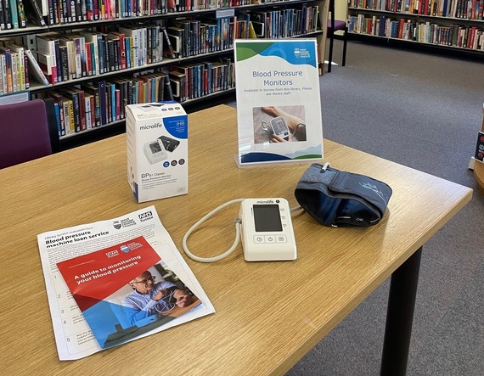
A loan that could save your life!
West Sussex residents can now borrow blood pressure monitors free of charge from all 36 libraries across the county.
This new initiative aims to help detect high blood pressure - often called the “silent killer” - which can lead to heart attacks, strokes, and other serious conditions.
Library members can borrow the easy-to-use kits for up to three weeks to monitor their blood pressure at home. Each kit includes a guide, a results diary, and health advice. If readings are too high or low, users are encouraged to contact their GP.
This partnership between the county council and NHS Sussex supports early detection and prevention, helping residents take control of their health.
For more health and wellbeing support, visit: www.westsussexwellbeing.org.uk
Find out more

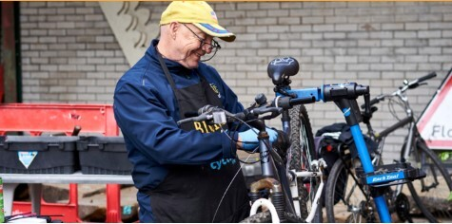
West Sussex awarded government funding to support job seekers
People facing barriers to finding work will soon be able to access personalised support through a new employment programme called Connect to Work.
We have been awarded funding to deliver the programme as part of the government’s Get Britain Working strategy.
Connect to Work will provide tailored support for residents who are living with a long-term health condition, or other barriers to employment.
Individual mentoring will help them to build the confidence and skills to successfully apply for jobs and settle in once they start.
Applications to join the programme will open in November 2025.
Find out more

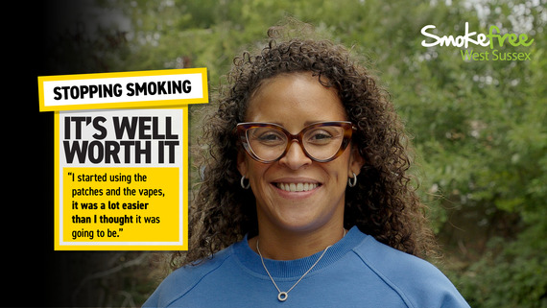
Stoptober: free local support to help you quit
If you're a smoker in West Sussex and ready to make a change, there's never been a better time to quit. A wide range of free support is available to help you take that first step - and stick with it.
Smokefree West Sussex offers several ways to help you quit, so you can choose the option that works best for you:
- Quit 4 Wellbeing – a specialist, countywide, stop-smoking service offering face-to-face and telephone support.
- Wellbeing teams - run by the district and borough councils, offering stop-smoking support as well as a range of other advice, including how to maintain a healthy weight, how to be physically active, and support with drinking within recommended guidelines.
- Smokefree app – a fully digital stop smoking service, for West Sussex residents.
- Stop-smoking support is also available from participating GP surgeries and pharmacies.
Hear how Sophie quit smoking for her son and her health, thanks to the help of a Smokefree West Sussex advisor. Watch the video here.
To find out more or to access free support to quit smoking visit the link below or call 0330 222 7980. Support is available face-to-face, over the phone or via the Smokefree app.
Find out more


Take up the offer of breast cancer screening
This Breast Cancer Awareness month we want to remind everyone who is invited for breast cancer screening to take up the offer.
Breast screening can detect cancer long before you can even feel it. Or more likely, put your mind at rest.
So, when you're invited, save the date, it could save your life. If you missed your appointment or need to change it, call your local NHS breast screening service on 01903 239757 or email: uhsussex.westsussexbreastscreening@nhs.net
Check your breasts/chest by regular self-examination (around once a month), to get to know what is normal for you.
The NHS provides a ‘How to check your breast or chest guide’, which includes a helpful video showing how to do so.
Please share with friends, family and colleagues.
Find out more


Help local nature thrive
Nature in Sussex is under pressure. Two new strategies aim to change that - and you can help shape them by giving your views.
We’re working with partners to develop a Local Nature Recovery Strategy for West Sussex to support our work on nature and environment within our Climate Action and Adaptation Plan.
The proposed strategy sets out how we can restore and enhance local habitats, support wildlife, and make nature more accessible in towns and cities based on input from residents, farmers, and community groups.
Based on 7 driving principles, it lists 24 priorities, and over 100 practical actions that can be taken.
Please help by looking at the draft strategy, exploring the habitat maps, and submitting your views via the consultation to help guide our approach.
The consultation will run for six weeks and closes on 25 November 2025.
Find out more


Head to our Newsroom to find all the latest news.
- Have your say on proposals to create 170 additional school places across West Sussex for children and young people with special educational needs and disabilities (SEND). The proposals at 3 special schools across the county are part of our ongoing commitment to ensuring children, young people and families with SEND are given the support they need to thrive.
- Storms and cold snaps can disrupt power, water and other services. Taking 3 simple steps now will help you – and those you care for – be ready for whatever winter brings. The steps include whether you are eligible to join the Priority Services Register which means you get extra support during a power or water outage.
- Increase your skills and awareness on the road as a biker, pillion rider and/or general road user by attending a free Biker Down! course in Chichester on 23 October.
- Our firefighters have issued a warning after attending a house fire in Aldwick which was caused by a vape.
- We've completed the latest part of a scheme to provide a safe and accessible cycling route between Bognor Regis and the South Downs National Park.
- It’s all hands on deck this October half term in our libraries with pirate-themed stories and craft activities for children aged over 4. Plus craft sessions for young people in selected libraries. All events are free to attend but booking is required to guarantee a place.
- Our Adult Social Care Strategy helps to steer our way forward, ensuring we’re making best use of resources and keeping people safe. We’re now refreshing it and want to check we’re still focused on what matters most to you. Please take a few minutes to complete our short survey and share your views.
- Our Breakwater children’s home in Shoreham has once again been rated outstanding by Ofsted, following its latest inspection.

The NHS is offering free vaccinations for those at higher risk of serious complications from flu and Covid-19.
Make sure you check your eligibility before booking an appointment as the criteria are different for each.
Did you receive this eNewsletter from a friend? Sign up here.


