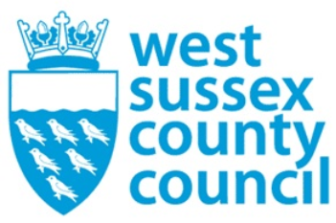

news release
12 September 2025

Business case for local government reorganisation in West Sussex completed



West Sussex councils have reached a significant milestone in the journey towards reshaping local government.
A business case for local government reorganisation has now been completed and will be presented at council meetings across the county, districts, and boroughs towards the end of September.
This marks a key step in the collaborative effort of all councils to respond to the government’s requirement to re-structure local government and create a simpler structure for local government.
The business case demonstrates that both single and two unitary models are viable options for the future of local government in West Sussex.
Read the case in papers published for an extraordinary meeting of the County Council on Tuesday 23 September.
Councils will submit a letter to central government on 26 September proposing their preferred option for local government in West Sussex.
Once submitted, the government will undertake consultation and a final decision from government is anticipated in Spring 2026.
We would like to extend our thanks to the thousands of residents, businesses, community groups and council staff who took part in the recent Shaping West Sussex engagement survey. Your feedback has been vital in shaping the proposals and ensuring they reflect the priorities of our communities.
Cllr Paul Marshall, Leader of West Sussex County Council said: “This is a milestone in the collaborative working that has taken place over the past few months to deliver a submission that is based on strong evidence and research.
“Our next step is for our submission to be put before our respective councils for debate and discussion before being submitted to Government on 26 September 2025.
“The intention of all involved was to deliver a submission that presented options that will benefit our residents, businesses and communities in developing a local government system that compliments and strengthens the positives that the creation of a strategic combined authority will bring to Sussex.”
Future of local government in Sussex.
​

For further information please contact the news desk on 0330 222 8090 or email pressoffice@westsussex.gov.uk.
For urgent out-of-hours enquiries please call 07767 098415.
 

Click to Unsubscribe

