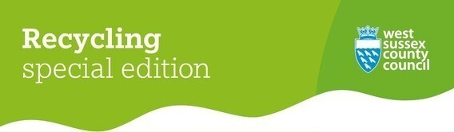
Welcome to this special edition newsletter, dedicated to all things recycling and waste prevention.
Recycle Week is coming!
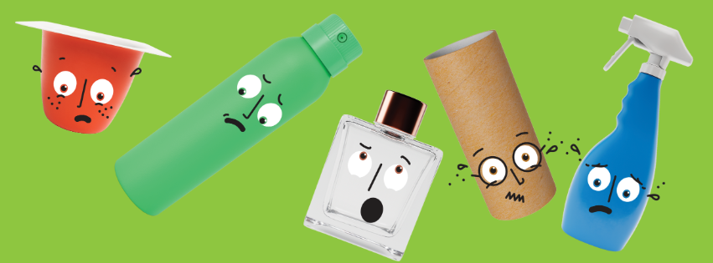
Recycle Week runs from 22 to 28 September. This year we're highlighting the importance of keeping recyclable materials out of the general waste bin.
In West Sussex, we’re proud to be supporting the Waste and Resources Action Programme’s (WRAP's) mission to make sure valuable recyclables are put in the right bin.
You can recycle a core set of materials right from your home:
- Cartons
- Foil (scrunched into a ball larger than a jam jar lid)
- Glass bottles and jars
- Plastic bottles, pots, tubs, and trays (all colours!)
- Paper and card
- Metal cans and aerosols
Just remember, items must be clean, dry and loose before going into your recycling bin.
Are you missing out on recycling everyday items?
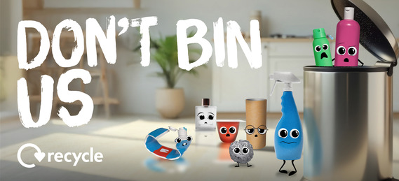
According to our recent recycling survey, many residents are missing out on recycling some everyday items including:
- Trigger sprays – just squash the bottle and pop the spray back on.
- Flexible toothpaste tubes – squeeze them empty and replace the lid.
- Empty aerosol cans – yes, they’re safe to recycle!
- Aluminium foil – often forgotten, but it’s endlessly recyclable. Scrunch it into a ball larger than a jam jar lid to make sure it’s picked up at the recycling facility.
- Coloured plastics – all colours of household bottle, pots, tubs and trays can be recycled at home in West Sussex, including black plastics like microwave meal trays.
44% of West Sussex residents said they sometimes put recyclable items in the general waste bin because they weren't sure if they could be recycled.
If you are ever in doubt, the West Sussex Recycles A-Z of recycling and waste has information on specific materials all in one place.
Explore A to Z of recycling

Get bin reminders straight to your phone
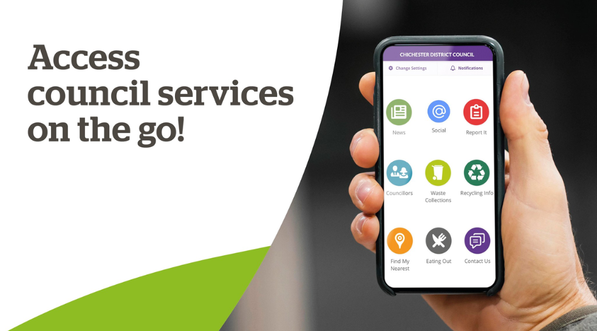
Did you know some of the local district and borough councils in West Sussex have a free app that provides access to council services from your phone?
This includes recycling information, latest council news and it can even send you notifications to remind you to put your bin out!
The app is available on the Apple App Store and Google Play Store for free. Downloading the app can also allow you to be the first to hear about service changes or disruptions to your bin collections.
Download the app for your local council below:
- Adur & Worthing Councils
- Arun District Council
- Chichester District Council
- Horsham District Council
Please note, the app is not available for Crawley Borough Council or Mid Sussex District Council.
Food waste collections coming soon!
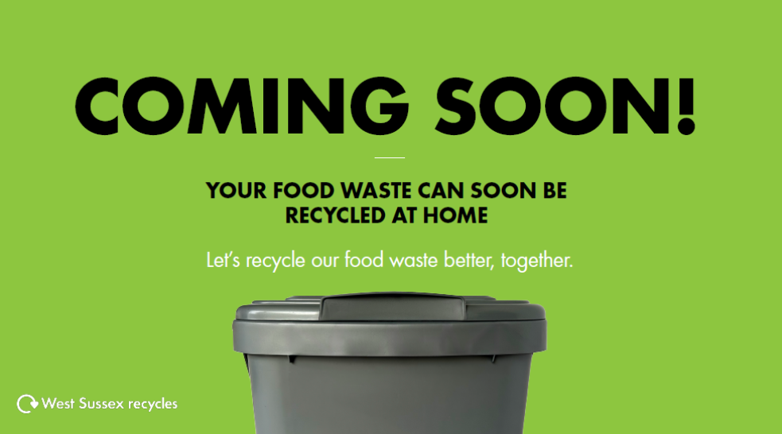
Over the next 12 months, food waste collections will begin in West Sussex following a change in legislation from the Government.
Don't worry, you'll be able to recycle all the same items as before in your current recycling bin. Food waste collections are an extra service with different bins.
Your local district or borough council will collect your food waste each week.
The food waste that's collected will go to an anaerobic digestion plant in Horsham. The plant recycles the waste into:
- fertiliser to help farmers grow crops
- energy to power the plant
The start date for your collections will depend on where you live. For more information on food waste collections in West Sussex, click on the button below.
Learn more about food waste

Autumn/winter opening hours return to Recycling Centres from October

From 1 October 2025, Recycling Centres will switch to their autumn/winter opening hours. All 11 centres will be open from 9am to 4pm on selected days until 31 March 2026.
Remember to book your slot online before heading to the centre. Appointments can be booked up to 14 days in advance or even on the same day there’s availability. If you no longer need your slot, don’t forget to cancel it so someone else can use it.
Check opening hours

UKHarvest Community Food Hubs
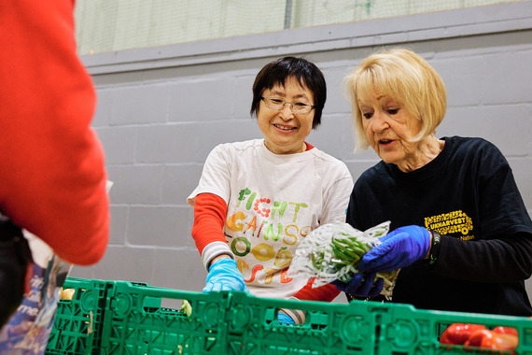
The UKHarvest Community Food Hub project has been extended to continue until April 2027, thanks to additional funding from the county council. This means the programme will continue to redistribute surplus food from suppliers and provide food waste prevention advice for a further year.
Launched in partnership with Sussex-based charity UKHarvest, the Community Food Hubs offer residents access to surplus food for a small voluntary donation of £5, no referrals needed. These child-friendly hubs run monthly in each district and borough across West Sussex, helping communities reduce food waste and save money.
Since its launch in April 2023, the scheme has so far saved over 106 tonnes of food from going to waste.
Alongside food redistribution, the hubs provide food waste prevention advice, recipe ideas, and information on wellbeing, recycling, fire safety and Citizens Advice services.
Find a UKHarvest hub near you

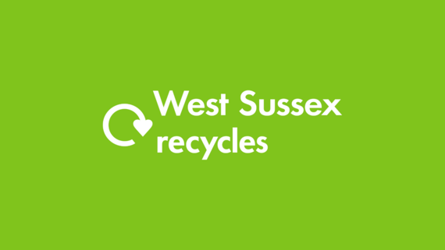
Follow WSRecycles
If you enjoyed this special edition resident’s newsletter, why not check out our other West Sussex Recycles channels. We run social media accounts, a YouTube channel and monthly newsletter for all things waste prevention and recycling!
Follow us here:
- Facebook
- Instagram
- X(Twitter)
- YouTube
Subscribe to our newsletter



