
Welcome to the late September 2025 edition of our Residents’ eNewsletter, featuring the latest news and updates from your county council.
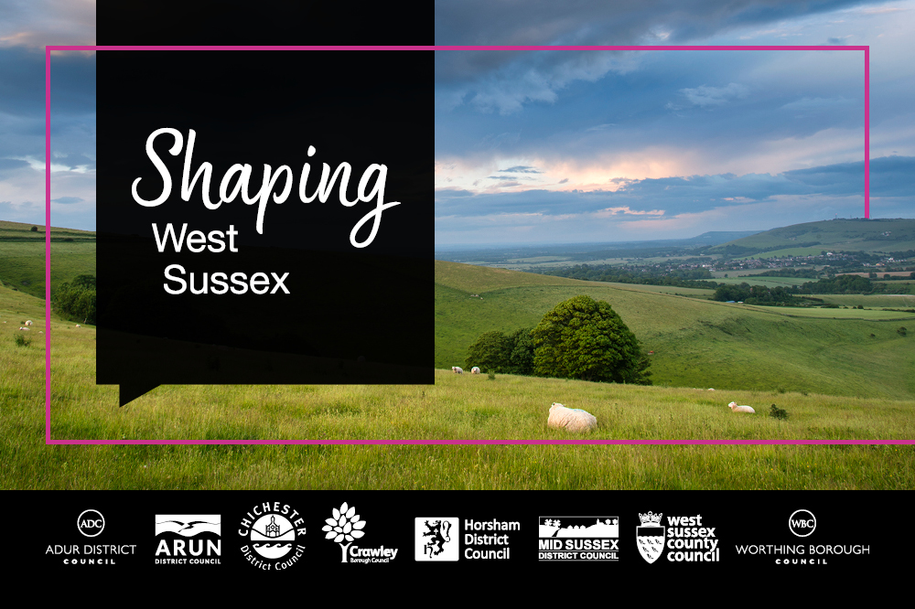
Reshaping local government in West Sussex - West Sussex County Council states its preference for a one unitary authority
West Sussex County Council is stating its preference for a single unitary authority for the whole of the county as its preferred option for local government reorganisation.
The council maintains that a single authority is best for providing high-quality and financial sustainable services to residents.
A business case for local government reorganisation in West Sussex was developed and agreed by all 8 councils in the county. Each council is taking its own decision on its preferred option.
The joint business case and each authority’s preference will be submitted to government by Friday this week (26 September) for a final decision in spring 2026.
Leader of West Sussex County Council, Cllr Paul Marshall is now writing to the government to ask ministers to consider the council’s preferred option.
He said: “Thank you to my fellow council leaders and chief executives who have worked collaborated successfully to develop the options in the business case.
“As the case shows, creating a singly unitary authority will save £50m per year, which is £30m a year greater than the savings that would be generated by moving to two unitary authorities, and pays back the cost of change much more quickly. This unlocks millions we can invest in crucial public services while minimising disruption to services, especially those that protect vulnerable people.
“Creating two unitary councils in West Sussex will mean having to split essential services that keep our most vulnerable people safe and that are currently delivered countywide, notably children’s and adults’ social care. We are very conscious in reaching this conclusion that the unavoidable disruption if a two unitary model is adopted will create further challenges in these sectors, both of which are already under significant pressure, and impact on the significant improvements we’ve made as a council over the last few years.
“While we prefer a singly unitary option, whatever the government choses, we will maintain our successful collaboration and shared focus of achieving the best outcome for residents.”
Councils in East Sussex and Brighton & Hove City Council have also produced their own business cases. While East Sussex councils have been open about the shape of their plans for some time, Brighton & Hove City Council did not reveal the areas covered by its proposals until just a few working days before the submission deadline, meaning that it has not been possible to fully assess the proposals impact on West Sussex at this point.
Cllr Marshall is therefore also calling on ministers not to consider the Brighton & Hove business case. He said: “I was personally very disappointed to see Brighton & Hove City Council’s alternative proposal for local government reorganisation in Sussex, which was issued after our case was published in papers for our council and cabinet meetings.
“Brighton & Hove City Council has not engaged with us and so we have not been able to test their assumptions or modelling. Our initial assessment though is that the case lacks sufficient detail, due diligence and analysis, and it is difficult to see how the proposals meet the government’s criteria, notably financial stability, engaging with councils affected, and managing the risks of services being disrupted.”
Engaging with communities
The business case for West Sussex draws on feedback from the views of 9,000 residents who took part in engagement work over the summer.
What came across very strongly in the responses was a desire for local councils be focused on the differing needs of the places they are responsible for, and for an effective local voice in shaping decisions. This will be a key requirement to build into the new council or councils when they are created.
The government will run its own consultation on the options in the coming months, giving the public a chance to express their view based on the full business case, including the estimated financial impact of each option, which was not available for the earlier engagement exercise.
Elections
In his letter to ministers, Cllr Marshall additionally makes the case for deferring county council elections due to take place in May 2026.
He argues that when taking into account the potential disruption the process of LGR, the cost of holding elections (around £1.5m), the likely limited time for which those elected will hold office, and possible voter fatigue and confusion with elections for a Sussex Mayor represent a strong rationale for the government to postpone county council elections until the new model is agreed and elections for the new structure are held.
Further information
Read the joint West Sussex business case for local government reorganisation.
Find out more about the future of local government in Sussex


Reducing roadworks reaps real rewards
Disruption caused by roadworks in West Sussex has been reduced by almost a third, thanks to a scheme which encourages utility companies and contractors to plan their works more effectively.
We’re one of only four local authorities in the country to operate a Government-endorsed lane rental scheme, which allows us to charge up to £2,500 a day for works on our busiest roads.
Not only is the scheme helping to keep traffic moving and reduce inconvenience to residents and road users, it is also generating much needed income we can reinvest in road repairs and community highways projects that we would not otherwise be able to support.
Organisations can apply to the Lane Rental Surplus Fund for projects that benefit West Sussex highways.
Find out how we’re helping to keep traffic flowing


Podcasts highlight the cost of romance fraud
Romance fraud is on the increase and it’s not just emotions that are being manipulated.
Between April and June this year, West Sussex residents lost nearly £443,000 after being conned into believing they were in a loving relationship.
As a response to the rising number of people worldwide losing money and trust through fake online relationships, World Romance Scam Prevention Day was started two years ago in the US.
This year it falls on 3 October, and our Fraud Prevention Working Group wants to highlight the importance of the day by asking residents to listen to their Romance and Relationship Fraud podcast episodes, which are available on YouTube.
The three short episodes debunk myths around romance fraud, explore case studies from people who have used Victim Support, identify red flags in on and offline relationships, and signposts listeners to organisations that can help.
Romance and relationship fraud podcast YouTube series

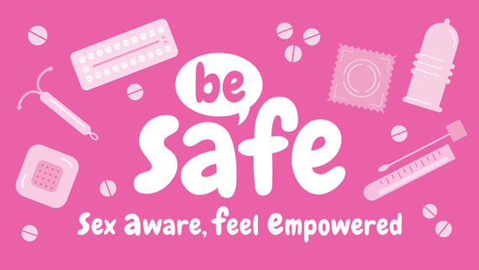
Be SAFE: a new campaign for sexual health
We launched our new Be SAFE campaign during the recent Sexual Health Week to promote the importance of regular testing for sexually transmitted infections (STIs) and making the right choice for you when it comes to contraception.
SAFE stands for ‘Sex Aware, Feel Empowered’.
There’s a lot of information out there about sexual health and sometimes it can be tricky to find what you need, when you need it.
Our new webpage provides an overview of reliable sources of information you can trust, so you can quickly and easily find where you can go for services, advice and support such as STI testing, free condoms and more across West Sussex.
Visit the Be SAFE webpage today via the link below and please do share with friends or family who might also find it a useful resource.
Find out more


Lights, camera, action! Road safety shows return to Sussex schools
Road safety is taking centre stage in Sussex secondary schools this autumn with the return of Theatre-in-Education performances.
These engaging shows use drama, humour and audience participation to help students learn about road traffic dangers in a memorable way.
- Year 7 students (ages 11–12) will see Look Up, a show focused on pedestrian safety and responsibility, which is particularly important for those who may be walking to school without their parents for the first time.
- Year 11 students (ages 15–16) will watch Take a Second, which explores the impact of choices made as passengers and future drivers as they reach their final year of secondary school.
The programme is supported by the county council, and neighbouring authorities in East Sussex and Brighton & Hove, reflecting a shared commitment to road safety education.
Read more


Protect your child from flu this winter
Flu can be very unpleasant for children and can sometimes cause serious problems, such as pneumonia. Children under the age of 5 years have one of the highest rates of hospital admissions due to flu.
Getting your child vaccinated not only protects them but also helps protect your family. It reduces the risk of flu spreading to relatives who may be more vulnerable, such as grandparents or family members with long-term health conditions. Vaccination can also help prevent the disruption flu causes, meaning you’re less likely to need time off work or other activities to care for a sick child, or if you become unwell yourself.
The nasal spray flu vaccine for children is quick, safe and helps keep families and communities protected over winter. It's offered to children aged 2 to 3 years, school-aged children (Reception to Year 11) and children with certain long-term health conditions.
Find out more including how to get the children’s flu vaccine


Head to our Newsroom to find all the latest news.
- Considering the various challenges we face as a county council, planning the future of adult social care in West Sussex is essential, so we can sustain the services people rely on. As set out in our Council Plan, our priority is to keep people safe from vulnerable situations with a focus on supporting people to live independently. Our Adult Social Care Strategy helps to steer our way forward, ensuring we’re making best use of resources and keeping people safe. The current strategy was shaped with residents and partners and sets out five priorities for how we deliver care and support. We’re now refreshing it and want to check we’re still focused on what matters most to you. Please take a few minutes to complete our short survey and share your views.
- Along with Surrey County Council, we are inviting residents to help shape future transport improvements along the A24 between Worthing, Horsham and Dorking.
- Stopping smoking is well worth it this Stoptober. If you or someone you know is thinking about quitting smoking this Stoptober, free help is available to anyone who lives or works in West Sussex. Quitting is much easier when you get the right support and, with professional help, you're 3 times more likely to quit for good. Visit Smokefree West Sussex or call 0330 222 7980 to get free support from trained advisors to help you quit smoking for good or you can download this Smokefree app.
- Community Food Hubs receive an additional year’s funding from West Sussex County Council.

Planning on getting married? Then come along to a Wedding Fair at Edes House in the centre of Chichester on Sunday 5 October from 10am to 2pm.
It’s free entry and you'll receive a welcome drink.
You can view the wedding venue and meet a range of suppliers keen to help make your special day perfect.
Did you receive this eNewsletter from a friend? Sign up here.


