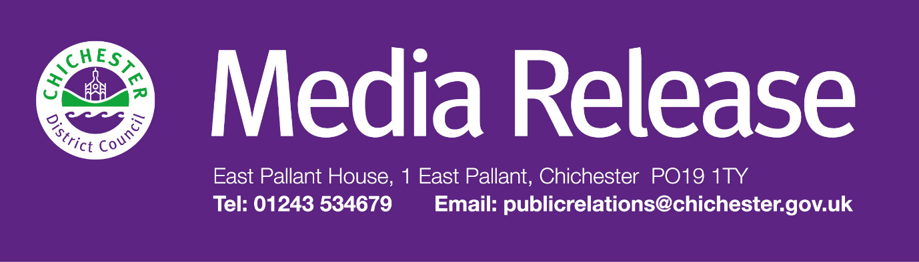
Date of Release: Thursday 25 September 2025 Ref: 4521

Chichester District Council backs two-unitary council option as part of local government reorganisation

Chichester District Council has backed the option of two unitary authorities in West Sussex, describing it as the most appropriate model for local government reorganisation.

The council’s preferred option, which consists of one authority comprising Chichester, Arun, Worthing, and Adur, and another covering Crawley, Horsham, and Mid Sussex, was approved by Cabinet members following a full council debate.

This option has also received unanimous backing from all district and borough councils within West Sussex.

Each council in West Sussex must decide on their preferred option, which they will submit to the government, alongside a joint business case for local government reorganisation in West Sussex. The business case has been developed and agreed by all eight councils across the county. This was shaped by extensive engagement with residents, businesses, community groups, and council staff and presents three viable options for reform — two of which propose a two-unitary model, and one a single-unitary model. These proposals reflect the priorities and feedback gathered through the recent Shaping West Sussex engagement survey.

The joint business case and each authority’s individual preference will be submitted to government by Friday 26 September for a final decision in spring 2026.

“This is a major milestone in the collaborative work that has taken place over recent months to deliver a submission based on strong evidence and research,” said Councillor Adrian Moss, Leader of Chichester District Council.

“We’ve responded closely to the government’s criteria and used data and feedback from our residents, businesses and community groups to narrow the options down to three. After careful consideration, Chichester District Council is supporting the two-unitary model, which proposes the creation of one authority for Chichester, Arun, Worthing and Adur, and the other covering Crawley, Horsham and Mid Sussex.

“A two-unitary structure would give West Sussex a stronger strategic voice, with each unitary leader sitting on the strategic authority alongside the new Mayor. Given West Sussex’s size — nearly double that of East Sussex and triple that of Brighton and Hove — this model ensures fair representation.

“It also supports better democratic engagement, with 140 councillors proposed under the two-unitary model compared to 100 under a single-unitary. With nearly 900,000 residents across a large geographical area, we believe this structure better reflects the diversity and needs of our communities.

“Both of the two-unitary models scored equally against the government’s criteria. Our preference for the south west / north east (B2), two unitary option, is based on stakeholder feedback and strategic advice. This configuration has received strong support across the county and has been chosen by all of the other district and borough councils as their preferred option. The fact that all of the district and borough councils in West Sussex are backing this option strengthens the case for a two-unitary model — something our residents have clearly indicated they want.

“The decision now rests with the government, and we await their response. That’s why it’s vital for residents and businesses to engage with the formal consultation process once it is launched. We’ll be actively encouraging participation to ensure local voices are heard and represented.”

The shared business case sets out three options:
- a single county unitary
- two unitary councils – broadly west (Arun, Chichester and Worthing) to east (Adur, Crawley, Horsham and Mid Sussex)
- two unitary councils – broadly south west (Arun, Adur, Chichester and Worthing) to north east (Crawley, Horsham and Mid Sussex).

The business case also outlines proposed structures for future councils; explains how the new model would enhance service delivery and democratic representation; highlights the benefits for residents, businesses and communities; and raises key questions for government around boundaries, funding and governance.

To read the full business case and learn more about the work carried out by all West Sussex councils, people can visit: www.shapingwestsussex.org

The government is expected to launch a formal consultation on the proposals in November, with a final decision anticipated in spring 2026. If approved, the new structure would be implemented from April 2028, following elections in spring 2027 and a shadow year to ensure a smooth transition.

The partnership of West Sussex councils consists of Adur District Council, Arun District Council, Chichester District Council, Crawley Borough Council, Horsham District Council, Mid Sussex District Council, West Sussex County Council and Worthing Borough Council.
For further information, please contact Sarah Parker, Communications Manager at Chichester District Council on 01243 534537

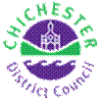 | Terri Foster  Senior Communications Officer  Communications  Chichester District Council

Ext: 21226 | Tel: 01243521226 | tfoster@chichester.gov.uk | https://www.chichester.gov.uk
East Pallant House opening hours: 9am-4pm Monday to Friday

________________________________________________________________________

