
Welcome to the early September 2025 edition of our Residents’ eNewsletter, featuring the latest news and updates from your county council.

Reshaping local government in West Sussex – next steps
West Sussex councils have reached a significant milestone in the journey towards reshaping local government.
A business case for local government reorganisation has now been completed and will be presented at council meetings across the county, districts, and boroughs towards the end of September.
This marks a key step in the collaborative effort of all councils to respond to the government’s requirement to re-structure local government and create a simpler structure for local government.
The business case demonstrates that both single and two unitary models are viable options for the future of local government in West Sussex.
Find out more about the future of local government in Sussex


New season - new job opportunities!
Looking to find a new job, make a career change, or enhance your workplace skills?
We've got some ways to help you:
New jobs eNewsletter: We’ve launched a new monthly Jobs and Opportunities eNewsletter. It provides information and guidance on applying for jobs within the county council, offers career advice and tips, shares experiences from our staff and details of upcoming recruitment events. Sign up here.
Recruitment event: If you’re looking to take your first step towards a career in Children’s Services come along to the Children, Young People and Learning Recruitment event at Cuckfield on Thursday 2 October from 2pm to 5pm. The event will include a presentation from our Children’s Residential team and a CV and Application workshop from our Recruitment Specialists. Find out more or sign up here.
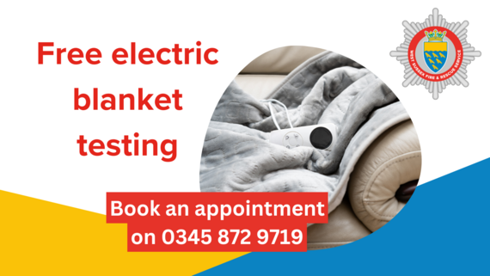
Free electric blanket testing
Our West Sussex Fire & Rescue Service is offering free electric blanket testing sessions.
Last year 37% of the blankets tested were found to be defective. Faulty electric blankets are a common cause of fire in the home.
Testing is recommended for blankets more than two years old. Blankets over 10 years old should be replaced.
The sessions will take place by appointment only. For venues with events running over two days, appointments will only become available on the second day after the first day has been full booked.
Book by calling 0345 872 9719.
- 30 September and 1 October (9.30am to 4.30pm) Bognor Fire Station, West Meads Drive, Bognor Regis PO21 5TB.
- 2 October (10am to 4pm) Horsham Library, Lower Tanbridge Way, Horsham RH12 1PJ.
- 7 and 8 October (9.30am to 4.30pm) Durrington Community Centre, 2 Romany Road, Worthing BN13 3FJ.
- 9 October (10am to 4pm) Shoreham Library, St Mary’s Road, Shoreham-by-Sea BN43 5ZA
- 14 and 15 October (9.30am to 4.30pm) Haywards Heath Fire Station, Mill Green Road, Haywards Heath RH16 1XQ.
- 16 October (10am to 4pm) Crawley Library, Southgate Avenue, Crawley RH10 6HG.
If your blanket is found to be faulty, a limited number of replacement blankets will be available thanks to our partnership with SGN. These will be given free of charge to vulnerable residents who receive certain benefits, while stocks last.
The sessions will also be attended by the Sussex Fraud Team and nurses from the Prevention Assessment Team who will be on hand to offer advice and support.
Keep safe and warm at home


Flu and Covid-19 seasonal vaccinations
We are urging eligible residents to take up the offer of vaccinations as soon as they’re able to ensure protection ahead of the peak winter virus season.
The flu vaccine is now being offered to children aged 2 to 3 years, all school-aged children from Reception to Year 11, and children with certain long-term health conditions.
Vaccinations for children will take place at their GP practice, in school, or at a local community clinic.
Pregnant women will be offered the flu vaccine at maternity appointments but can also choose to book at their GP practice or local pharmacy.
The NHS National Booking System is now open for all other eligible individuals to book their winter flu and Covid-19 vaccinations, with appointments starting from Wednesday 1 October.
This year, Covid-19 vaccinations are available to adults aged 75 and over, older adult care home residents, and people who are immunosuppressed.
Find out more about vaccinations for babies, children and adults, including why they're important and how to get them on the link below.
Find out more

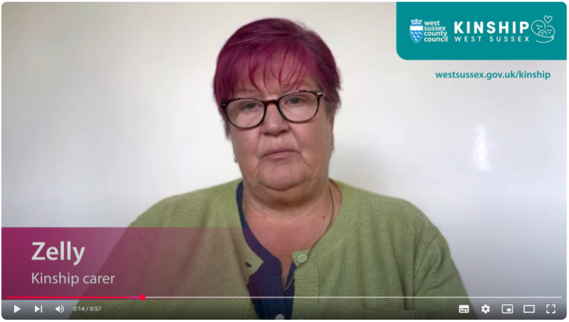
Are you caring for a family member or friend’s child?
Many incredible people like Zelly step in, often unexpectedly, to care for the child of a relative or friend and are known as kinship carers.
This usually happens because a child’s parents are unable to look after them.
It can be an emotional and anxious time for both carers and children, which is why our Kinship Care Support team provides a range of support, including advice regarding family contact time, guidance around education and health, training and specialist workshops, peer mentoring, and more.
A Kinship Conference will be held on Wednesday 8 October, with speakers, access to partner organisations, and the opportunity to meet other kinship carers.
If you, or someone you know would like to attend, or to speak to the team, click the button below or call 01403 229900.
More about kinship care


Suicide - help to save a life
It was World Suicide Prevention Day on 10 September, and we’re promoting access to support.
If you think someone you know might be at risk of suicide, take action and start a conversation, show them you care.
When life is difficult, Samaritans are there – day or night, 365 days a year.
Call them for free on 116 123, email jo@samaritans.org or download the Stay Alive app: stayalive.prevent-suicide.org.uk



Head to our Newsroom to find all the latest news.
- We are celebrating the news that our Adults Services have been rated ‘good’ by the Care Quality Commission (CQC).
- Make the bus part of your everyday journeys. It’s a simple, affordable way to stay connected and get where you need to go. Whether you’re heading to an appointment, school or the high street – there’s a bus journey for you.
- A Crawley business has been prosecuted and fined for selling vapes to children and stocking illegal naphthalene mothballs. An employee has also faced prosecution for personally selling a vape to a minor.
- The next Worthing Community Food Hub will be a multi-agency support hub, bringing a wide range of supporting services together under one roof, including West Sussex Waste Prevention Team, Citizens Advice and community healthcare workers, among others. Come along on Thursday 18 September from 10am to 11am at The Charmandean Centre, Forest Road, Worthing, to fill a bag with rescued food and have chat with all of the services.
- Find out the ways our 36 libraries and e-library can help you learn.
- Applications for secondary school places in West Sussex for September 2026 are now open and parents are being urged to get their applications in before the deadline of Friday 31 October 2025.
- A rogue builder has been sentenced to 30 months imprisonment for defrauding a homeowner in Henfield, following an investigation by our Trading Standards service.

It's Know Your Numbers Week, a national campaign led by Blood Pressure UK to raise awareness of the risks of high blood pressure, or hypertension.
We’re joining with NHS Sussex to urge all adults aged 40 and above to take advantage of the free blood pressure checks available in community pharmacies.
Anyone aged 40 or over who does not already have a diagnosis of high blood pressure (or has not had their blood pressure checked by a healthcare professional in the past six months), can use the service – no GP appointment is needed.
You can also borrow a blood pressure monitor to use at home from Crawley, Bognor Regis, and Goring-by-Sea libraries.
Find out more

Did you receive this eNewsletter from a friend? Sign up here.


