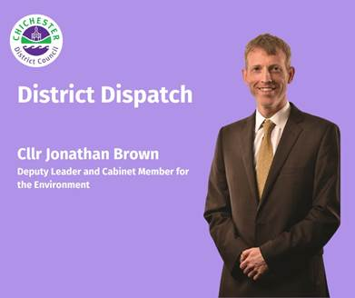
District Dispatch

In my last District Dispatch article, I shared the exciting news that we’ve adopted our ambitious new Climate Emergency Action Plan. This five-year plan sets out a range of actions and projects that we’ll be delivering to help tackle climate change and support our communities in becoming more sustainable.

Within the plan, we place a strong emphasis on collaboration. We want to bring people together to share knowledge, inspire each other, and work together on climate action initiatives in their communities. I’m pleased to say that we now have our first event in the calendar!

On Friday 3 October, we’re offering free training for community groups and volunteers, focused on how to set up and run a successful environmental community group. Whether you're just starting out or looking to strengthen an existing group, this is a great opportunity to gain practical skills and connect with others who share your passion for climate action.

To deliver this training, we’ve partnered with Voluntary Action Arun & Chichester, who support over 550 member organisations and groups in the Voluntary, Community and Social Enterprise sector. The training will take place at our Chichester District Council offices (East Pallant House, PO19 1TY), with two sessions to choose from: 9.30am-12.30pm or 1.30pm-4.30pm. Spaces are limited, so I’d encourage people to book early by emailing: climatechange@chichester.gov.uk

This event supports another key project — to further develop our Chichester District Climate Action Network. The network aims to connect and support climate action groups across the district, leading to even more steps being taken to tackle climate change. We will officially be launching the network on this year’s Carbon Literacy Action Day on 10 November.

To mark the occasion, we’re hosting a Carbon Literacy training event at Graylingwell Chapel, Chichester (PO19 6BZ) from 9am until 5pm on 10 November. Designed by the globally recognised Carbon Literacy Project, this training aims to help people identify changes in their lives, workplaces and communities that could help them to reduce their carbon footprint. The training is being delivered by our experienced in-house Carbon Literacy Facilitator, Mike Pierce, and the event will also include a networking session at midday to connect trainees with community action groups.

If you’d like to attend the training and become certified as ‘Carbon Literate’, please book your place at: www.eventbrite.co.uk/e/carbon-literacy-action-day-training-tickets-1610566320219. If you represent a community action group and would just like to attend the networking session, please email: climatechange@chichester.gov.uk.

Another key action in our Climate Emergency Action Plan is to continue the great work of our Tree Chichester District scheme. Since December 2020, we’re proud to have planted over 65,000 trees across the Chichester District. We’ve delivered a variety of tree planting projects, including planting mini urban forests in the Miyawaki style of planting, running free and subsidised tree schemes, awarding grants for community orchards, and funding tree planting on farms and private land.

As part of the council’s Climate Emergency Action Plan, I’m pleased to say that the council plans to continue to fund further tree planting projects this winter and beyond. For more information about previous planting or upcoming funding, please contact our Tree Project Officer, Sophie Hamnett, by emailing: treescheme@chichester.gov.uk

These are just a few of the steps we’re taking as part of our Climate Emergency Action Plan. I’m looking forward to seeing the positive impact these projects will have — and I hope you’ll join us in making a difference.

To stay informed about our climate initiatives, sign up to our dedicated newsletter: www.chichester.gov.uk/climatechangenewsletter

Best Wishes

Cllr Jonathan Brown
Deputy Leader and Cabinet Member for Environment at Chichester District Council

 | Terri Foster  Senior Communications Officer  Communications  Chichester District Council

Ext: 21226 | Tel: 01243521226 | tfoster@chichester.gov.uk | https://www.chichester.gov.uk
East Pallant House opening hours: 9am-4pm Monday to Friday


