
Welcome to the August 2025 edition of our Residents’ eNewsletter, featuring the latest news and updates from your county council.

Bank holiday then back to school safely
The holidays are still here! The new school term starts in less than a fortnight, but there’s still a bank holiday to look forward to.
We’re here 24/7 if you need to contact us over the bank holiday weekend (23 to 25 August), and if you're looking for something to do visit Experience Sussex for some late summer inspiration.
Schools return on Wednesday 3 September. Check out the term dates for the next year here.
If your child is moving up to secondary school, this brings new challenges including some pupils travelling to school independently for the first time.
If they plan to walk or bike to school on their own or with friends, now is a good time to sit down with your child and talk through their new route to school and how to keep themselves safe whilst making these journeys without you.
Road casualty data shows that the number of child pedestrian casualties doubles between the ages of nine and 11, with incidents more likely to happen during school drop-off and pick up times.
This free, printable activity sheet is a great way to interact with your child to help them prepare for this significant transition to secondary school.

Remembering the Shoreham Airshow disaster victims
Tomorrow (Friday 22 August) marks the 10th anniversary of the Shoreham Airshow disaster.
Eleven people lost their lives that day and our thoughts remain with them, their loved ones, and everyone in our community affected by what happened.
To honour those who died, West Sussex County Council is commemorating the anniversary with a minute’s silence.
We invite everyone to join us, wherever you may be, in pausing at 1.22pm tomorrow, which is the time the tragedy occurred 10 years ago.
All flags at county council and West Sussex Fire & Rescue Service buildings will be lowered to half-mast on Friday as a mark of respect.

Emergency Alerts system test in September
The UK government is testing the Emergency Alerts system on Sunday 7 September 2025 at 3pm.
Compatible mobile phones and tablets will receive an alert, make a loud siren-like sound and vibrate. You will not need to take any action.
If you or someone you know is a victim of domestic abuse with a concealed phone, it may be more appropriate to turn off alerts.
How you opt out depends on your device, but if you aren't sure how to do it, Refuge, the largest specialist domestic abuse organisation in the UK, has a guide on how to turn off emergency alerts and secure your device on their Tech Safety website.
Find out more


New Skills Bootcamps: fast-track your career with free training
We’ve launched free Skills Bootcamps, a new initiative designed to help residents gain practical, in-demand skills that local employers are actively seeking.
Whether you're looking to change careers, step into your first job or progress in your current role, Skills Bootcamps offer a fresh, flexible approach to learning.
They are:
- open to anyone aged 19+ who lives or works in West Sussex
- inclusive and have accessible training options
- focused on real-world skills that lead to job opportunities or career progression
- developed in partnership with local employers to meet current workforce needs.
Explore the courses available and start building your future today via the link below.
You can also find out if you’re eligible to take part in free and subsidised adult learning courses that could help you learn new skills and follow new career paths.
Find out more


Childhood vaccinations update
Illnesses like measles and whooping cough can spread very easily between children who are not vaccinated. These illnesses can make children very sick, leading to hospital stays or lifelong problems.
It’s important that vaccines are given on time for the best protection. If your child is not vaccinated, they are not protected.
It’s never too late to have vaccinations, and the school holidays are an ideal time to make sure children are up to date with their vaccinations.
There have been recent changes to the childhood vaccination schedule.
Please check the updated schedule to ensure your child has received all recommended vaccinations and is fully protected.
You can also check your child’s red book or speak to your GP practice or health visitor to see if they have missed any of their vaccinations
Find out more

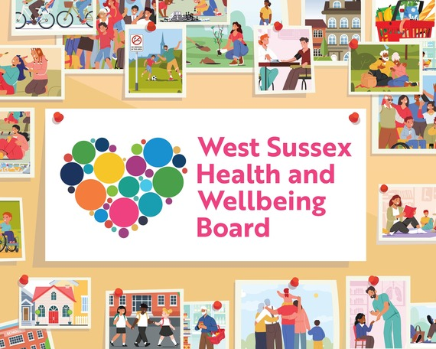
New strategy to improve West Sussex residents’ health and wellbeing
A new five-year strategy has been published which is the county’s overarching plan to improve the health and wellbeing of residents and communities across West Sussex and reduce health inequalities.
Developed by the West Sussex Health and Wellbeing Board and wider partners, the plan also includes feedback following a public consultation on the draft strategy held earlier this year.
The strategy presents the board’s vision of ‘Improving Lives Together in West Sussex.’
It focuses on five priority areas, with three principles which are central to its delivery.
The five priority areas are:
- Food and nutrition
- School readiness
- Transitioning to adulthood – children and young people’s mental health and wellbeing
- Tobacco control
- Health and wellbeing in temporary accommodation
Watch our short animation to find out more about this work.
Find out more


Think Before You Throw survey results
There were more than 3,000 respondents to our recent recycling survey and 92% said that recycling is very important, and we agree!
The survey also revealed there’s still some confusion around recycling plastics.
In West Sussex, you can recycle all colours of plastic bottles, pots, tubs, and trays, as long as they’re clean, dry, and loose.
Plastic bags and wrapping, like crisp packets and carrier bags, cannot be recycled at home due to the way our recycling facility works.
You can, however, take these materials to your local supermarket for recycling. Find your nearest participating store online here.
View a video about plastics recycling, or find out more below.
Find out more


If you are passionate about our local environment and climate change and want to know more, then take a look at our latest Environment and Climate Change eNewsletter here.
This month's edition includes news about the updated flood risk management strategy, a new pollinator highway, and how you can reduce waste by visiting one of our reuse shops.



Head to our Newsroom to find all the latest news.
- Congratulations to everyone who has recently received their A-level or GCSE results! Our careers advisors are on hand to give one-to-one advice about your next steps. Chat with the careers team by calling 0330 222 7175 or emailing careersadvice@westsussex.gov.uk. You can also visit the careers guidance webpage for more information. Feeling down, stressed or anxious after opening your grades? You can find support, advice and plenty of useful resources to help you with your emotional wellbeing on the E-Wellbeing website.
- Thank you to those who completed the survey on local government reorganisation. We’ll keep you informed as the process continues and you can find further information here.
- A property management company and its sole director have been ordered to pay a total of £1,588 after being found guilty of breaching a fire safety order.
- Two of our cabinet members have written to the Secretary of State for Education to express the council’s views on the state of Special Educational Needs and Disabilities (SEND) support nationally and to propose necessary changes to the system.
- Firefighters have issued a warning following a fire at a property in Chichester which was caused by lithium-ion batteries left on charge.
- Three children’s homes we run have been commended by Ofsted for the quality of care they are providing children and young people.
- Local health leaders want residents to share what matters to them about the NHS, and where further improvement is needed. A survey is running until 7 September to collect your views and experiences about health services in Sussex.

You can do so much online via our West Sussex Record Office website and eLibrary. Find out what new and improved digital services are available.


