
Welcome to the Greenprint special edition of our Residents' Newsletter!
What is Greenprint?
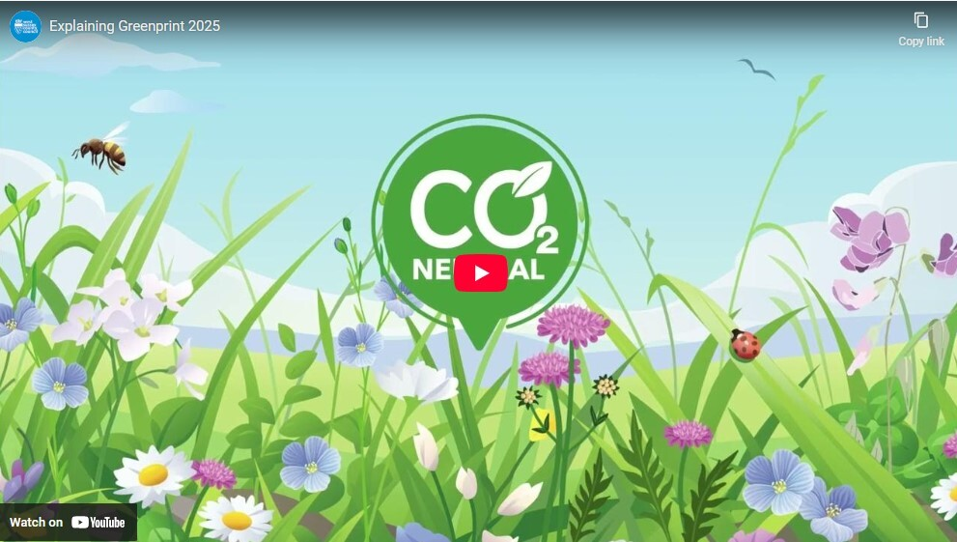
Greenprint is an exciting 3-year project to test if grass cuttings collected from mowed verges can be converted into biofuels and a material called biochar, a carbon-rich substance that's like charcoal.
We’re also measuring how changes to the way we cut the grass can give nature a boost, reduce greenhouse gas emissions and capture carbon in the ground.
Read on to discover how we're trialling a new way of managing grass verges to reduce the carbon footprint associated with highways maintenance.
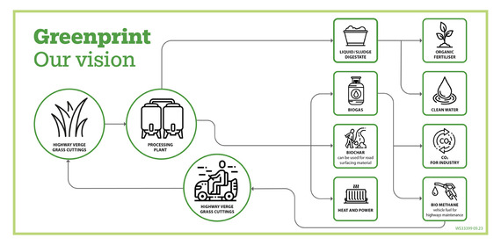
Rethinking verge maintenance
We’ve partnered with South Gloucestershire Council to explore new ways to maintain roadside verges and open spaces. In West Sussex we’re using special mowers to 'cut and collect' grass on urban verges in Horsham and rural verges in Aldwick, Bersted and Pagham. We're trialling different cutting schedules and taking the cut grass away.
Cuttings are usually left to compost on the ground but that creates carbon dioxide (CO2) and nitrous oxide (N2O), the gasses that contribute to climate change.
Collecting the cuttings reduces these greenhouse gas emissions and the grass regrows more slowly so more wildflowers that attract pollinating insects have a chance to grow.
This captures more carbon in the soil and the collected cuttings can be processed to create useful products like biofuel and biochar.
Slower grass regrowth also reduces the number of times we need to cut the grass each year. Which means the mowing machines need less maintenance and we use less fuel to power them.
Last year we cut and collected over 909 hectares of grass, equivalent to 1,400 football pitches. The project is now in its third year and we’re proud of the progress we’re making.
Read the latest Greenprint progress report

Transforming cuttings into Biochar
Biochar is a very stable carbon-rich material made from plants. It can be incorporated into construction materials like concrete and asphalt.
Because it is very slow to decompose it can safely store carbon for centuries, which can help reduce carbon dioxide in the atmosphere.
Greenprint is evaluating different ways of converting the cut grass we collect from roadside verges into biochar. Our trials and lab tests looked at two methods.
- Hydrothermal carbonisation (HTC) that processes organic material using heat and water.
- Pyrolysis that breaks down the cuttings using dry heat in the absence of oxygen.
Pyrolysis proved to be the most viable option because HTC had problems processing litter in the grass, which resulted in poorer quality biochar.

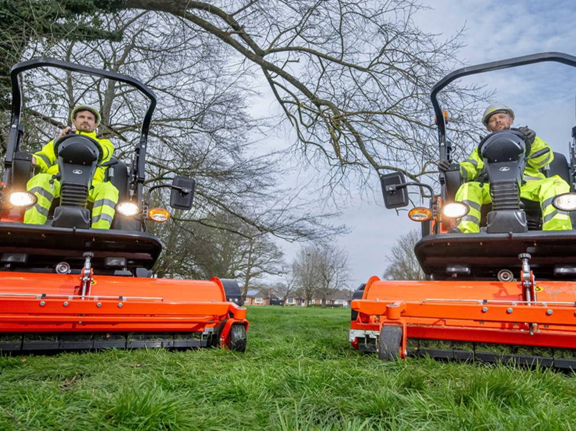
Can we use biochar to fix potholes?
We're planning road trials to investigate the use of biochar in road maintenance. Yes, that’s right, we’re seeing if biochar made from grass cuttings collected from roadside verges could be used in our road repairs.
Adding biochar to road surfaces or using it to build the road substructure helps trap carbon dioxide in a stable form within the ground. We will study how these eco-friendly road construction methods can be used to store carbon and lower emissions.
This could close the loop and play a big role in creating a road infrastructure that helps fight climate change.
Blooming roadside verges

Our project partner, Plantlife, is studying verges where the cuttings are removed and the grass is cut less frequently. They take soil samples and count the varieties of plants to see how changes to mowing affects the biodiversity.
Last year they recorded 149 different plant species growing on the Greenprint verges in West Sussex and South Gloucestershire.
Overall, they found that rural verges had more plant species compared to urban verges. But sections of the Greenprint urban verges were richer in plant species.
Different mowing practices play a crucial role in promoting the widest range of biodiversity.
Discover more about Plantlife

Nationwide network

Greenprint is part of ADEPT Live Labs 2: Decarbonising Local Roads in the UK, a three-year, UK-wide £30 million programme funded by the Department for Transport (DfT) that aims to decarbonise the local highway network.
Greenprint is one of 7 Live Labs 2 projects that get a share of the funding, being run by local authorities around the UK from Lanarkshire to Devon.
Find out more about LiveLabs 2


Keep up to date with Greenprint
Interested in hearing more about Greenprint? To get regular updates on the project subscribe to the quarterly newsletter and bookmark the Greenprint page on the West Sussex County Council website.
Subscribe to the Greenprint newsletter



