NEWS RELEASE | 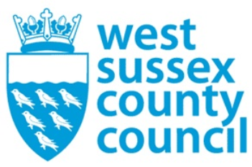

07 August 2025

West Sussex County Council and UKHarvest expand multi-agency support hubs across the county
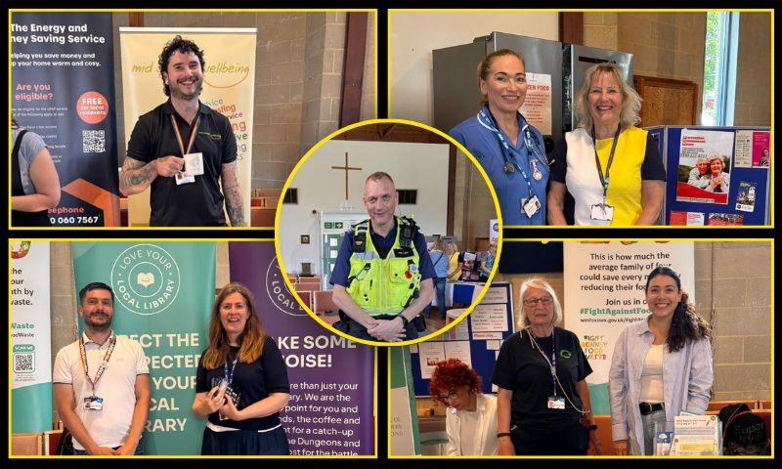

Following the success of a recent multi-agency support hub held alongside the Haywards Heath Community Food Hub, West Sussex County Council and UKHarvest will be hosting three further multi-agency support hubs in Crawley, Worthing and Bognor Regis.
The multi-agency support hub initiative brings together a variety of community services under one roof to support residents at UKHarvest Community Food Hubs.
The first event, held at Ashenground Community Centre in Haywards Heath in June, welcomed 43 residents and supported 106 individuals with nutritious food that would have otherwise gone to waste. In total, the Community Food Hub distributed 366kg of food on the day.
Services available at the Haywards Heath event included:
- Citizens Advice
- Community Energy Pathways
- Early Help
- LEAP Energy Advisors
- Mid Sussex Food Partnership
- Prevention & Assessment Team
- Sussex Wellbeing
- Sussex Libraries
- Sussex Police Neighbourhood Policing Team
- West Sussex Recycles (including a clothing swap)
The initiative is part of the wider West Sussex County Council and UKHarvest collaboration which focuses on reducing food waste across the county through Community Food Hubs. These child-friendly hubs are open to all residents, offering an opportunity to fill a bag with delicious, rescued food. Learn more about the project here.
Deborah Urquhart, West Sussex County Council Cabinet Member for Environment and Climate Change, said: “At a time when many people are facing cost-of-living pressures, we’re proud that our Community Food Hubs can support residents beyond providing affordable food. These supporting services are a valuable asset to the residents who visit the hubs, and the success of the Haywards Heath event proves this.
“By housing all the supporting services under one roof, residents are able to benefit in many areas, from money-saving advice from Citizens Advice to fall prevention tips from Sussex Wellbeing.”
Simon Thresher, Head of Operations, Logistics and Compliance at UKHarvest supports the expansion: "Our Community Food hubs offer more than just a place to collect surplus food. They’re welcoming spaces where people can connect, seek support and engage directly with agencies.
“By teaming up with West Sussex County Council to introduce multi-agency support hubs, we’re making it easier for people to access vital services face-to-face, from health and wellbeing to housing and finance. The response so far has been fantastic, and we’re excited to keep building on this momentum.”
Upcoming multi-agency support hubs:
Crawley:
- Location: Broadfield Community Centre, Broadfield Barton, Crawley, RH11 9BA
- Date: Wednesday 20 August 2025, 10am to 11am
Worthing:
- Location: Charmandean Centre, Forest Road, Worthing, BN14 9HS
- Date: Thursday 18 September 2025, 10am to 11am
Bognor Regis:
- Location: Bognor Youth and Community Centre, Westloats Lane, Bognor Regis, PO21 5JZ
- Date: Wednesday 5 November 2025, 10am to 11am
Even if your local Community Food Hub isn’t hosting a multi-agency support hub, many of these services will still visit individual hubs throughout the year.
To find full dates and locations of UKHarvest Community Food Hubs in partnership with West Sussex County Council, visit: www.westsussex.gov.uk/UKHarvest
For further information please contact the news desk on 0330 222 8090 or email pressoffice@westsussex.gov.uk.
For urgent out-of-hours enquiries please call 07767 098415.
 

Click to Unsubscribe

