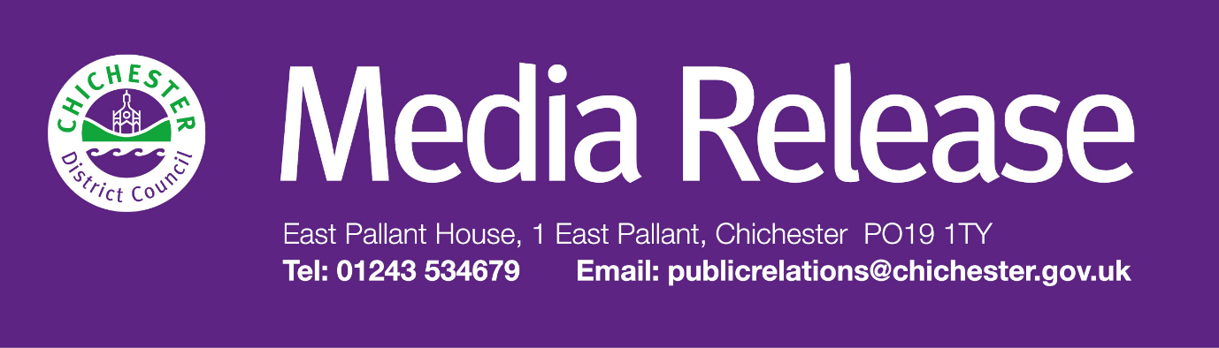
Date of Release: 12 August 2025 Ref: 4508

Volunteers sought to help shape major women's history project
The Novium Museum is inviting members of the public to get involved in its major new project, ChichestHER: Their Story, Our Inspiration.

Funded by The National Lottery Heritage Fund, ‘ChichestHER’ will shine a light on the remarkable lives and achievements of women across the Chichester District — past and present — and culminate in a headline exhibition opening at The Novium Museum in Chichester in October 2026.

The museum is calling on volunteers to support this important work by helping to uncover stories, identify objects, and preserve them for future generations.

Two volunteer roles are now open for applications:

- Research Volunteers will help investigate the lives of local women using archives and collections, supporting the development of future exhibition content.
- Digitisation Volunteers will work with the museum’s collection, photographing and recording relevant objects and ephemera, helping to create a digital record of women’s lives in the district.

These roles are ideal for people with an interest in local history, women’s history, or museum practice. Full training will be provided.

The roles will be central to helping to uncover stories that have often been forgotten and ensuring that they’re preserved and celebrated for future generations.

To find out more, members of the public are invited to a coffee afternoon at The Novium Museum on Wednesday 10 September at 1.30pm, where they can meet the team, ask questions, and register interest. A volunteer induction will take place on Friday 19 September, with roles beginning shortly after.

To find out more or register your interest, email rng@chichester.gov.uk, or visit www.thenovium.org/chichesther

For further information, please contact Terri Foster, Senior Communications Officer at Chichester District Council on
01243 521297

