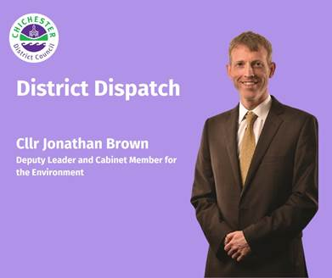
District Dispatch

I’m pleased to say that the council has now adopted its ambitious new Climate Emergency Action Plan, which sets out a range of actions and projects that we will take forward and deliver over the next five years.

Lat year, we ran our ‘Let’s Talk: Climate Change’ consultation to gather people’s views on the types of climate change initiatives that they wanted us to prioritise. Over 1,300 people visited the online survey to have their say and the feedback we received was vital in helping us develop our new plan. I’d like to thank everyone who helped shape this important piece of work, which is a real reflection of what people want us to do locally in response to climate change.

The five-year plan was agreed last month and identifies a wide range of actions, including significantly increasing our work to help households cut their energy bills and reduce carbon emissions. This was something that a significant number of people told us that they wanted to see. In our district, the second largest source of emissions is from housing, and this is also the area where we — as a council — can help make one of the biggest differences. We will be taking on a dedicated housing decarbonisation officer who will help people make their homes more energy efficient and use more solar power by providing information and helping people to access funding.

People who responded to our survey were also keen to see the work of our tree officer continue, and so once the current central Government funding for the post ends, this work will be funded by the council. Other projects include looking at opportunities for enabling carbon storage in coastal habitats; using planning policy to increase street tree planting and green travel plans for new developments; developing the network of climate action groups throughout the district; working with schools to encourage debate and action on climate change; and collaborating with other West Sussex councils to look at the work being done to adapt to climate risks facing the area and what additional work needs to be done.

In addition, the plan includes setting up regular networking events for public sector employers and other not-for-profit organisations so they can share knowledge, collaborate on projects, and identify climate change policies for community organisations to easily incorporate into their work. This complements the council’s work to support Small- and Medium-Sized Enterprises to grow their business sustainably, adapt to climate change and set measurable climate-related goals.

The plan also includes actions that the council will take to reduce its own emissions. This includes looking for a suitable lower carbon fuel to replace the diesel used by its refuse collection vehicles and looking for a contract with a green electricity provider that offers credible greenhouse gas emission reductions. Both actions would significantly reduce the council’s emissions and set it on the path to be net zero by 2040.

Although there’s no legal requirement for the council to achieve net zero — either through the organisation or in the district — our council declared a climate emergency in 2019. We’re absolutely committed to doing what we can to reduce our own impact on the environment and support others to make effective changes. We also want to seize ‘win-win’ opportunities to improve the urban and natural environment in our area and help with reducing the cost of living long-term.

This plan is about bringing everyone in the district together to help tackle a crisis that affects us all. There are some things that can only be successfully accomplished at a national or international level, but our plan meets the widespread local demand to take the lead on the areas where we have the most influence locally — directly or indirectly — and can make the biggest difference.

To keep up-to-date on climate change initiatives, sign up to our dedicated email newsletter: www.chichester.gov.uk/climatechangenewsletter

Best Wishes

Cllr Jonathan Brown
Deputy Leader and Cabinet Member for Environmental Strategy at Chichester District Council

 | Sarah J Parker  Communications Manager  Communications  Chichester District Council

Ext: 21273 | Tel: 01243521273 | sparker@chichester.gov.uk | https://www.chichester.gov.uk
East Pallant House opening hours: 9am-4pm Monday to Friday


