
Welcome to our August 2025 eNewsletter

Emergency Alerts system test in September
The UK government is testing the Emergency Alerts system on Sunday 7 September 2025 at 3pm.
Compatible mobile phones and tablets will receive an alert, make a loud siren-like sound and vibrate. You will not need to take any action.
However, if you or someone you know is a victim of domestic abuse with a concealed phone, it may be more appropriate to turn off alerts.
How you opt out depends on your device, but if you aren't sure how to do it Refuge, the largest specialist domestic abuse organisation in the UK, has a guide on how to turn off emergency alerts and secure your device on their Tech Safety website.
Refuge | Secure your tech


Domestic abuse doesn’t take a summer break
Summer can be a time of sunshine and rest — but for some, it brings increased stress, isolation and risk. During school holidays, when routines shift and families spend more time at home, incidents of domestic abuse can rise.
Abuse doesn’t always look the same. It can be physical, emotional, sexual or financial. It can affect anyone, no matter your age, background, gender, sexuality or situation.
If this sounds familiar, or you're worried about someone else, please know you're not alone.
In an emergency call 999 (if you or someone else is in immediate danger). If you can’t speak, press 55 when prompted to let the operator know you need help.
To report non-emergency concerns call 101 or report online via the Sussex Police website.
Domestic abuse | Support in West Sussex

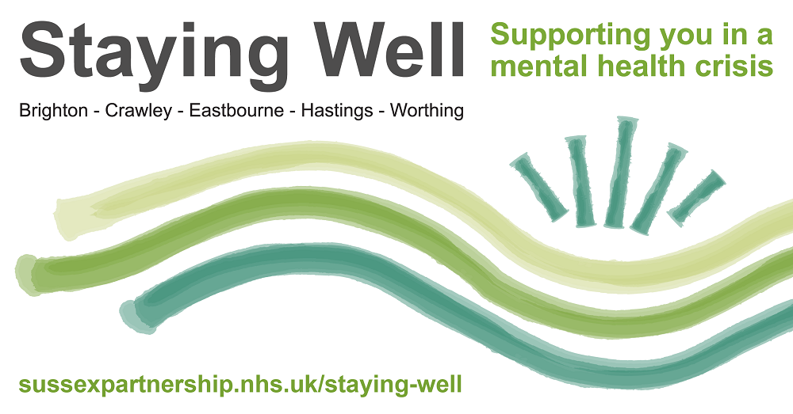
Out-of-hours mental health support in West Sussex
Last year, it was reported that 1 in 6 people were living in West Sussex with a common mental health condition / disorder, but when we’re feeling low it’s not always easy to know where to go for support, especially when it is outside of normal working hours.
In West Sussex, there are two Staying Well locations which offer out-of-hours mental health crisis support for people aged 18+ in:
- Crawley – run by Waythrough.
- Worthing – run by West Sussex Mind.
Anyone from across the county can go to either location and get support in a safe, relaxed and friendly environment. You can find out more information, including their opening times on the links above.
Outside of West Sussex, there is also out-of-hours support available in Brighton, Eastbourne and Hastings.
For further details about all the options available to help you with your mental health, just visit the Sussex Partnership NHS Foundation Trust website.
Sussex Partnership NHS Foundation Trust | Mental health support


Photo courtesy of the Office of the Police and Crime Commissioner
Young people raise awareness about online grooming amongst peers
Since the start of the year, our Digital Safety & Fraud Prevention team have been supporting the Office of the Police and Crime Commissioner (OPCC) to recruit 48 13–18-year-olds to the Youth Ambassadors Project for Sussex.
This project, led by the Breck Foundation and funded by the OPCC, aims to empower young people to raise awareness about online grooming amongst their classmates.
Last month, the project had its official launch at BHASVIC College in Brighton, where the ambassadors were congratulated for passing their first phase of training. They were also able to present a video showcasing their team building activities, training and why they wanted to be ambassadors.
We will continue to update you on the progress of the project, but for now why not take a look at the amazing work the Breck Foundation already do.
Breck Foundation website


Vital support available for carers in West Sussex
Did you know that a lot of paid and unpaid carers don’t see themselves as carers? Instead, they may feel that they are taking on a natural role to look after a family member, loved one, friend or neighbour.
However, if you look after another adult (18 years and over) within or outside the family who is physically ill, mentally ill, frail or disabled, you can get support and advice.
In West Sussex, there is help available through Carers Support West Sussex, a local charity who offer carers vital information, guidance, and emotional support services.
To find out more about how they can help you, or someone you know, you can call their helpline on 0300 028 8888, email them at info@carerssupport.org.uk or visit their website.
Carers Support West Sussex


Free online safety sessions available from our Digital Safety & Fraud Prevention team
Our Digital Safety & Fraud Prevention team's role is to raise online safety and fraud awareness amongst individuals, communities and professionals across West Sussex.
They are currently running the following sessions which are free to attend:
- Are you scam savvy? - A one and a half hour online course looking at the rise in scams, including telephone, courier and romance fraud and what you can do to stop yourself becoming a victim.
- Digital confidence training - An in-person three and a half hour training session for anyone who wants to increase their own digital confidence or help support others.
- Online safety for parents - A one hour online course will provide you with the essential knowledge and tools to help keep your children safe online.
To find out more, visit their Eventbrite page.
Eventbrite | Digital Safety & Fraud Prevention

More free webinars available with the South East Cyber Crime Unit
The South East Cyber Crime Unit is currently running a number of free webinars for individuals, businesses and charities to help educate everyone on how to defend themselves against, and be more resilient to, cyber crime.
The current topics with upcoming sessions are:
- Cyber security for business.
- Empower yourself: Online safety for beginners.
- Protect your purpose: Cyber security for charities.
- The digital dilemma: Keeping children safe online.
For more information and to book a place, visit their Eventbrite page.
Eventbrite | South East Cyber Crime Unit

HSBC UK host fraud and cyber awareness webinars for business owners
HSBC UK hold regular fraud and cyber awareness Zoom webinars for business owners where they discuss the best ways of protecting businesses from fraud and cybercrime.
Their next session is on Wednesday 17 September where members of the Fraud Business Management Team will discuss the rising threat of purchase scams, techniques used by fraudsters and how to spot them. The webinar is free to attend and is taking place at 10am and 3pm.
Free spots at either time can be booked on the HSBC UK website, and they also have recordings of previous webinars available on their website too.
HSBC UK | Fraud and cyber awareness webinars

West Sussex Mind Experts by Experience sessions
Did you know that the West Sussex Mind Parenting Service runs a series of Experts by Experience sessions for parents and carers in West Sussex?
These are regular training support groups with themes around mental health to help parents and carers support their children and young people.
There are currently two Experts by Experience sessions coming up:
- Wednesday 3 September: Supporting children and young people who self harm, 7.30pm - 9.30pm.
- Wednesday 1 October: Emotional & self regulation skills in children & young people, 7.30pm - 9.30pm.
You can book your free spot and find all the other upcoming training courses and events run by West Sussex Mind on their Eventbrite page.
Eventbrite | West Sussex Mind


Citizens Advice in West Sussex is working with the NHS to find out about the needs of people aged 16-25.
They are asking anyone in this age range to share their experiences and insights in this confidential survey so they can work together with the NHS, and other organisations, to shape services that truly meet the needs of young people and make meaningful improvements.
If you know a person in this age range, please ask them to take five minutes to fill in the survey.
Your Health, Your Voice survey

Following extensive consultation, Police & Crime Commissioner Katy Bourne has launched her new Police & Crime Plan for Sussex.
Within her fourth plan, PCC Katy Bourne has set three priorities; prevent crime and support victims and witnesses, investigate crime and bring offenders to justice and improve trust in policing and build public confidence.
You can watch an informative video about the plan on YouTube.
YouTube | Sussex Police & Crime Plan 2024-2028



