

news release
07 July 2025

Bookmark the date of this year’s Summer Reading Challenge!

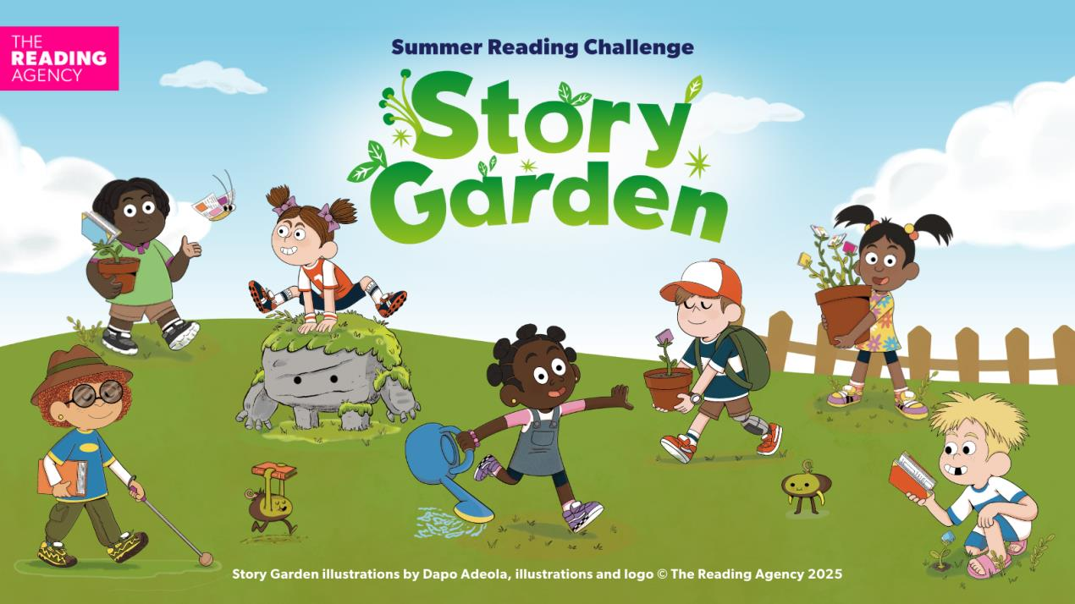
Children of all ages can combine reading with nature and the great outdoors at West Sussex libraries when taking part in Story Garden, the 2025 Summer Reading Challenge.
The annual initiative aims to encourage kids to keep reading over the school holidays with rewards available for completing the challenge, including a special medal and certificate.

The challenge runs right across the summer and children aged 4 to 11 can join in anytime from Saturday 12 July to Saturday 13 September. It’s free to take part and you just need a library card, available from all West Sussex libraries.
Meanwhile, little ones aged four and under can join the Story Garden Mini Challenge and collect stickers as they share library books over the summer, before receiving a special gold sticker and certificate when they finish.
Councillor Duncan Crow, the county council’s Cabinet Member for Community Support, Fire and Rescue, said: “The challenge is not only a fun activity for young people to take part in, but it also helps to improve their reading skills and confidence. This supports a key priority of Our Council Plan which is to help people fulfil their potential.
“Over 340,000 books were read by children and young people in West Sussex last summer and almost 10,000 children took part in the challenge. It’s fantastic to see a consistently high number of children getting involved each year. The challenge is free to join and I would urge all children and families to sign up and take part at their nearest library.”
Some of the council’s libraries are appealing for volunteers aged 14 and over to support staff in promoting the challenge and in return develop their skills and gain valuable experience working with children and families.
See West Sussex Libraries for full details of how to sign up to the 2025 Summer Reading Challenge, and how to volunteer.
​
For further information please contact the news desk on 0330 222 8090 or email pressoffice@westsussex.gov.uk.
For urgent out-of-hours enquiries please call 07767 098415.
 

