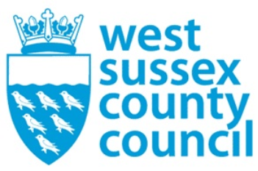

news release
10 July 2025

Shaping the vision for the future of local authorities as local government reorganisation progresses

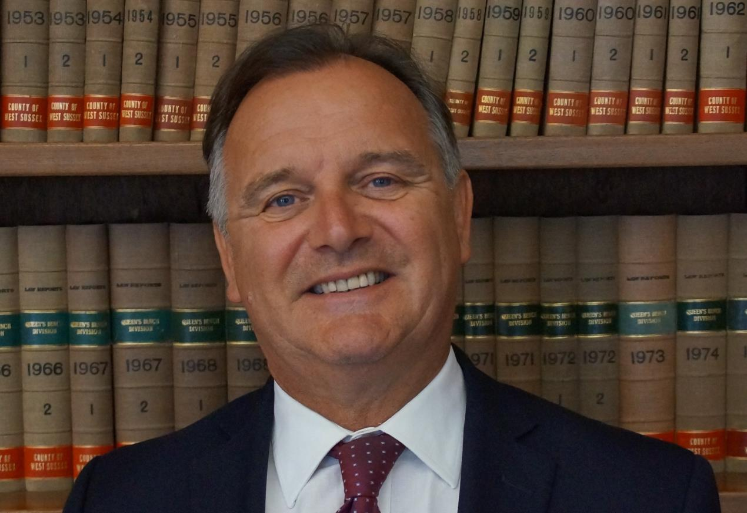

Collaboration between councils across West Sussex to explore options for local government reorganisation continues to make strong progress.

Council leaders are working to shape a shared vision for the future and develop the evidence to progress options for a new structure that will most benefit communities.

West Sussex County Council Leader Councillor Paul Marshall said:“Reorganisation is a once-in-generation opportunity to reshape local government in West Sussex for the better.

“It is also a complex process so it’s no surprise there are differing views on the best way forward. One of the real strengths of our work together, however, is the diversity of perspectives and mutual respect we bring as leaders.

“I’ve previously made the case that we must focus on delivering an effective and cost-efficient solution that works for our communities to ensure we make the most of the opportunities.

“As leader of the county council, I have responsibility for delivering vital social care services to vulnerable people, services that account for the majority of local government spend in the county. This gives me a unique lens through which to view the potential impact of reorganisation.
“I’m approaching the process with an open mind and am very conscious that there is still work to do in developing our position, including engaging with communities.

“However, the evidence I’ve seen so far points towards a single unitary authority as the best option for West Sussex. It offers the clearest model of service delivery for residents and delivers the government’s ambitions for reform while minimising disruption and cost.

“With the national criteria on reorganisation in mind, I find it hard to see how splitting the county into multiple unitary authorities will deliver the changes that the government wants and that our communities need. It would mean dividing social care services, increasing running costs and taking money away from essential services, and introducing unnecessary complexity and distraction at a time when we need to continue our focus on improving services and managing major national reforms.

“In short, the evidence would need to identify something new if the answer for me were to be anything other than a single unitary authority.”

West Sussex County Council, together with the district and borough councils submitted to government a draft interim plan for reorganisation in March this year. It outlined options for consideration. The government is expected to make a final decision later in 2025.

Cllr Marshall added: “There are mixed views about the benefits of reorganisation, but I maintain it is the right thing to do. It will bring a more efficient way of working with clearer accountability and a simpler system for residents.

“The journey to get there will be a challenge and involve significant cost. However, the severity of both will depend on the options we as council leaders favour and the option the government ultimately decides upon.

“Whatever the outcome, councils will need to work differently in the future. The model of local place leadership currently provided by district and borough council will need to be replaced and a new authority will need to be designed to meet the different needs and characteristics of communities across county, including Horsham, Crawley, Mid Sussex, Worthing, Arun, Adur and Chichester.

“The great benefit of a creating a new, single unitary authority is that will have the ability to do just that, building within it the DNA of our local communities and a model that will offer West Sussex a real chance to flourish and prosper.”

See Future of local government in Sussex for more information about the work on local government reorganisation and devolution in our region.
​
For further information please contact the news desk on 0330 222 8090 or email pressoffice@westsussex.gov.uk.
For urgent out-of-hours enquiries please call 07767 098415.
 

