District Dispatch
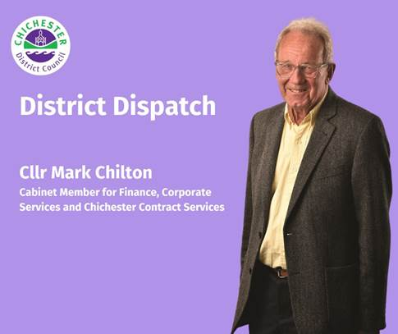
From Spring 2026, we will start rolling out a new weekly food waste recycling collection for households. Implementing a new service like this is a big job, and requires a lot of forward planning, but we are excited to have placed orders for our trucks, caddies and bins.

Each household will receive a small food waste caddy to use in the kitchen and a larger bin for outdoor collection. These will be distributed next year in time for the service rollout, which will take place between March and the end of May 2026. The rollout for properties who share communal bins will start later in the year and more information will be released nearer the time.
Food waste collections will be every week, with all household recycling, waste, and garden waste (if subscribed to) continuing as usual every two weeks.

Currently, about a third of the waste in the average household bin in the district is food. By collecting food waste separately, it can be recycled via Anaerobic Digestion — a process where food waste is broken down to produce biogas and bio-fertiliser and is a much more efficient and environmentally friendly way of processing.

The new service is also expected to encourage residents to reduce their food waste, potentially saving around £20 per person per month. For tips on how to reduce your food waste, you can visit: www.westsussex.gov.uk/fightagainstfoodwaste

To help you prepare, we are encouraging you to download our free Chichester District App from either the Apple or Google Play store and turn on your notifications.
This is the best way to receive regular, tailored updates about your bin collections.

By turning on notifications, you can get reminders and updates specific to your collection schedule and stay up to date with information on the new service rollout. This means that we can let you know if our crews are running late, and it allows us to notify you of planned changes to your collection schedule — such as collection day changes over bank holidays. The app also allows you to view your personalised waste and recycling dates and provides recycling advice and helps you to identify which items should go in which bins.

We’ve received great feedback from those using the app because it enables us to keep you well informed if our crews have any issues on the roads, or if severe weather is preventing us from reaching you, and it provides excellent reminders and information.

The app allows you to complete ‘Report It’ forms for issues such as street cleaning and fly tipping, or even to request a new bin. You can also view local food hygiene ratings for restaurants and cafes — which is especially useful if you are planning a night out or are looking for somewhere to meet up with friends. It also allows you to find your nearest facilities, such as recycling centres, car parks and public toilets. In order to access this, all you need to do is visit either the Apple app store or the Google Play store and search for the Chichester District Council app. You can also find out more about this at: www.chichester.gov.uk/chichesterdcapp

Introducing the food waste service is a significant change that promises to bring substantial benefits to our district. We will keep you well-informed of our progress and provide more details as we approach the launch of the new service. You can also find out more at: www.chichester.gov.uk/food-waste

Best Wishes
Cllr Mark Chilton
Cabinet Member for Finance, Corporate Services and Chichester Contract Services at Chichester District Council

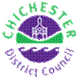 | Terri Foster  Senior Communications Officer  Communications  Chichester District Council

Ext: 21226 | Tel: 01243521226 | tfoster@chichester.gov.uk | Fax: 01243776766 | https://www.chichester.gov.uk
East Pallant House opening hours: 9am-4pm Monday to Friday


