CHICHESTER DISTRICT COUNCIL
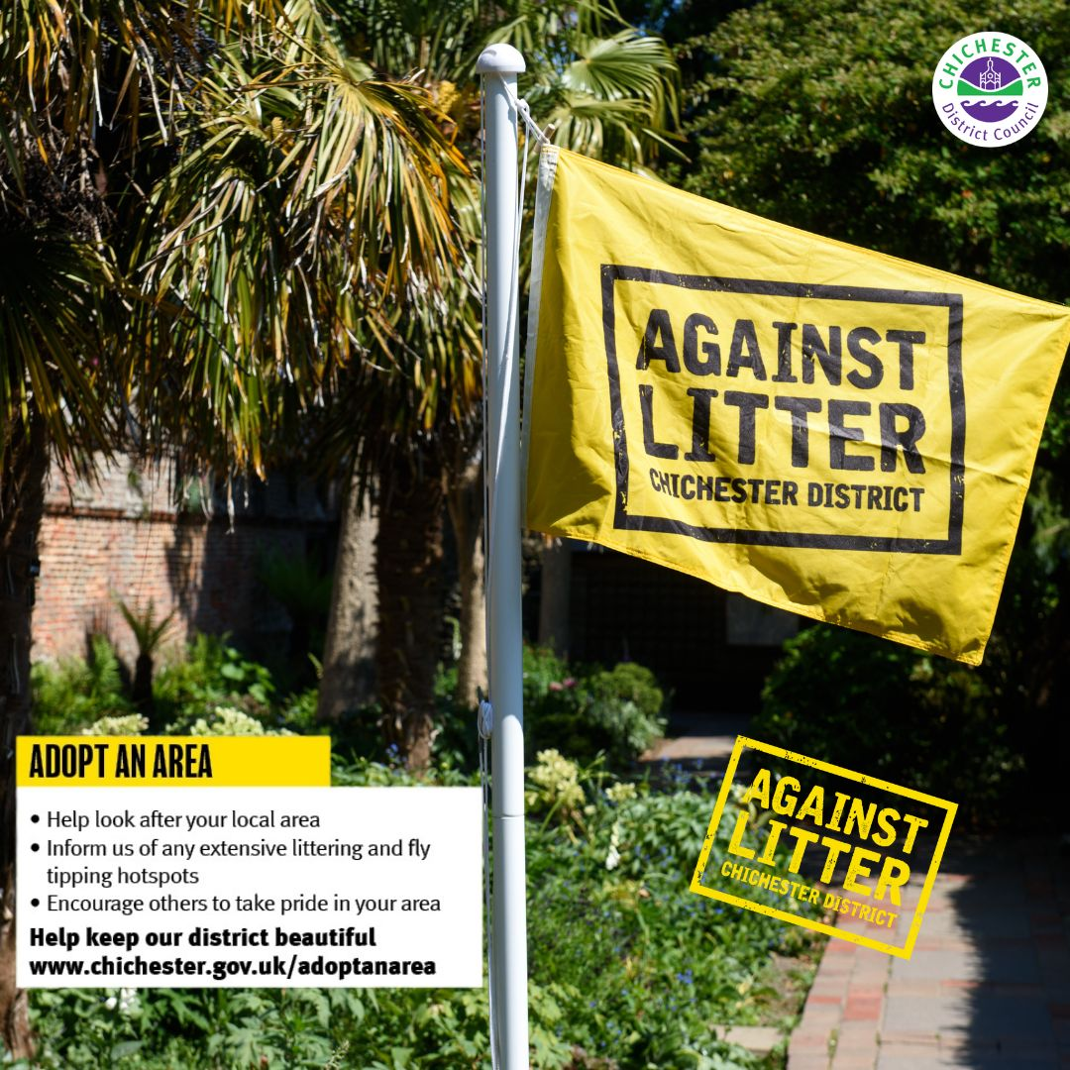

Good morning
I hope you are well. I am reaching out to let you know that the council have relaunched our award-winning Against Litter campaign. With the warmer weather here, and people enjoying our green spaces, countryside, and beaches, we thought this would be a perfect time to reintroduce some key messages to the public.
Firstly, we want to remind residents and visitors to either take their rubbish home with them or dispose of it in one of our many public bins, and encourage others to do the same. We have over 300 square miles to look after, but we can’t do it alone, so we are asking everyone to play their part.
We are also reminding residents of our Adopt an Area scheme, where individuals and groups can pledge to look after a particular area of the district by undertaking litter picking on a regular basis. If anyone is interested in signing up to the scheme, where they will receive an Adopt an Area pack which contains tips on how to plan a clean-up activity and details of how we can support them, they can visit our webpage: https://www.chichester.gov.uk/adoptanarea

Similarly, they can sign up to our Green Dog Walking Scheme, where individuals can pledge to be a responsible dog owner, and be a friendly reminder to other dog walkers to clean up after their dogs too: https://www.chichester.gov.uk/greendogwalkers
Lastly, if any residents are having a clear out, we want to remind them to ensure that their waste is disposed of responsibly. They must always use a licenced waste carrier, and check their waste carrier number with the Environment Agency to make sure that they are registered. Individuals could face a fine if their rubbish is fly tipped and they didn’t use a licenced service provider: https://www.chichester.gov.uk/flytipping
We have already issued a District Dispatch about the relaunch, and there are a number of other ways we are sharing news of the campaign this summer – including via social media, sharing assets with key partners, media releases, and exploring potential case studies to showcase best practice. We also have an article about Against Litter in our summer issue of initiatives, which has recently been distributed to households in the district.
We wanted to share with you these key messages, so that you are able to pass them on as much as you can. Please do support our Against Litter posts etc. that we release over the next few months as well where you can, to help as many people as possible receive this messaging and hopefully take action.
I attach some digital assets for you to share / distribute, where appropriate. These include:
- Two social media assets, to suit most social media platforms.
- An Against Litter poster, with a focus on Adopt an Area. These are in A4 and A3 format.
If you would like printed versions of any materials, just let us know.
We thank you for your support.

Kind regards,
Lotty

 | Lotty Mansfield  Graduate Trainee - National Graduate Development Scheme  Communications  Chichester District Council

Tel: 01243 534776 | lmansfield@chichester.gov.uk | https://www.chichester.gov.uk
East Pallant House opening hours: 9am-4pm Monday to Friday

________________________________________________________________________

