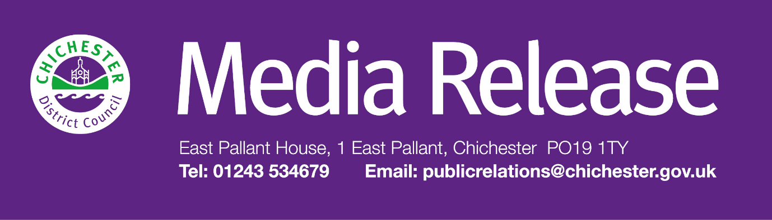

**Date of Release:**  7 May 2025**Ref:** 4467

**The Novium Museum awarded grant from The National Lottery Heritage Fund to celebrate women’s history in Chichester District**

A psychoanalyst who fled Nazi Germany, a suffragist fighting for women rights and an award-winning author will be just a few of the of the fascinating individuals to be included in a major women’s history exhibition being planned by The Novium Museum thanks to a grant from the National Lottery Heritage Fund.

The grant of £117,266 will help the museum deliver ‘ChichestHER: Their Story, Our Inspiration’ – a key two-year project that will shine a light on the lives, work, and achievements of women, past and present, across Chichester District.

The ‘ChichestHER’ project will include a headline exhibition, a new interactive website, and a series of community-led initiatives. It will celebrate local female pioneers and begin to redress the historical imbalance that has so often seen women’s contributions overlooked or underrepresented in local heritage, providing a platform for the voices and experiences of local women.

The project will explore the impact women have made to life in Chichester District – from suffrage and education to art, medicine, politics, and beyond. It will research, collect and share their stories, highlight and address gaps in the museum’s collections, and encourage the public to contribute their own research and memories to ensure a fuller, more inclusive record of the past.

**ChichestHER** will feature:

* A **major exhibition** at The Novium Museum, due to open in October 2026, celebrating the impact of local women, shaped by community-led research, oral histories, and creative workshops.
* A **new interactive website** where the public can submit stories, photographs, and research about local women – creating a digital archive accessible to all and representing the whole of the district.
* A **contemporary collecting initiative**, encouraging donations of everyday objects that tell local women’s stories and enriching the museum’s representation of female lives.
* A programme of **volunteer involvement**, from digitising items from the museum’s collection to supporting research and engagement.

Among those to be featured in the resulting exhibition will be remarkable psychoanalyst **Kate Friedlander (1902–1949)** who fled Nazi Germany in 1933. One of very few women in her field during the Second World War, Friedlander worked in Chichester and helped to establish and lead the West Sussex County Council Child Guidance Clinic in 1945. Her influential publication ‘The Psycho-Analytical Approach to Juvenile Delinquency’ was ahead of its time, yet today her name and achievements remain virtually absent from the historical record. This project will help to uncover, preserve, and share stories like hers – those that deserve far greater recognition.

The project aims not only to fill gaps in the historical record but also to inspire future generations by making the achievements of women visible, valued and remembered.

Councillor John Cross, Cabinet Member for Culture, Sport and Place at Chichester District Council, says: “We are thrilled to have received this support from The National Lottery Heritage Fund. Thanks to National Lottery players, ‘ChichestHER’ will provide a long-overdue opportunity to recognise the incredible women who have helped shape our district.

“This project is not only about celebrating the women of our past – it’s also about inspiring the women and girls of our future. By uncovering stories that have so often been overlooked, we can build a fuller, more inclusive picture of our local heritage – one in which these achievements are remembered, valued, and preserved for generations to come.”

The project will also include a dynamic programme of community events, including talks by inspirational women, family activities, tactile tours, and 'Makers Mornings' led by local women to share their skills, creativity, and expertise.

For more information, or to get involved in the project, contact [**thenovium@chichester.gov.uk**](mailto:thenovium@chichester.gov.uk) or call **01243 775888**.

More information will be available online soon at: [**www.thenovium.org/chichesther**](http://www.thenovium.org/chichesther)

**For further information, please contact Clare Hawkin, Senior Communications Officer on 01243 534679 or by emailing** [**chawkin@chichester.gov.uk**](mailto:chawkin@chichester.gov.uk)