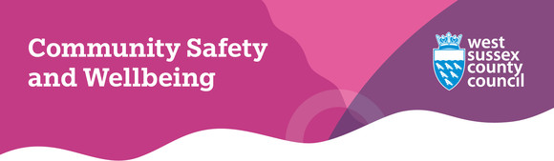
Welcome to our May 2025 eNewsletter
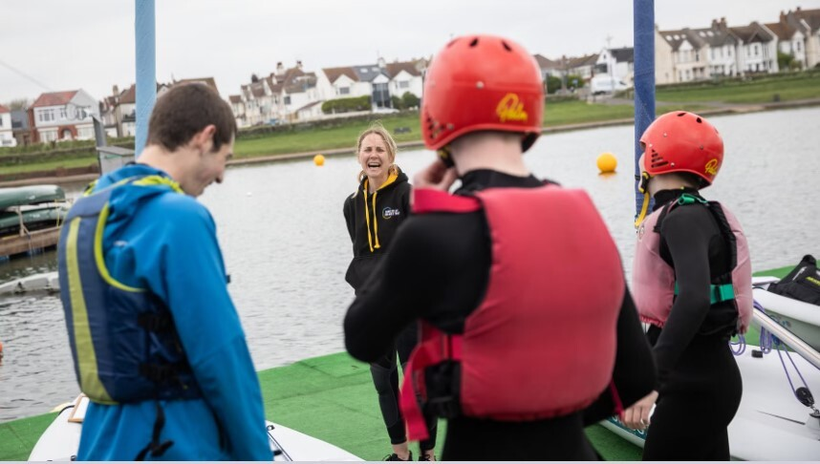
UK’s top former athletes mentor West Sussex youngsters to tackle antisocial behaviour
We have just finished a great project with Govia Thameslink Railway to fund a mentoring scheme arranged by the Dame Kelly Holmes Trust.
The 11-week programme was delivered in partnership with West Sussex Alternative Provision College and supported 58 young people who were considered at risk of getting involved in antisocial behaviour in their local communities, in particular along the Southern West Coast rail route.
By working with their Olympic athlete mentors, Liz Johnson, Hannah Beharry and Sarah Ayton, the young people accessed new opportunities and developed their confidence and skills to choose a more positive path in life.
You can read the full story by clicking the blue button below.
Read the full story on the Govia Thameslink Railway website


How safe do you feel at your local train station?
Talking of safe train travel, we’ve been working with the national charity Railway Children over the last year to consider community safety in and around train stations across the South Coast.
This has included meeting and surveying hundreds of passengers, rail staff and local businesses, to find out what communities think and feel about rail travel and our local stations.
Due to its success, we have now secured additional funding to continue this work in the north of the county during Community Rail Week (Monday 19 - Friday 23 May).
Over the week we will be visiting six stations across Crawley, Horsham and Mid Sussex alongside partners from a range of agencies to find out what commuters, both young and old, think we can do to help improve safety and travel on the rail network.
We'll tell you more about the visits in June's newsletter, and you can find out more about the range of activity taking place during Community Rail Week on their website.
Community Rail Week activities


Photo by Ahmad Pishnamazi on Unsplash
Domestic abuse and mental health – reaching out can save lives
The mental health impact of domestic abuse is profound and far-reaching and a recent report compiled by the Vulnerability Knowledge & Practice Programme highlights the link between domestic abuse and the risk of suicide.
We often forget that during and after living through an abusive relationship victim-survivors can and will experience trauma, anxiety, depression, and suicidal thoughts, meaning domestic abuse is not just a crime—it’s also a public health issue.
The effects are invisible, but they are real. No one should suffer in silence and whether you’re experiencing abuse or concerned about someone else, help is available and early support can save lives.
If you or someone you know is struggling, visit our Domestic and Sexual Violence and Abuse website for more information - you are not alone.
WORTH services | How to access help

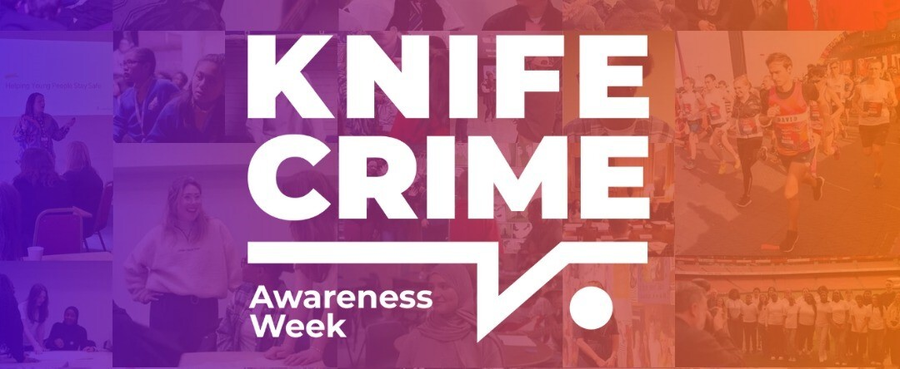
Help make a difference during Knife Crime Awareness Week
Knife Crime Awareness Week is taking place next week (Monday 19 - Sunday 25 May) and is a biannual event organised by the Ben Kinsella Trust.
While West Sussex remains a relatively safe area, knife crime is a growing concern across the UK and as a county we must stay vigilant and proactive in protecting our communities.
Working in partnership with Sussex Police, district and borough councils and the Ben Kinsella Trust, we want to highlight our commitment to prevention, education and early intervention. We also want to raise awareness, support victims and steer young people away from violence.
During the week (and beyond) we are asking residents to help by:
- asking young people to anonymously report any concerns related to knife crime via the Fearless website (click on the blue button for more details).
- supporting local anti-knife crime initiatives.
- educating young people about the risks of knife crime.
Together, we can make a difference.
Fearless | Give information anonymously


How going digital can save you money
AbilityNet invites individuals to a free webinar exploring how going digital can help save money.
The session will focus on practical ways to cut costs by using online tools and services, with expert guidance on accessing pensioner benefits and financial information from the Department for Work and Pensions (DWP).
Aimed at older adults and those facing common challenges, the webinar will highlight online savings tips, benefit calculators, Pension Credit, and trusted digital resources.
The webinar takes place next Tuesday (20 May) from 1pm to 1.45pm and individuals can sign up for a free place on the AbilityNet website.
Book your free space on the AbilityNet webinar

Free online safety sessions for parents and carers
If you didn't catch it last month, South East Cyber, a regional Police Cyber Crime Unit, are running free online safety sessions for parents and carers to help keep their children (and themselves) safe when using the internet - wherever they are.
Designed to be accessible and not needlessly technical, the session covers key topics, including:
- Emails and mobile phones: The art of spotting a scam with lots of hints and tips to share with your children around phishing and other fraud types.
- Social media safety: The risks around social engineering, disinformation, AI, privacy and hacked accounts.
- Gaming: Understanding what the risks are to young people when gaming, particularly online, and discover ways to monitor and restrict usage.
- Password mastery and Two-Factor Authentication (2FA): Helping you and your family to secure your accounts following best practice.
For more information and to book a place, visit the South East Cyber Crime Unit Eventbrite page.
Book your free space for online safety training

West Sussex Mind: Self-Harm Learning Network
The Self-Harm Learning Network, which is part of the Sussex Health and Care Partnership Integrated Care System's suicide prevention work, is back for 2025-26 and is running free workshops for parents and carers on the following subjects:
Self-harm online safety training
- Wednesday 1 October 2025 - 9.30am to 12.30pm.
- Wednesday 30 April 2026 - 9.30am to 12.30pm.
Self-harm and neurodiversity/Autism Spectrum Disorder (ASD)
- Monday 7 July 2025 - 9.45am to 12.15pm.
- Monday 8 December 2025 - 9.45am to 12.15pm.
Self-harm, eating disorders and body dysmorphia
- Wednesday 12 November 2025 - 9am - 12pm.
- Monday 11 May 2026 - 1pm - 4pm.
You can find out more on the topics, and how to book your free place, on their flyer.
Flyer for Self-Harm Learning Network courses


Are you worried someone close to you is expressing extreme views or hatred which could lead to them harming themselves or others?
ACT Early, the Counter-Terrorism Policing webpages, give advice and guidance to the public on spotting the signs of potential radicalisation and where to turn if you are concerned for a friend or family member.
ACT Early | Prevent radicalisation

While many people use alcohol to unwind, even just one or two drinks a day is associated with an increased risk of depression and anxiety.
During this Mental Health Awareness Week (12 to 18 May), our Public Health colleagues are asking you to take a moment to find out if your drinking might affect your wellbeing or if you’d benefit from accessing support by clicking on the 'Call the shots' button below.
For mental health support and advice, visit Sussex Partnership NHS Foundation Trust's How Are You Really Feeling? resource.
Call the shots on alcohol



