I am pleased to inform you the public consultation on the emerging new Management Plan has commenced.

[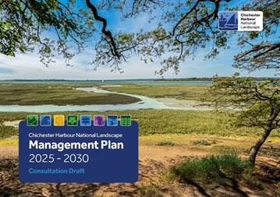](https://www.conservancy.co.uk/about-chichester-harbour-conservancy/our-purpose/management-plan/)

You can now download the draft Plan, in PDF format, from this link:

<https://www.conservancy.co.uk/about-chichester-harbour-conservancy/our-purpose/management-plan/>

We are inviting comments back through an online questionnaire:

<https://www.surveymonkey.com/r/chichesterharbour>

The deadline for responding is **30 June 2025 (23:55)**. I will be notifying a range of partners the consultation has started.

Please use the feedback form for any comments that you may have, so they will be properly captured for consideration.

If you have any questions with regards to this process, please do not hesitate to reply.

With thanks, Richard

Richard Austin BSc M.A. PhD

**National Landscape Director**

01243 510982 / 07918074165

