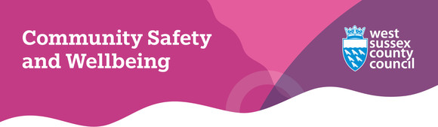
Welcome to our April 2025 eNewsletter

Help represent residents with low digital skills and confidence
West Sussex County Council's Digital Strategy sets out a clear vision for the use of technology to create a more connected and inclusive future for West Sussex residents and communities.
As part of this, the Digital Inclusion, Access and Safety (DIAS) Partnership is working to make the digital world more accessible for residents, including creating a testing panel to review the council's digital products and ensure they work well for everyone - especially those who may lack digital skills or the confidence to use technology.
If you feel you have low digital confidence or skills and would like to join the panel, please email communitysafety.wellbeing@westsussex.gov.uk or telephone 01243 777100.
Find out more about the DIAS Partnership

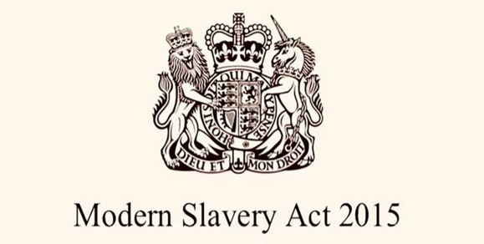
2025 marks 10 years of the Modern Slavery Act
The Modern Slavery Act 2015 came into effect 10 years ago and was designed to give law enforcement the tools to fight modern slavery, make it easier to prosecute offenders and ensure support and protection for victims.
A decade on, West Sussex County Council is committed to doing everything in its power to make sure our county is free of modern slavery and to mark this year’s anniversary, we are asking our residents to take a few minutes to find out more about modern slavery on the Unseen website, including how to spot the signs and how to report potential victims.
Unseen | Spot the signs of modern slavery

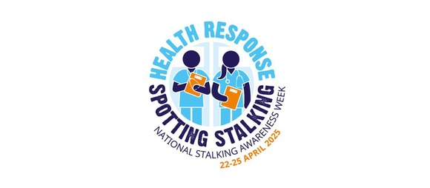
National Stalking Awareness Week 2025
Taking place between 22 April and 25 April, National Stalking Awareness Week is an annual event dedicated to raising awareness about stalking and its impact on victims.
The latest data from the Office for National Statistics shows that one in five women and around 1 in 11 men aged 16 years and over has been a victim of stalking.
Stalking can take many forms and has a devastating and long-lasting impact on people’s lives.
If you or someone you know is experiencing fixated, obsessive, unwanted or repeated contact from anyone, this is stalking and you can report it to the police.
In Sussex, there's also a stalking advocacy service called Veritas Justice who provide support to stalking victims.
Veritas Justice | Stalking advocacy service


Countering the threat of Self-Initiated Terrorist incidents
Currently, the threat from Self-Initiated Terrorism (SIT) remains high throughout the country following periods of political and civil unrest.
In the UK, a self-initiated terrorist is defined as an individual who threatens or engages in violence without material support or direct guidance from a terrorist organisation, such as the 2016 murder of Labour MP Jo Cox, the Finsbury Park Mosque attack in 2017 and the Fishmongers’ Hall attack in 2019.
SIT is often committed by vulnerable individuals and the people closest to them may have worries about certain behaviours long before anything happens, such as family members, friends or even co-workers.
By trusting your instincts and contacting the police to address your concerns, you may be able to stop these acts of extreme violence.
To find out more, Protect UK has produced some guidance in line with UK Government and Counter-Terrorism Policing guidelines.
Protect UK | Advice on Self-Initiated Terrorists

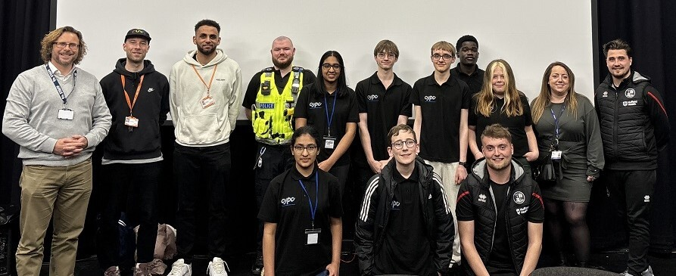
Staying safe online is a hot topic for young people in Crawley
Recently, our Digital Safety and Fraud Prevention team worked with members of the Crawley Young Person’s Council (CYPC) to provide data, information and moral support for a presentation about online safety for young people.
The presentation was one of several being delivered to year 9 and 10 students from schools across Crawley at the CYPC's youth question time event.
As online safety is a broad subject, the group's 45-minute presentation was broken down into three separate themes - sextortion, online gaming, and generative AI.
These topics were designed to raise awareness and provide the students with tips and advice on what to look out for when using the internet. The presentation resulted in students asking several questions in the panel discussion at the end of the day.
If you want to find out more about keeping children and young people safe from online harms, visit our dedicated staying safe online and fraud prevention page.
Keeping children and young people safe online


The Digital Dilemma: keeping children safe online
Run by South East Cyber, a regional Police Cyber Crime Unit, these free Digital Dilemma webinars give information and advice to parents and carers regarding theirs and their family's online behaviours and internet-enabled device usage.
Designed to be accessible and not needlessly technical, the sessions focus on emails and mobile phones, social media, gaming, how to secure your online accounts, Cyber Choices and useful resources so you have the tools to go away and improve your children's online safety and security - and yours too!
There are dates available in May and June and tickets can be booked through the Eventbrite website.
Book your free ticket now


West Sussex County Council is supporting a major NHS England breast screening campaign which aims to detect thousands of cancers earlier by highlighting the benefits of screening and encouraging more people to make the most of regular mammograms.
Find out more about the campaign

The West Sussex Health and Wellbeing Board is seeking residents’ views on its draft five-year strategy (2025 to 2030), which sets out the overarching plan for improving health and wellbeing and reducing inequalities across the county. A public consultation on the draft strategy is now open until 11.55pm on Sunday 27 April 2025.
Have your say on the five-year strategy



