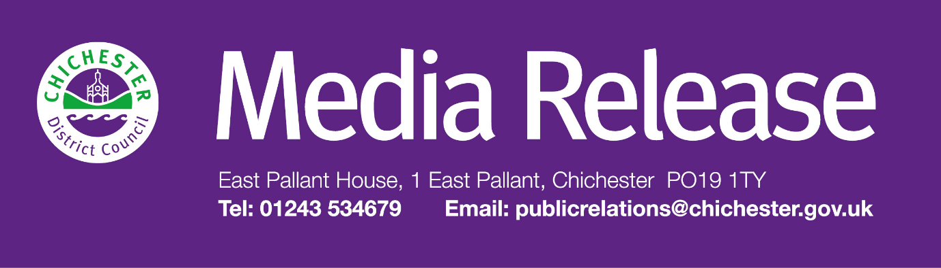

**Date of Release:**  31 March 2025**Ref:** 4456

**Families can help shape history at an upcoming Shippam’s Family Focus Group**

The Novium Museum is inviting local families to take part in a unique opportunity to help shape its upcoming headline exhibition about Shippam’s, one of Chichester’s most iconic brands.

A Shippam’s Family Focus Group will take place at The Novium Museum in Chichester on **Wednesday 16 April** at 2pm, offering families with children aged 5 to 11 the chance to hear about interactive displays, share ideas, and help ensure the upcoming exhibition is engaging for young visitors. Places are free but must be booked in advance through the museum’s website.

The focus group is part of a major project made possible by a £44,593 grant from Arts Council England, which explores Shippam’s rich history through digitisation, oral histories, and a headline exhibition opening in July 2025.

Founded in 1786, Shippam’s was not only a leading name in food production but also a cornerstone of Chichester’s community, employing generations of local families. The exhibition will showcase personal stories, memories, and the lasting impact of the company on the district.

Councillor John Cross, Cabinet Member for Culture, Sport and Place at Chichester District Council, says: “The Shippam’s Family Focus Group is a fantastic opportunity for local families to get involved in shaping this exciting exhibition. By taking part, children will play an active role in helping to create engaging and interactive displays, making history come alive for future visitors. It’s a great way to be part of something special that will leave a lasting impact.”

In addition to the focus group, The Novium Museum has a packed programme of family-friendly activities this Easter. From **Friday 4 April to Saturday 19 April**, visitors can take part in the ‘80s Cel-egg-brity Easter Egg Hunt — a nostalgic trail with an iconic 80s twist. Trail sheets cost £1.50, with an Easter prize for those who complete the challenge.

Creative workshops include ‘Make an Easter Train’ on **Wednesday 9 April**, where children can design and decorate a colourful train to take home (£7 per child). Families travelling by train can take part for free, thanks to Railway 200 funding — simply book as normal and show a valid train ticket on the day for a refund. On **Wednesday 16 April**, the ‘Make Your Own Pride Flag’ workshop (£3 per child) invites children to learn about LGBTQ+ Pride flags before designing their own.

For more information and to book, visit: [**http://www.thenovium.org/whatson**](http://www.thenovium.org/whatson)

**For further information, please contact Terri Foster, Senior Communications Officer on 01243 534537 or by emailing [tfoster@chichester.gov.uk](mailto:tfoster@chichester.gov.uk)**

|  |  |
| --- | --- |
|  | **Terri Foster** Senior Communications Officer Communications Chichester District Council |

|  |  |
| --- | --- |
| Ext: 21226 | Tel: 01243521226 | [tfoster@chichester.gov.uk](mailto:tfoster@chichester.gov.uk) | <https://www.chichester.gov.uk> | |
| East Pallant House opening hours: 9am-4pm Monday to Friday | |
|  |  |

[](https://www.chichester.gov.uk/emailbanner)