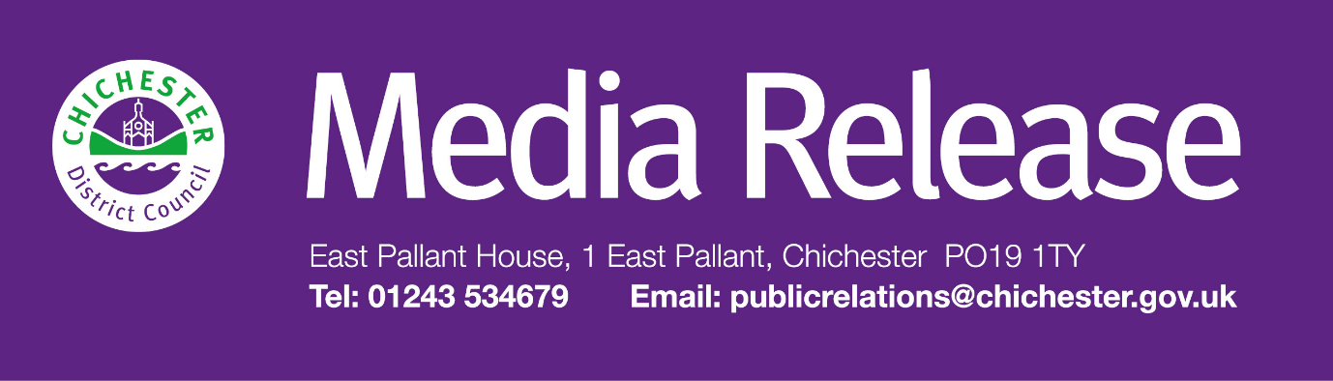

**Date of Release: 1 April 2025                                                        Ref: 4457**

**Residents in Chichester District can take advantage of spring offer for council’s Bulky Bag Service**

As spring fast approaches, Chichester District Council is reminding residents about its Bulky Bag service, which is ideal for house clearances or clearing large volumes garden waste.

The service offers three convenient sizes of bags, which can be delivered straight to their address, or collected directly from the Chichester Contract Services (CCS) depot at Westhampnett when the order is made.

With prices starting from £150, customers can choose from three different bag sizes; Medium, Large, and Mega. The Medium bag can hold up to 1 tonne of non-hazardous waste, suitable for everyday DIY waste.  For those undertaking bigger projects the Large or Mega bags are ideal and can take up to 1.5 tonnes. Residents can use the discount code SPRING15 when placing their order in April and May to receive 15% off.

“As the nicer weather arrives, more of us will be out doing work in the garden or making time to spring-clean around our homes, so this is a perfect time to remind residents that our Bulky Bag service provides a straightforward, cost-effective way to get rid of bulky household or garden waste,” says Councillor Mark Chilton, Cabinet Member for Finance, Corporate Services and Chichester Contract Services at Chichester District Council.

“The service is easy to use and with three sizes of bag available to purchase from, it’s suitable for clearing after DIY or garden projects, big or small, or for clearing out household waste. The service is also available to businesses too.

“At the moment, the service is only available in certain areas of the district, so it is important that residents check that operate in their postcode area when booking the service online.  This is easy to do with our postcode look-up!

“We are also running a special Spring discount offer until the end of May 2025. Simply order your bag online at [www.chichester.gov.uk/bulkybag](http://www.chichester.gov.uk/bulkybag) and use the code SPRING15 to get 15% off (terms and conditions apply, see website for full details).”

Once the order is completed and paid online, the bag will be delivered to the chosen address within five working days.

The bags are made from durable recycled plastic and provide an ideal solution to dispose of heavy and bulky waste. However, the bags cannot be used to dispose of hazardous or specialist waste, such as asbestos, batteries, food waste, or items such as mattresses and fridges or freezers. Examples of what cannot be accepted in the bags can be found in a helpful list on our Bulky Bag page, in the Frequently Asked Questions section: [**www.chichester.gov.uk/bulkybag**](http://www.chichester.gov.uk/bulkybag)

Once the bag is filled and ready for collection, people can request their collection online with their customer reference number, and collection will be made within 10 working days of the request.

For smaller volumes of waste, we also have a range of other services that can help which includes our large item collection service [www.chichester.gov.uk/bulkywaste](http://www.chichester.gov.uk/bulkywaste) and our Garden Recycling Service [www.chichester.gov.uk/gardenwaste](http://www.chichester.gov.uk/gardenwaste)

Alternatively, if you are clearing out any unwanted or damaged clothing, textiles or small electricals, you can make use of our bookable collection service and we will recycle these for you.  It's free to use and bookings can be made easy online – simply visit  [www.chichester.gov.uk/textileandelectricalrecycling](http://www.chichester.gov.uk/textileandelectricalrecycling)

For more information about the Bulky Bag service, people can visit [**www.chichester.gov.uk/bulkybag**](http://www.chichester.gov.uk/bulkybag)

For the latest issue of Initiatives magazine, people can visit **www.chichester.gov.uk/initiativesmagazine**

**For further information, please contact Thomas Carr, Communications Assistant at Chichester District Council on 01243 521297**

|  |  |
| --- | --- |
|  | **Thomas Carr** Communications Assistant Growth and Place Chichester District Council |

|  |  |
| --- | --- |
| Tel: | [tcarr@chichester.gov.uk](mailto:tcarr@chichester.gov.uk) | <https://www.chichester.gov.uk> | |
| East Pallant House opening hours: 9am-4pm Monday to Friday | |
|  |  |

[](https://www.chichester.gov.uk/emailbanner)