**news release**

**24 March 2025**

**Have your say on health and wellbeing in West Sussex**

[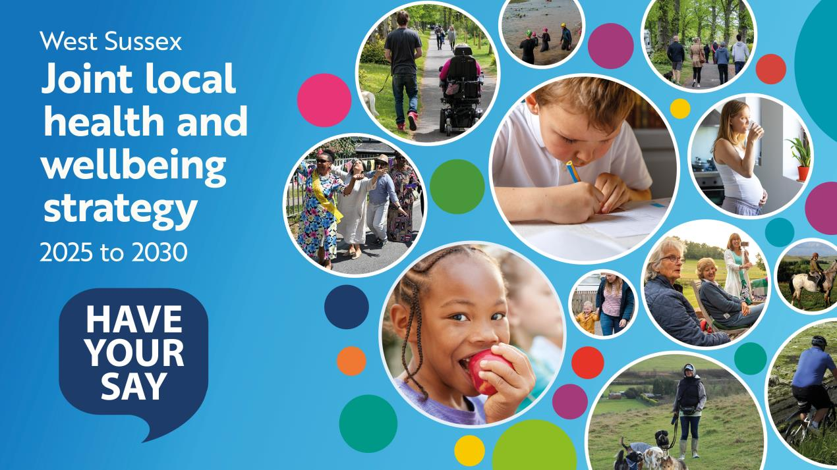](https://dmscdn.vuelio.co.uk/publicitem/ed82e71f-b331-4547-ae69-b3bcd901ecf9)

The West Sussex Health and Wellbeing Board is seeking residents’ views on its draft five-year strategy (2025 to 2030), which sets out the overarching plan for improving health and wellbeing and reducing inequalities across the county.

The draft strategy uses the latest evidence to identify the challenges and needs of people and communities in West Sussex and presents the board’s vision and five priority areas:

* Food and nutrition
* School readiness
* Transitioning to adulthood – children and young people’s mental health and wellbeing
* Tobacco control
* Health and wellbeing in temporary accommodation

A public consultation on the draft strategy is now open until 11.55pm on Sunday 27 April 2025.

Everyone in West Sussex, including young people, professionals, and local organisations, is invited to take part at the following link:

[Draft Joint Local Health and Wellbeing Strategy 2025 - 2030 | Your Voice West Sussex](https://yourvoice.westsussex.gov.uk/jlhws)

Those who would prefer to complete a paper copy of the survey can visit their local library where copies are available. The survey is also available to download and print and can be returned to any West Sussex library. [Find your local library on our website](https://www.westsussex.gov.uk/find-my-nearest/library/).

**Commitment to improving health and wellbeing and reducing inequalities**

Councillor Bob Lanzer, West Sussex County Council Cabinet Member for Public Health and Wellbeing, and Chairman of the West Sussex Health and Wellbeing Board, said: “I really encourage all our residents, including young people, our partners and local organisations, to complete this short survey and have their say on the five priority areas, including their thoughts and suggestions on how they may be delivered.

“The five priority areas identified reflect some of the wider factors that impact our health, such as our homes and the food we eat. By focusing on them collectively, the board feel these are the areas they can have the most impact and make a real difference to people’s lives.

“The county council has a strong commitment to improving the health of our communities, reducing inequalities, and helping people to fulfil their potential, as outlined in Our Council Plan.”

**About the West Sussex Health and Wellbeing Board**

The [West Sussex Health and Wellbeing Board](https://www.westsussex.gov.uk/about-the-council/how-the-council-works/committees-and-decision-making/joint-arrangements/west-sussex-health-and-wellbeing-board/) is chaired by the county council’s Cabinet Member for Public Health and Wellbeing. Members of the Health and Wellbeing Board include representatives from across the health and care system, including the county council, NHS Sussex, NHS service providers, district and borough councils, Voluntary, Community and Social Enterprises (VCSEs), for example, a charity, and Healthwatch West Sussex.

Health and Wellbeing Boards are a statutory committee of local authorities in England, and provide a forum where political, professional, clinical and community leaders from across the local health and care system come together to improve the health and wellbeing of their local population and reduce health inequalities.

With integration and partnership at the heart of their work, Health and Wellbeing Boards provide a strong focus on place (for example, West Sussex), facilitate joint working and improving the wellbeing of their local population, and set strategic direction to improve health and wellbeing. They have a statutory role to plan how best to meet the health and wellbeing needs of their local population and tackle health inequalities.

Their responsibilities include assessing the health and wellbeing needs of their residents through carrying out a Joint Strategic Needs Assessment (JSNA), which assesses current and future health and social care needs of the local population and developing a Joint Local Health and Wellbeing Strategy (JLHWS) to meet the health and wellbeing needs identified in the JSNA.

**For further information please contact the news desk on 0330 222 8090 or email** [**pressoffice@westsussex.gov.uk**](mailto:pressoffice@westsussex.gov.uk)**.   
  
For urgent out-of-hours enquiries please call 07767 098415.**   
  
[](https://www.facebook.com/WestSussexCC/)  [](https://twitter.com/WSCCNews)