District Dispatch
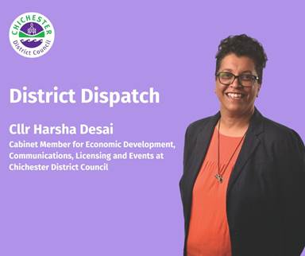
Following the success of our laser light shows back in February half-term, I’m pleased to tell you that we have two more exciting events coming up this month for you to enjoy.

This starts with our popular Cross, Market & More event in Chichester city centre on Sunday 16 March between 10am and 4pm. We’ve been running this popular event since 2021, which offers an innovative and quality market. Showcasing local artisan creatives, designers, and makers, with delicious street food and drink through the day, visitors will be able to browse a variety of products — from textiles and jewellery to homemade prints, arts and crafts, and much more. We will also be welcoming the Fishbourne Mill Morris Dancers, who will be performing on the day, along with other local musicians. These markets showcase the wealth of talented creatives that we are so lucky to have on our doorstep. We introduced this event in response to increased demand from residents for more varied markets to support the high street, and it has certainly delivered.

I’m also pleased to tell you about a brand-new event that we are launching in partnership with the Goodwood Estate on Saturday 29 March. The event is called the ‘Good Food For All Feastival,’ and will take place between 10am and 6pm in Chichester city centre, with food demonstrations taking place between 11am and 4pm. The event aims to inspire and show people how to eat healthy, satisfying meals on a budget.

It will feature a series of short demonstrations, presentations and talks from local chefs, including Jameson Stocks, an internationally renowned, Michelin-starred, celebrity chef who has multiple restaurants around the world and lives in the Chichester District. He also runs Just Street Food at The Ghost at the Feast in North Street, Chichester. In addition, there will be a variety of local food producers, nutritionists on hand for information and advice. Representatives from locally based UK Harvest, which works to reduce food waste and increase access to nutritious food for less, will also be attending.

Members of the public will be able to watch local food experts, including chefs from the Goodwood Estate, cook up a range of culinary delights and hear advice on how to use local ingredients. Goodwood will also have some of their delicious farm shop produce for people to taste.

This event has been designed to help people make the most of the amazing food and produce around us locally, and to give people ideas on how to use up the fruit and vegetables and other ingredients that always seem to get left behind in the fruit bowl or the fridge!

It’s about giving people the confidence to turn the food that they buy into the most delicious and nutritious meals, using some simple tips from local experts, and we’re really delighted that Goodwood Estate has come on board with us. This is a fun and inclusive event for everyone across the district, and there will be something of interest for everyone whatever their budget or taste. The idea is that you can come along and watch a ten-minute demo and come away with some fantastic ideas to try out in your own kitchen!

To find out what’s happening across the next number of months, you can visit our What’s On pages at: www.chichester.gov.uk/whatson; sign up to our monthly email newsletter: www.chichester.gov.uk/newalerts; and follow the council’s social media pages and it’s Events and Markets Facebook page at: www.facebook.com/ChichesterDistrictEventsAndMarkets

Finally, if you haven’t already, we would be grateful if you would participate in our short survey on proposed improvements to our Chichester play aarks at: https://letstalk.chichester.gov.uk/playareas by 31 March. Your feedback really matters to us — so thank you in advance!

Best Wishes

Cllr Harsha Desai
Cabinet Member for Economic Development, Licencing, Communications and Events at Chichester District Council

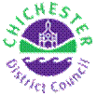 | Terri Foster  Senior Communications Officer  Communications  Chichester District Council

