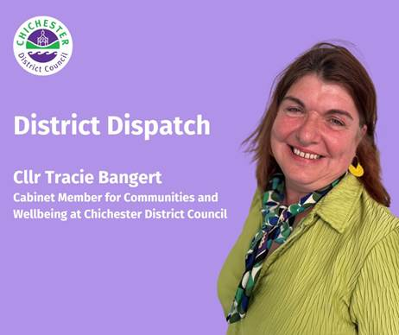
District Dispatch

I’m really proud to tell you that this year, our award-winning Community Wardens are celebrating their 20th anniversary.

Those who have come into contact with, or received support from, our Community Wardens will know what an amazing role they play within their local communities. They work in Chichester East and Whyke; Chichester West; Tangmere and Oving; Selsey and The Witterings.

They play a key role in bringing the community together, as well as dealing with environmental issues and working with the police to help reduce crime, anti-social behaviour and fear of crime. They also check in on elderly and vulnerable people — popping in for regular chats, dropping off prescriptions, and literally helping people through some very dark times. And the wardens are also seen as friendly authority figures to the young people in their community, offering both guidance and support. In the words of a local resident — ‘they are the face of the community.’ They are also there to signpost people to support services for a range of issues and even act as digital ambassadors, to help keep people safe online.

Over the years, the wardens have helped organise activities for young people; supported those who are struggling emotionally; and even worked with Selsey Care Shop to help protect some of the area’s most vulnerable residents. This involves conducting in-person welfare checks on vulnerable residents when volunteers are not able to contact them during their daily 'good morning' check-in calls. In some cases, they have found that a resident has fallen or is unable to reach the door and so, as a result, they came up with a simple and cost-effective idea to help improve people's safety and peace of mind — by encouraging residents to install special key safes. The wardens even managed to access funding to pay for 60 of them. You may have seen our recent campaign on scam awareness, which was led by one of our wardens. This is one of the many schemes and projects the team deliver — and every Christmas they even help organise a festive lunch for people in Oving who haven’t got anyone else to celebrate with.

Collectively, our Community Wardens operate seven days a week on a shift pattern. You can find out more about our Community Wardens and how to contact them at: www.chichester.gov.uk/communitywardens. If you live in one of the communities where they operate, please do say hello to them and find out how they are helping your community. They are very special people, and we are very proud of the work that they deliver.

I also want to let you know that to mark the fifth anniversary of the pandemic, a COVID-19 Day of Reflection will take place on 9 March across the UK to remember the pandemic and its impact on communities. People are invited to come together to remember and reflect on this unique period of our history as well as their own experiences. The pandemic had a huge impact on all of us. This provides us with an opportunity to remember the friends and loved ones that we lost, as well as the sacrifices that so many people made. It is also a time to pay tribute to the work of health and social care staff, frontline workers, researchers and all those who volunteered and showed acts and kindness during this unprecedented time.

There are lots of ways to take part, whether it’s organising or attending a community event, or remembering in your own way at home. It’s important that people take part in the way that is right for them. I know that in my area, St John’s Church in Southbourne is offering a space where people can go and remember those affected on Sunday 9 March between 11.30am until 1pm.

Best Wishes

Cllr Tracie Bangert
Cabinet Member for Communities and Wellbeing at Chichester

 | Terri Foster  Senior Communications Officer  Communications  Chichester District Council

Ext: 21226 | Tel: 01243521226 | tfoster@chichester.gov.uk | Fax: 01243776766 | https://www.chichester.gov.uk
East Pallant House opening hours: 9am-4pm Monday to Friday

