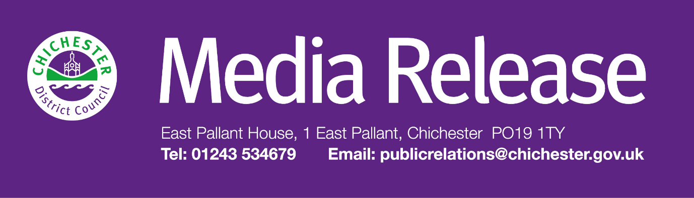

Date of Release: 27 February 2025                                                        Ref:   4445

**£5.58 council tax rise per year for the average taxpayer is agreed to protect vital services in Chichester District**

Chichester District councillors have agreed to increase the average council tax bill by £5.58 a year for a Band D property, in order to protect vital services across the district.

The decision was made at Chichester District Council’s Full Council meeting on 25 February 2025, where the 2.99% rise was agreed for 2025 to 2026. This means that the average Band D council taxpayer will pay £192.06 a year for the council’s 80 plus services. This amounts to around 52 pence a day.

Chichester District Council collects all the council tax, but only keeps around an 8% share of this. The other 92% is then distributed to West Sussex County Council (77%); The Sussex Police and Crime Commissioner (11%); and parish councils (4%). Each of these public service providers make decisions about its council tax increases independently.

Councillor Adrian Moss, Leader of Chichester District Council, and Cabinet Member for Regeneration and Property, says: “We always aim to keep council tax as low as we can, and we continue to be one of the lowest charging authorities in the area. Over the last few years, we have faced some serious challenges with issues including pressures from inflation, the cost-of-living crisis and current world events. Uncertainty will continue for the foreseeable future, but overall, I see this as an ambitious, community-focused and prudently funded budget – and I would like to stress that the council remains financially stable and well-resourced.

“We have a legal duty to deliver a balanced budget and once again we have delivered this without the need to use council reserves. In fact, we are adding to our reserves this year, while also investing in valuable projects and capital schemes.

“We take our financial management very seriously as a council. We continue to review our finances on a monthly basis, involving teams across the council in order to ensure our financial stability. Because of these proactive measures we’ve achieved a realistic budget which protects valuable community services, and which matches our priorities.

“We are pleased to continue funding our vital Supporting You service to assist those who are experiencing cost of living related issues. We’re also continuing to support discretionary housing payments for those who need our help the most.

“We’ll also be receiving just over £327,000 from the government as part of an extension to the UK Shared Prosperity Fund. We have committed to using £263,000 of this to continue projects that have already started, including Choose Work, the Culture Spark initiative, and supporting events and the night-time economy, which are all important in supporting our communities.

“Overall, I believe this is a really strong budget. We have a range of major projects that we are promoting, and we have a very sound base to take this council forward. This council remains financially stable, we are debt-free, and our financial resources are strong. Our aim is to improve our district and the lives of the people that live here.”

For more information, and to read a copy of this year’s budget, go to: [**www.chichester.gov.uk/budgetsspendingandperformance**](http://www.chichester.gov.uk/budgetsspendingandperformance)

Anyone in the district who is struggling is urged to contact the **Supporting You Team**, who can help people access a wide range of assistance including financial help to pay bills, help with housing, and health and wellbeing support.

In addition, the team can also signpost people to our other partner organisations when they feel this is appropriate, such as Arun and Chichester Citizens Advice, Arun and Chichester Food Partnership and the Community Hub. The team can be contacted by emailing [**supportingyou@chichester.gov.uk**](mailto:supportingyou@chichester.gov.uk) or calling **01243 534860**. Information is also available online at: [**www.chichester.gov.uk/supportingyoucampaign**](http://www.chichester.gov.uk/supportingyoucampaign)

Every day, Chichester District Council provides more than 80 different services. These range from emptying bins, checking food hygiene standards, cleaning the streets, looking after the coastline, caring for parks and open spaces, and providing support and reassurance to the vulnerable — to name just a few services.

**For further information, please contact Clare Hawkin, Senior Communications Officer on 01243 534537 or by emailing** [**chawkin@chichester.gov.uk**](mailto:chawkin@chichester.gov.uk)

|  |  |
| --- | --- |
|  | **Terri Foster** Senior Communications Officer Communications Chichester District Council |

|  |  |
| --- | --- |
| Ext: 21226 | Tel: 01243521226 | [tfoster@chichester.gov.uk](mailto:tfoster@chichester.gov.uk) | <https://www.chichester.gov.uk> | |
| East Pallant House opening hours: 9am-4pm Monday to Friday | |
|  |  |

[](https://www.chichester.gov.uk/emailbanner)