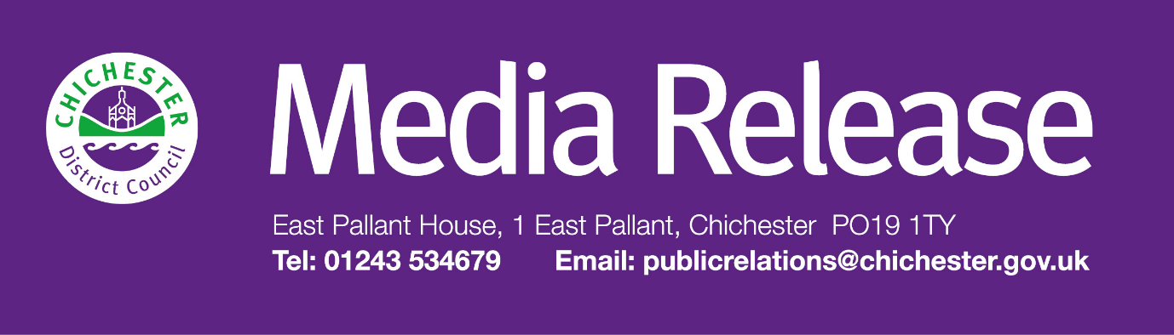  
  
Date of Release: 5 February 2025                                                 Ref: 4431

**Inclusive events celebrate LGBTQ+ History Month in Chichester**

The Novium Museum in Chichester is hosting a series of exciting events celebrating LGBTQ+ history, theatre and storytelling, as part of its new ‘Out & Proud in Chichester’ exhibition.

‘Out & Proud in Chichester’ is The Novium Museum’s new community exhibition, celebrating LGBTQ+ history and community. Developed in collaboration with Chichester Pride, the exhibition is free to visit and highlights local, national and international LGBTQ+ history, with a special focus on the experiences of Chichester’s LGBTQ+ community.

At the first event, families are invited to enjoy a fun-filled, inclusive storytelling show at The Guildhall, Priory Park, as ‘Drag Queen Story Hour’ comes to Chichester on Thursday 20 February 2025. Designed to encourage a love of reading while celebrating diversity, these interactive sessions provide a welcoming space for families to enjoy stories that explore themes of kindness, self-expression, and acceptance.

Led by award-winning author and performer Aida H Dee, Drag Queen Story Hour brings stories to life with lively performances, engaging characters, and plenty of laughter. Aida’s performances are a mix of storytelling and singalongs, packed with energy and excitement.

Councillor John Cross, Cabinet Member for Culture, Sport and Place at Chichester District Council, says: “Events like these provide a fantastic opportunity to bring our community together, celebrating inclusivity, creativity, and representation. I encourage everyone to come along and take part in what promises to be a fun and engaging experience for all ages.”

Sessions will take place at 11 am and 1pm and are suitable for all ages, with the stories aimed at children aged 3 and above. Tickets cost £6 per child, with accompanying adults £1. Chairs and cushions will be provided, but attendees are welcome to bring a blanket for extra comfort.

This event has been made possible with funding from the UK Government’s Shared Prosperity Fund.

In March, The Novium Museum will also welcome Helena Berry, Heritage and Archive Manager at Chichester Festival Theatre, for A Journey Through LGBTQ+ History at CFT and Beyond. Taking place on Thursday 6 March 2025, this insightful talk will explore the rich and often overlooked history of LGBTQ+ productions at Chichester Festival Theatre, tracing queer narratives through the theatre’s history, from groundbreaking productions to avant-garde performances.

This talk offers a fresh perspective on pride through the lens of performance. A Q&A session will follow, offering a chance to explore this fascinating subject further. The talk begins at 6pm at The Novium Museum. Tickets cost £5 per person, and booking is essential.

For more information and to book tickets for these events, visit: [**www.thenovium.org/whatson**](http://www.thenovium.org/whatson)

Both events are part of ‘Out & Proud in Chichester’, The Novium Museum’s new community exhibition celebrating LGBTQ+ history and community. Find out more at: [**www.thenovium.org/pride**](http://www.thenovium.org/pride).

**For further information, please contact Terri Foster, Senior Communications Officer, by emailing** [**tfoster@chichester.gov.uk**](mailto:tfoster@chichester.gov.uk)

|  |  |
| --- | --- |
|  | **Terri Foster** Senior Communications Officer Communications Chichester District Council |

|  |  |
| --- | --- |
| Ext: 21226 | Tel: 01243521226 | [tfoster@chichester.gov.uk](mailto:tfoster@chichester.gov.uk) | <https://www.chichester.gov.uk> | |
| East Pallant House opening hours: 9am-4pm Monday to Friday | |
|  |  |

[](https://www.chichester.gov.uk/emailbanner)