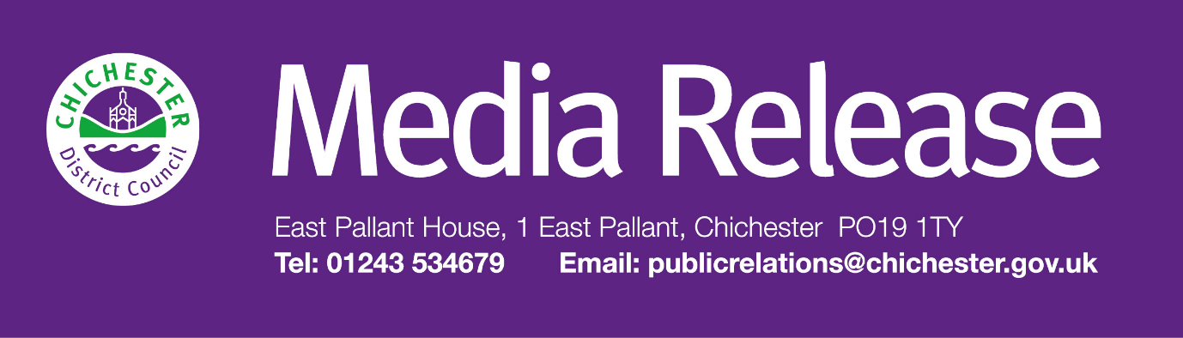

**Date of Release:** 2 December 2024                                                         **Ref:** 4412

**Celebrate the 1980s with a fun-filled exhibition open day at The Novium Museum**

Visitors are invited to rewind the clock and immerse themselves in the bold and colourful 1980s as The Novium Museum’s newest exhibition, ‘I Grew Up 80s’, launches this weekend in Chichester.

The exhibition opens with an exciting ‘A Celebration of the 80s’ event on **Saturday 7 December**, offering a day full of free, family-friendly activities to kick off the nostalgic journey.

Visitors to the opening day can take part in free activities, such as glitter face painting, a classic 1980s dance workout, and friendship bracelet making. They will also have the chance to meet some iconic 1980s characters before visiting the exhibition (normal exhibition admission fee applies).

‘I Grew Up 80s’ offers a vivid trip down memory lane, bringing the ‘greatest decade in the history of history’ to life. Featuring over 200 items of memorabilia, the exhibition captures childhood experiences of the 1980s, when music came on cassettes, shellsuits and leg warmers were must-haves, and Rubik’s Cubes were found under every Christmas tree.

From iconic toys like Care Bears, My Little Pony, and Transformers, to album covers of timeless musicians like Queen and George Michael, the exhibition is a celebration of the decade’s youthful exuberance. Visitors can also test their skills on a vintage Donkey Kong arcade game for just 50p per play!

Councillor John Cross, Cabinet Member for Culture, Sport and Place at Chichester District Council, says: "We’re thrilled to host this exciting exhibition at The Novium Museum. The opening day will be a fantastic celebration of the 1980s, and we hope people will dig out their shellsuits and join us for what promises to be a day of fun and nostalgia for the whole family!"

The ‘A Celebration of the 80s’ activities will run all day on **Saturday 7 December.** Booking is recommended for the 1980s dance workout: [**www.thenovium.org/whatson**](http://www.thenovium.org/whatson)**.** All other activities are drop in and are subject to availability.   
  
The 'I Grew Up 80s' exhibition opens at The Novium Museum on Saturday 7 December 2024 and runs until Saturday 8 June 2025. Tickets cost £5 for adults, £3 for children or £14 for a family of up to five (maximum 2 adults). For more information and to book your visit, head to: [**www.thenovium.org/1980s**](http://www.thenovium.org/1980s)

To tie in with the exhibition, Chichester District Council has organised an **80s themed silent disco** on **Thursday 12 December** in Priory Park’s Guildhall in Chichester, as part of a packed programme of Christmas events and activities. The silent disco will take place from 8.30pm until 10pm and tickets cost £7.50. Tickets for all of the Guildhall Christmas events can be booked online: [**www.chichester.gov.uk/festiveprioryparkevents**](http://www.chichester.gov.uk/festiveprioryparkevents)The following day (**Friday 13 December**), Dawn Gracie will be hosting a Retro 80s Bingo night at The Novium Museum. Dawn will take visitors through the timeless game with the addition of themed quizzes and games. Expect throwback 80s tunes and fun prizes! Tickets cost £16.50 per person, and advanced booking is essential: [**www.thenovium.org/whatson**](http://www.thenovium.org/whatson)

**For further information, please contact Terri Foster, Senior Communications Officer at Chichester District Council on 01243 521298 or** [**tfoster@chichester.gov.uk**](mailto:tfoster@chichester.gov.uk)

**About The Novium Museum**

Built over the remains of a Roman bath house, The Novium Museum is Chichester District's award-winning museum, located in the heart of the city centre. Their mission is to collect and preserve the heritage of the Chichester District. The museum uses its collections and external loans to maximise educational benefit and social impact for the community, helping people feel part of their society and shaping the local distinctiveness of the district.

The Novium Museum provides enriching, participatory and inspiring experiences for learning and enjoyment for the local community and visitors, contributing to a thriving economy.

|  |  |
| --- | --- |
|  | **Terri Foster** Senior Communications Officer Communications Chichester District Council |

|  |  |
| --- | --- |
| Ext: 21226 | Tel: 01243521226 | [tfoster@chichester.gov.uk](mailto:tfoster@chichester.gov.uk) | Fax: 01243776766 | <https://www.chichester.gov.uk> | |
| East Pallant House opening hours: 9am-4pm Monday to Friday | |
|  |  |

[](https://www.chichester.gov.uk/emailbanner)