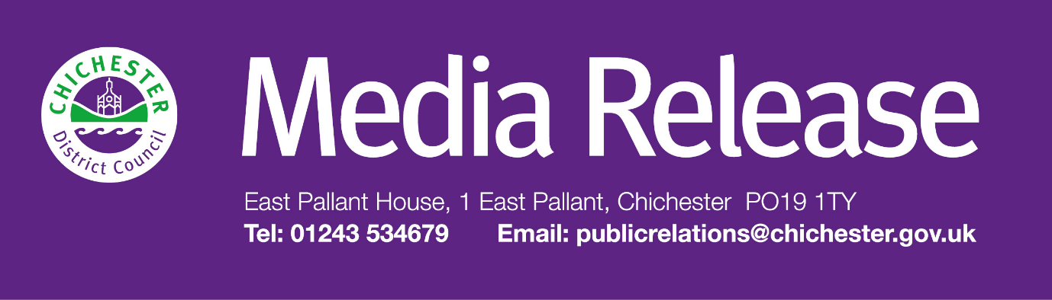 **Date of Release: 10 December 2024                                                        Ref: 4315**

**Scheme will continue to help Chichester District residents on low incomes pay their Council Tax**

A scheme which supports low-income residents across Chichester District to pay their council tax has been renewed.

The Council Tax Reduction Scheme will continue for 2025 – 2026. The scheme is a means tested benefit and does not take into account an individual’s outgoings.

Councillor Oona Hickson, Cabinet Member for Housing, Revenues and Benefits at Chichester District Council, says: “If you or someone you know is struggling to meet their council tax costs then I would really urge you to get in contact with us and consider making an application for Council Tax Reduction as it will make a huge difference to your household finances – you can apply for the benefit on our website at: [**https://www.chichester.gov.uk/applyforbenefit**](https://www.chichester.gov.uk/applyforbenefit)**.**

If a resident has claimed other benefits such as Universal Credit it is important for them to make an application for this support directly to Chichester District Council, as this will ensure that they do not miss out on support that they may be entitled to. People can find out more at [**www.chichester.gov.uk/myaccount**](http://www.chichester.gov.uk/myaccount)

In addition, the council runs a discretionary council tax reduction scheme which runs alongside the main scheme.

Cllr Hickson adds: “If people are struggling then the council’s dedicated Supporting You Team could help, they can be contacted by emailing [**supportingyou@chichester.gov.uk**](mailto:supportingyou@chichester.gov.uk) or calling **01243 534860**. People can also fill in a referral form at [**www.chichester.gov.uk/supportingyouteam**](http://www.chichester.gov.uk/supportingyouteam)

“These specialist, trained advisors work alongside services across the council to help people access a wide range of assistance including financial help to pay bills, help with housing, and health and wellbeing support. Again, if you think that you might need help then I would strongly encourage you to get in contact with the team.”

If residents have specific queries about the Council Tax Reduction, then they can email [**benefits@chichester.gov.uk**](mailto:benefits@chichester.gov.uk) or call **01243 534509**.

**For further information, please contact Clare Hawkin, Senior Communications Officer, Chichester District Council**

**on 01243 534679.**