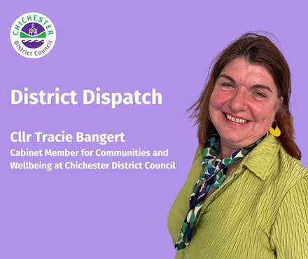
District Dispatch from Cllr Tracie Bangert, Cabinet Member for Communities and Wellbeing at Chichester District Council
District Dispatch

As we look towards the New Year, many of us will be thinking about how we can improve our health and wellbeing.
If you’re looking to make positive and healthy lifestyle changes, or if you need help with finances, you may be interested to know that our first Chichester Farmers’ Market of 2025 will have a ‘Feel Good’ twist!

Following its success this year, the ‘Feel Good Friday’ farmers’ market will return to East Street on Friday 17 January 2025, from 9am until 2pm. Our normal traders, who will be offering fresh local produce and artisan goods, will be joined by teams and organisations who can offer help and advice on improving our health and wellbeing. At the time of writing, we’re expecting to welcome representatives from Everyone Active, Fitjoy, Citizens Advice Arun & Chichester, as well as Chichester District Council’s Social Prescribers, Wellbeing team and Supporting You team.
The following Saturday (26 January), Chichester will be welcoming back the popular vegan market, bringing together vegan street food vendors, artisan bakers, craft brewers, ethical jewellery, cosmetics, clothing and more! www.veganmarkets.co.uk/location/chichester

Whatever your health and wellbeing goals next year, we’re here to support you. Our dedicated team of Wellbeing Advisors offer a free, friendly and confidential service to help with matters such as eating well, losing weight, reducing alcohol intake; being more active; and reducing stress.
If you’re trying to stop smoking, the team’s trained advisors can offer free Nicotine Replacement Therapy, saving you money as part of a free package of one-to-one support. The team’s new weight management course will also start mid-January and is free to join, offering advice on making long term sustainable changes. Find out more at: https://chichesterwellbeing.org.uk

In partnership with our leisure provider, Everyone Active, they offer a range of activities such as walking groups; a beginners’ running club; walking netball, cricket and football. Look out for more information on our new beginner exercise classes starting in February — these confidence building courses will be for those who currently do less than 150 minutes of exercise a week. Our volunteer-led ‘Heartsmart’ walks will continue over the Christmas period and into the new year, offering a chance to get out and about across our beautiful district.

If you’re experiencing non-medical issues that may be adversely impacting your wellbeing, it’s worth getting in touch with one of our friendly Social Prescribers. Those accessing the service can either be referred by their GP or through our self-referral form: www.chichester.gov.uk/socialprescribing

Around 70% of people who visit their GP have an underlying issue which isn’t necessarily medical. Someone could feel isolated or lonely; might not be managing a chronic condition well; or might be having problems sleeping due to issues such as debt. Many of these things will impact on a person’s physical and mental health and manifest themselves into medical symptoms. Our Social Prescribers spend time with clients, working with them to get to the root cause and helping them to find long-term solutions.

We also offer a similar service for young people aged 13 to 25. This was introduced following the pandemic, which had a huge impact on many young people. The service can assist those who lack confidence; are lonely or isolated; or want to have a greater sense of connection to their community and friends. The social prescriber will develop a plan with the young person to help connect them with activities, events and organisations that will help them to feel better.

Finally, I wanted to remind you about our ‘Supporting You’ team. They offer a range of assistance, from help with paying bills to help with housing — if you’re struggling with the cost of living, please find out more about how they can support you by visiting: www.chichester.gov.uk/supportingyou
Best Wishes

Cllr Tracie Bangert, Cabinet Member for Communities and Wellbeing at Chichester District Council

