Welcome to a special Budget 2025-2026 edition of our Residents’ eNewsletter

Prioritising our services to support communities and vulnerable people
We're working hard to balance our budget for the year ahead to ensure we make best use of resources and can continue to invest in and deliver services that support our communities.
Our budget for 2025-2026 amounts to over £2 billion which will be spent on services for our 900,900 residents and more than 42,500 businesses.
We reported in July that we were facing a budget gap of £60m in 2025-2026. This figure has now reduced to £38.5m, and projections show the figure could be brought down further to £8.2m if a decision is made to increase council tax.
The county council provides around 80% of local government services and touches the lives of every resident and business in West Sussex, as well as the tens of thousands of visitors we welcome to the county each year.
Services provided by the county council include adults’ and children’s social care, education, public health, fire and rescue, roads, libraries, trading standards, economic development and waste disposal and recycling.
Our focus is to deliver services that support our communities and vulnerable people.
We have key priorities which shape the way we deliver services.
They are:
- keeping people safe from vulnerable situations
- a sustainable and prosperous economy
- helping people and communities fulfil their potential
- making the best use of resources.
These priorities are all underpinned with a cross-cutting theme of protecting the environment.
More information


Watch our animation
Press 'play' to view a short video to explain why we’re running a budget consultation.

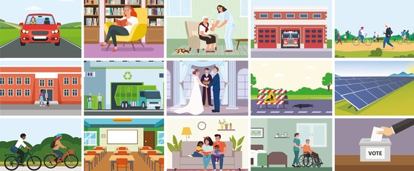
Tell us what you think
We want to hear your views about our budget and priorities and how we spend taxpayers’ money in the coming year 2025-2026.
Getting the views of our residents is a vital part of the budget setting process, so please take part by filling in our budget survey.
Anyone without access to the internet can visit a library or family hub to complete the consultation.
EasyRead surveys are also available online and in print.
If you know anyone who would like to receive a printed copy of the survey and a freepost return envelope, please call our customer services team on 01234 777 100.
The consultation closes on Sunday 15 December and all comments will be considered as part of the budget setting process for 2025-2026.
The Cabinet is due to consider feedback from the public consultation at a meeting in January before recommending the Council Plan and budget to Full Council in February for a final decision.
Take part in the consultation

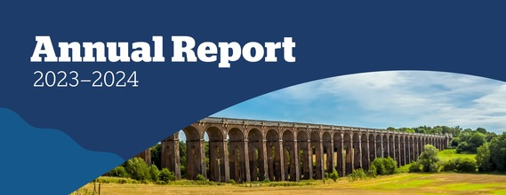
Transforming the ways we work
Our latest Annual Report outlining how the county council performed against the priorities in Our Council Plan is now published.
Between April 2023 and March 2024, we continued our proud track record of transforming the ways in which we work to make the best use of resources and deliver effective services.
The full report summarises what we delivered during this time and links to further details in our performance dashboard.
Read the Annual Report

Did you receive this eNewsletter from a friend? Sign up here.
