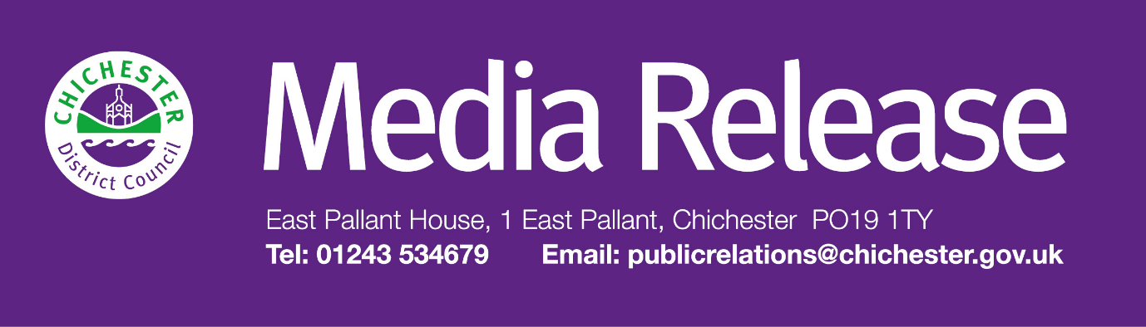

**Date of Release: 14 November 2024                                            Ref: 4392**

**Festive parking offers and annual review of parking charges agreed for Chichester District car parks**

Residents and visitors to Chichester District will once again be able to enjoy a series of parking offers during the festive period.

The parking offers will start in November in time for the Christmas light switch on event in Chichester and will run throughout December to support businesses.

For the big Christmas lights switch-on event in Chichester city centre on Saturday 23 November, the council will be offering free parking in its Avenue de Chartres car park from 4pm.

Then, during December, customers using the MiPermit app will be able to take advantage of a weekend offer — if they select two hours during weekends in December, they will receive a third hour for free. This will apply across the majority of council car parks except the Avenue de Chartres car park in Chichester.

In addition, there will be free Sunday parking in Avenue de Chartres car park in Chichester during December.

The annual review of parking charges has also been undertaken, and, in line with the council’s fees and charges policy, an inflation increase will be applied to parking charges which will come into force from 1 April 2025.  The inflation increase will also apply to the heavily discounted season tickets which are in place across several of the council’s car parks. Free parking periods will remain in the council’s rural and coastal car parks of between one and two hours, depending on location.

“Like all other councils, we consider fees and charges each year, and our Fees and Charges Policy requires us to increase all charges in line with inflation as a minimum,” says Councillor John Cross, Cabinet Member for Culture, Sport and Place at Chichester District Council.

“Parking charges provide essential income to support other key services provided by the council. This is more important than ever, at a time when there is an increased need for many of our services. Our policy is that car park users should cover the cost of parking provision.

“Parking charges also help to encourage turnover in our car parks; encourage alternative forms of travel; and provide improvements and enhancements to our car parks, including parking incentives.

“Even with these changes, our car parking charges are both fair and competitive. Our rural and coastal car parking charges continue to be some of the lowest and most competitive in the country, with free parking periods of between one and two hours, and the Sylvia Beaufoy car park in Petworth and Fernhurst car park remaining absolutely free — and of course there is free evening parking in the majority of our car parks.

“I’m pleased that we will once again be offering residents and visitors a series of parking incentives for the festive period as we know that this supports businesses in both the city and across the district.”

**For further information, please contact Clare Hawkin, Communications Officer at Chichester District Council on 01243 534679**

|  |  |
| --- | --- |
|  | **Terri Foster** Senior Communications Officer Communications Chichester District Council |

|  |  |
| --- | --- |
| Ext: 21226 | Tel: 01243521226 | [tfoster@chichester.gov.uk](mailto:tfoster@chichester.gov.uk) | Fax: 01243776766 | <https://www.chichester.gov.uk> | |
| East Pallant House opening hours: 9am-4pm Monday to Friday | |
|  |  |

[](https://www.chichester.gov.uk/emailbanner)