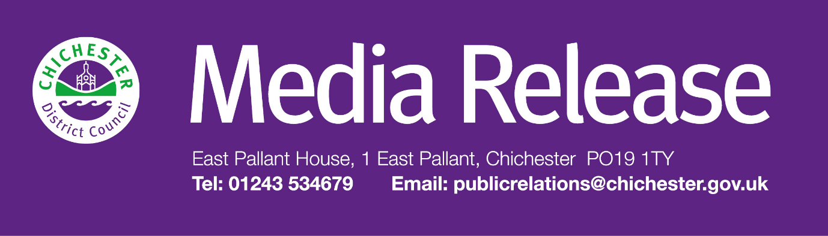 **Date of Release: 14 October 2024                                                          Ref: 4381**

**Go back to the 1980s with new exhibition at The Novium Museum, Chichester**

A fun and nostalgic showcase of memorabilia from the ‘greatest decade in the history of history’ is coming to The Novium Museum in Chichester.

 Opening on **Saturday 7 December** ‘I Grew Up 80s’ is set to provide a colourful trip down memory lane, capturing what the decade was like from a child’s perspective when music was on cassettes, shellsuits and leg warmers were must-haves and everyone received a Rubik’s Cube for Christmas.

 The period saw huge developments in science, technology, fashion, entertainment and the way we interact with each other. The exhibition will explore life before the internet and investigates the shared cultural experience of childhood in the 1980s.

 Visitors will find more than 200 items of memorabilia showcasing the youthful exuberance of the decade, from toys such as Care Bears, My Little Pony and Transformers, to album covers of timeless musicians like Queen, George Michael, Phil Collins and Kate Bush.

 Councillor Adrian Moss, Leader of Chichester District Council, says: “We’re really excited to be bringing this exhibition to Chichester. ‘I Grew Up 80s’ will be a nostalgic trip down memory lane for many of our visitors but will also provide an enlightening insight for younger visitors to see the differences between then and now.”

 As well as exploring what childhood looked like for their parents, children can explore interactive elements of the exhibition including 80s dress up, trivia questions, games and 1980s themed toys, including many old childhood ‘must-haves’!

 The exhibition will also feature a vintage Donkey Kong arcade game, which visitors can try their hand at for 50p per play.

 ‘I Grew Up 80s’ will replace the popular ‘Dinosaurs: Hungry Hatchlings’ exhibition, which closes on Saturday 9 November.

 The exhibition will launch with a free ‘Celebration of the 1980s’ event on Saturday 7 December and the museum will also be running a special events programme including an 80s Bingo Night with Dawn Gracie on Friday 13 December. Find out more by visiting: [**www.thenovium.org/whatson**](http://www.thenovium.org/whatson)

‘I Grew Up 80s’ opens at The Novium Museum on Saturday 7 December 2024 and runs until Saturday 8 June 2025. Tickets cost £5 for adults, £3 for children or £14 for a family of up to five (maximum 2 adults). For more information, and to book visit: [**www.thenovium.org/1980s**](http://www.thenovium.org/1980s)

**For further information, please contact Clare Hawkin, Senior Communications Officer, Chichester District Council on 01243 534679.**

|  |  |
| --- | --- |
|  | **Terri Foster** Senior Communications Officer Communications Chichester District Council |

|  |  |
| --- | --- |
| Ext: 21226 | Tel: 01243521226 | [tfoster@chichester.gov.uk](mailto:tfoster@chichester.gov.uk) | Fax: 01243776766 | <https://www.chichester.gov.uk> | |
| East Pallant House opening hours: 9am-4pm Monday to Friday | |
|  |  |

[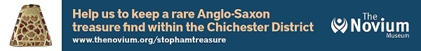](https://www.chichester.gov.uk/emailbanner)

________________________________________________________________________