
In the August edition of this newsletter you'll find a grass cutting update, information on our £1 Summer Special on Book-a-Bus as well as scheme updates from across the county.
Grass Cutting Update
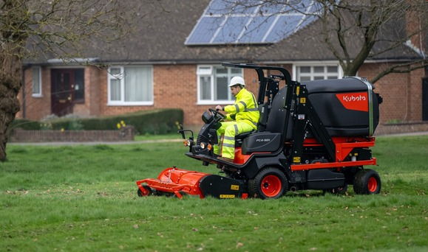
With the onset of warm, sunny weather we have seen significant levels of grass growth across the county.
West Sussex County Council is responsible for maintaining in the region of 12million sqm of grass verges and these are cut for safety and functional reasons only. The cutting regime is split into an urban and rural schedule to reflect the different environments and levels of use. We spend approximately £1.2million on grass cutting in West Sussex each year. Both the urban and rural cutting schedules are loaded onto our website here Grass cutting - West Sussex County Council
The urban cut currently consists of 5 overall cuts to verges maintained at public expense and equates to in the region of 5 million square metres. At the current time, the arisings from the cuts are left on site, and the contractor should blow arisings that have fallen onto the footway back onto the grass verge area before leaving site. It is not possible at the moment to collect and dispose of the arisings due to this being financially prohibitive, and any proposal to do so would likely impact the number of cuts we could undertake to make up for the cost difference. The council is exploring ways in which arisings can be used to create usable bi products such as supplements for road surfacing – for more information please see our Greenprint website pages here Greenprint - West Sussex County Council
It takes a minimum of 7 weeks for our grass cutting teams to complete a cut, and you’ll appreciate that with the right weather conditions, that is a long time for grass to grow quickly. Bringing a cut forward due to longer grass would run the risk of having long grass on verges right through the winter, as the number of cuts is fixed at 5.
Our rural verge cutting schedule recognises the positive impact these verges have on our pollinators and wildlife corridors. In light of that we only cut 3 times per year, focused on highway safety and sideways clearance. The first cut is a safety visibility splay cut at junctions only, the second cut is a visibility splay and one metre swathe cut for sideways clearance and the final cut is an overall cut of the verge in October/November. This gives wildflowers time to set seed and pollinators time to take advantage of wildflowers and valuable habitat in rural environments.
If you are made aware of issues that may impact the safety of highway users in between cuts (such as visibility at junctions), please do report to us in the normal way and we’ll organise for an inspection and any subsequent works, as necessary.
Make an enquiry or report a problem

£1 Summer Special on Book-a-Bus

Book-a-Bus is an on-demand, flexible bus service for areas in West Sussex with limited or no traditional bus service.
With Book-a-Bus fares capped at only £1 per trip for the whole month of August, you can plan a summer day out in the West Sussex countryside.
View our interactive map to plan your destinations.
Book a bus

Scheme Updates
Community Highway Scheme in Southwater
The proposal to install a new footpath along Blakes Farm Road, from its northern end to the roundabout junction with Wilberforce Way, is the result of a Community Highways Scheme (CHS) application from Southwater Parish Council.
This application was scored and prioritised as part of the autumn 2022 CHS assessment process and it has been progressed with the full support of the local county councillor, Nigel Jupp.
The scheme will begin construction on September 9th, 2024, and it will consist of approximately 400m of new footway on the west side of the road, as well as an improved pedestrian crossing point at the junction with Martindales. The construction period is expected to have a duration of 35 days, running until 25th October 2024.

Active Travel refurbishments for the local community of Lavant, Chichester
The Active Travel to School signalised crossing improvement in Lavant was funded by Active Travel England (ATE) following a successful bid to enable and support walking and wheeling. West Sussex County Council received £1,014,000 capital funding to deliver four active travel schemes and improvements during 24/25
Lavant CE Primary School is located on the western side of the A286 Midhurst Road, but there are a large proportion of residential dwellings located on the Eastern side of the road. Approximately 9,000 vehicles pass through the village per day. The improvement upgraded the existing uncontrolled crossing south of the St. Nicholas Road. The crossing will be of particular benefit to pupils, families, and staff walking to and from the primary school. The crossing will also benefit users of the St Nicholas Church (Northbound) bus stop, which is served by 2 public bus services to Midhurst – the heart of the Southdown’s National Park – and a school service. Similarly, residents of Lavant returning from work, leisure or retail trips to Chichester will also benefit from the crossing upgrade. Further benefits will be evident to residents accessing the allotments on the eastern side of the road. In addition, safety will be improved for staff and pupils walking to the church for community services and curricular activities.

Angmering Flood Alleviation Scheme, Phase 1
Work on a flood alleviation scheme for Angmering is due to start in early September. Angmering has a history of flooding. The primary cause of this flooding is the excessive flow of water in the Black Ditch following heavy rainfall events. This excessive flow surcharges the culverted watercourses that convey the Black Ditch from just downstream of the new Barratt David Wilson (BDW) Homes site down Water Lane and through the village. Working with the Environment Agency, Arun District Council, Angmering Parish Council and Barratt David Wilson Homes, West Sussex County Council have developed a scheme that will attenuate water adjacent to the new Barratt David Wilson (BDW) Homes site. This attenuated water will then be slowly released over time and thus reducing the pressure on the downstream drainage network.
Construction of the flow restriction structure, an 11m long x 2m high concrete wall with two orifices and some associated scour protection, will be constructed within the Black Ditch immediately upstream of the road access into the new Barratt David Wilson (BDW) Homes development. Construction will start in early September and is expected to take 8 weeks to construct.

Community Highway Scheme delivers traffic calming measures in Felpham
Community Highway Scheme was funded by Integrated Transport Block (ITB) following a successful bid to enable traffic calming measures in Firs Avenue. The scheme has successfully delivered traffic calming measures along Firs Avenue, between Felpham Way and Roundel Square. The works were undertaken to improve road user safety and reduce traffic speeds. The works included the installation of new speed cushions, refreshed road markings and revised traffic warning signs. The existing drain gully covers have been replaced with cycle friendly grates to further encourage the use of active transport methods.
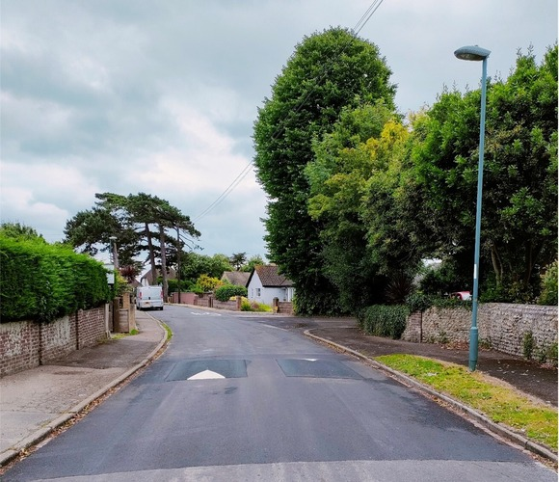
Follow us on X!
Project updates are frequently posted on the West Sussex Highways X account (formerly Twitter). Just search @WSHighways if you aren't already following.

Produced by the Stakeholder and Partnerships Officer, Highways Transport and Planning. Please contact active.communities@westsussex.gov.uk with any comments or suggestions.

