How safe do you feel in your local community?
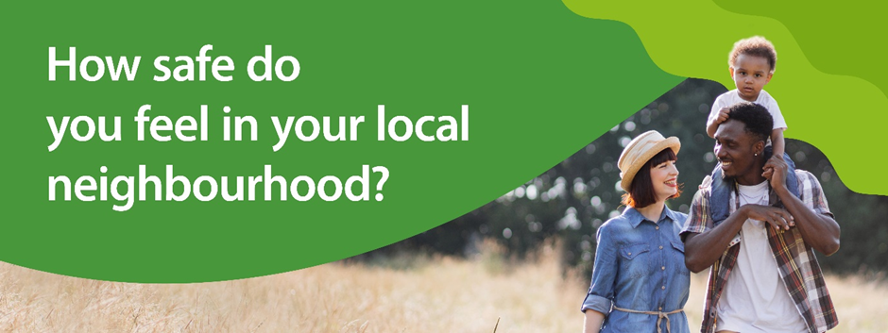
Community Safety Partnerships across West Sussex are asking residents how safe they feel in their local communities.
The online consultation, which launches on Monday 18 September, will be open to people of all ages to share their experiences of crime and anti-social behaviour in their local areas and will take around 10 minutes to complete.
The responses will allow the partnerships to further improve their understanding of the local communities and see whether their current priorities reflect the experiences of the residents living there.
Information from the consultation will be shared with the Safer West Sussex Partnership, which brings together the six district and borough Community Safety Partnerships, along with Sussex Police, the Sussex Police & Crime Commissioner, West Sussex Fire and Rescue, West Sussex County Council and other key agencies.
Mark Andrews, Chair of the Safer West Sussex Partnership, said: “The Community Safety consultation is an excellent opportunity for all residents of West Sussex to have their say on crime and anti-social behaviour in their local neighbourhood.
“It is a really important subject that affects everyone, and many people will have experienced or witnessed different issues in their surroundings, which they may or may not have reported.
“We hope that this consultation will give people the opportunity to have their say anonymously and help make their neighbourhood a safer place to live.”
Anyone without access to the internet, or who may struggle with filling in online forms, is encouraged to visit a West Sussex library, where free Wi-Fi and computers with internet access are available.
Library members may use the computers for free, for a maximum of two hours per day and if you are not a member, you can join on arrival at no cost.
Libraries also have Digital Volunteers available who offer free help in libraries and can support residents to complete the consultation. To arrange this, please contact the Library Digital Support team on 0330 222 3455 or library.digital.support@westsussex.gov.uk.
For those that would prefer a paper copy, this can be requested by calling 01243 777100 or emailing communitysafety.wellbeing@westsussex.gov.uk. Paper copies will be supplied with a return free post envelope.
For your chance to have your say, visit yourvoice.westsussex.gov.uk/community-safety, or your local West Sussex County Council library.
ENDS

Notes to Editor
Community Safety Partnerships
In each district and borough, there are statutory partnerships called Community Safety Partnerships. They look at reducing:
- Crime and the fear of crime.
- Anti-social behaviour.
- Alcohol and drug misuse.
- Re-offending.
More information about the local partnerships can be found below:
- Adur & Worthing Safer Communities Partnership
- Safer Arun Partnership
- Chichester District Community Safety Partnership
- Safer Crawley Partnership
- Horsham District Community Safety Partnership
- Mid Sussex Partnership
Safer West Sussex Partnership
The Safer West Sussex Partnership is a multiagency group with a statutory duty to work together to tackle and reduce:
- Reoffending.
- Crime and disorder.
- Anti-social behaviour.
- Alcohol and substance misuse.
- Any other behaviour which has a negative effect on the local environment.
Their role is to add value to the work already undertaken by individual agencies or localities and look at overarching issues affecting more than one area that require collaboration to address.
The partnership also ensures that funding opportunities are maximised to help create safety and wellbeing in the spaces and places communities spend their time.
Overall, the partnership seeks to support safer, stronger, and more resilient communities, and will achieve this by focusing on the particular risks and issues faced by vulnerable residents and communities.
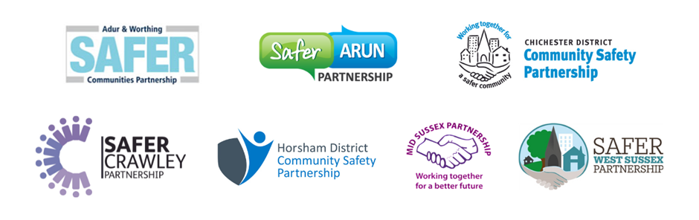
ENDS

For further information please contact the news desk on 0330 222 8090 or email pressoffice@westsussex.gov.uk.
For urgent out-of-hours enquiries please call 07767 098415.
 

